

Infrared Automated Optical Inspection
Senior Design: 120 Page

CREOL, The College of Optics and Photonics
Dr. Aravinda Kar

Department of Electrical Engineering and Computer Science
Dr. Lei Wei
Dr. Samuel Richie

OSE Group 1
Anthony Badillo (Photonics Engineering)
Garin Arabaci (Electrical Engineering)
Valery Jean (Electrical Engineering)
Joseph Sauceda (Computer Engineering)

1 Executive Summary 1
2 Project Description 2
2.1 Project Background 2
2.2 Motivation 2
2.3 Goals And Functionality 3
2.4 Requirements and Specifications 3
2.5 AOI Specifications 4
2.6 Laser Counter Specifications 4
2.7 Microcontroller Unit Specifications 4
2.8 Secondary Microcontroller Unit Specifications 5
2.9 General Specifications 5
2.10 Possible Project Constraints and standards 5
2.11 House of Quality 5
2.12 Hardware Flow 7
2.12.1 Responsibilities 8
2.13 Prototype Illustration 8
3 Research and Product Selection 9
3.1 Similar Product Research 9
3.1.1 Microscopy Systems 9
3.1.2 Thermal Imaging Systems 9
3.1.3 Relevant Data Inspections 10
3.2 Relevant Technologies 11
3.2.1 Telescopic Lens Systems 11
3.2.2 Thermal Sensor 12
3.3 Microcontroller Unit (MCU) 13
3.3.1 MSP430FR6989 13
3.3.2 ESP32 14
3.3.3 Raspberry Pi Pico 15
3.3.4 Raspberry Pi 4B 16
3.3.5 NVIDIA Jetson Nano 17
3.3.6 Secondary MCU 19
3.3.7 Main and Secondary MCU Selection and Comparisons 20
3.4 Electronic Fuse (eFuse) 20
3.5 Auto-Focusing Implementation 21
3.5.1 Stepper Motor Drivers 22
3.6 Implementing the Photodetector 23
3.6.1 What is a Photodiode 24
3.6.2 12-Bit Analog to Digital Converter 25
3.7 LEDs using PWM Channels 26
3.8 Through Hole vs Surface Mount Components 27
3.9 Power Supply 28
3.10 Voltage Regulators 30
3.10.1 Voltage Regulators 30
4 Poor efficiency 33
5 Consideration heat generation 33
6 Only step-down (buck) operation 33
6.2 Separation of Power and Control Circuits 41
6.3 Amplifier 41
6.4 Filtering 42
6.4.1 External Source 43
6.4.2 Internal Source 43
6.5 Voltage Divider 46
6.6 PCB Enclosure 47
6.6.1 Size 47
6.6.2 Access Needs 48
6.6.3 Cost 48
6.6.4 Temperature 48
6.6.5 Corrosion Resistance 48
6.7 Heat sink 49
6.8 Terminal Blocks 51
6.8.1 Wires and Cables 51
6.8.2 Connectors 52
6.9 Machine Learning 53
6.9.1 Artificial Neural Networks 53
6.9.2 Decision Trees 54
6.9.3 Support Vector Machines (SVM) 55
6.9.4 Machine Learning Summary 56
6.10 Digital Signal Processing (DSP) 57
6.11 Web Server 58
6.12 Graphical User Interface/HMI 58
6.13 Virtual Machine (VM) 59
7 Design Standards and Constraints 60
7.1 Standards 60
7.1.1 Serial Peripheral Interface (SPI) 60
7.1.2 Universal Asynchronous Receiver/Transmitter (UART) 60
7.1.3 C Language 62
7.1.4 Python 62
7.1.5 MATLAB 62
7.1.6 Laser Standards – Safety and Classifications 63
7.1.7 Optical Performance Standards 64
7.1.8 Standard-A USB 3.0 connector 65
7.1.9 TIFF Image File Format 65
7.1.10 Gigabit Ethernet (IEEE 802.3ab) 66
7.2 Constraints 67
7.2.1 Economic and Cost Constraints 67
7.2.2 Time 68
7.2.3 Health and Safety Constraints 68
7.2.4 Effectiveness 69
7.2.5 Ethical 69
7.2.6 Political and Social Constraints 70
7.2.7 Environmental 70
8 Design 71
8.1 Control System PCB Design 71
8.2 Power Supply PCB Design 87
8.3 Software Design 89
8.3.1 Software Design Overview 90
8.3.2 Software Flow 90
8.3.3 Software Design Components 91
8.3.4 Image Acquisition Software 93
8.3.5 Image Processing Software Overview 93
8.3.6 Support Software 98
8.3.7 LED Support Software 101
8.4 Software Design Summary 102
8.5 AOI 103
8.5.1 AOI View 103
8.5.2 AOI Component Choices 103
8.6 Laser Counter 105
8.6.1 Laser Counter Design and Cross Section 105
8.7 Component Selection 105
8.7.1 Lenses 105
8.7.2 Laser Comparison 106
8.7.3 Laser Goggles 107
8.7.4 Spot Size and Depth of Focus 107
8.7.5 Rayleigh Criterion 109
9 Project Prototyping & Testing 110
9.1 On-Board Power Supply Testing 110
9.2 Hardware Prototype Construction 110
9.3 Software Testing Overview 111
9.4 Simulated Software Testing 111
9.5 Physical Software Testing 112
9.6 Control System PCB Testing and Implementation 113
10 Conclusion 115
11 Administration Content 116
11.1 Budget 116
11.2 Budget Estimations 116
11.3 Milestones 118
11.4 Instruction Manual 120
11.4.1 General overview and startup of jetson 120
11.4.2 Creating initial files for capturing and training 123
11.4.3 Capturing Overview 123
11.4.4 Training Overview 125
11.4.5 Testing trained neural network 128
11.4.6 Things to know 129
11.5 Source Code 129
11.5.1 Jetson Nano Code 130
11.5.2 Jetson Nano GUI code 131
11.5.3 Raspberry Pi Pico Code 132
Appendices 133
Appendix A – Datasheets 133
Appendix B - References 133

List of Tables

Table 1: AOI Requirements and Specifications 4
Table 2: Laser Counter Specifications 4
Table 3: MCU Selection Comparison 20
Table 4: Stepper Motor Statistics 22
Table 5: Stepper Motor Driver Comparison 23
Table 6: Liner Voltage Comparisons 33
Table 7: Switching Voltage Regulator Comparisons 37
Table 8: Comparison of Linear and Switching Regulators 37
Table 9: Potential Considerations of Converters 39
Table 10: Comparison of the Enclosures 49
Table 11: Comparison of Heat sink Materials 51
Table 12: Machine Learning Algorithm Comparison 56
Table 13: Main MCU Connections on Control System PCB 74
Table 14: Secondary MCU Connections on Control System PCB 75
Table 15: A4988 Stepper Motor Driver Carrier Microstep Resolution Configuration 77
Table 16: All connections made in version 3 of the Control System Schematic 79
Table 17: Control System Schematic V3 Component Values 81
Table 18: LED Identifiers Table 102
Table 19:Optics Budget Estimation 117
Table 20:Optics Budget Actual 117
Table 21: Senior Design I Milestones 118
Table 22: Senior Design II Milestones 119

List of Figures

Figure 1: House of Quality 6
Figure 2: Hardware Block Diagram 7
Figure 3: Software Block Diagram 7
Figure 4: Prototype Diagram 8
Figure 5: The technical sheet for a current AOI 10
Figure 6: Galilean Telescope (Beam Expander/Telescope) diagram 11
Figure 7: A generic sensor showing the process of imaging 12
Figure 8: MSP-EXP430FR6989 BoosterPack Pinout Diagram (Texas Intruments Inc, 2013) 14
Figure 9: ESP32 on DEVKIT V1 Pinout Diagram (RandomNerdTutorials, 2022) 15
Figure 10: Raspberry Pi Pico Pinout Diagram (Raspberry Pi Ltd, 2012) 16
Figure 11: Raspberry Pi 4B Pinout Diagram (eTechnophiles, 2021) 17
Figure 12: NVIDIA Jetson Nano Developer Kit Layout (NVIDIA Corporation, 2022) 18
Figure 13: NVIDIA Jetson Nano 40-pin header Pinout Diagram (NVIDIA Corporation, 2022) 19
Figure 14: Electronic Fuse Block Diagram (Texas Instruments Inc., 2019) 21
Figure 15: A4988 Driver on Pololu Carrier Board Wiring Diagram (Pololu Corporation, 2001) 22
Figure 16: Recommended Circuit Diagram for SM05PD2B Photodiode (Thorlabs, Inc., 2017) 24
Figure 17: Photodiode Electrical Symbol 24
Figure 18: Responsivity of SM05PD2B Photodiode (Thorlabs, Inc., 2017) 25
Figure 19: Raspberry Pi Pico PWM Pinout Diagram (Raspberry Pi Ltd, 2012) 27
Figure 20: Bridge Rectifier 29
Figure 21: Bridge Rectifier Waveform 29
Figure 22: Capacitor in line with Bridge Rectifier 30
Figure 23: Power supply using Bridge Rectifier 31
Figure 24: Operation Amplifier 32
Figure 25: Low-Dropout Regulator 34
Figure 26: Quasi Low-Dropout Regulator 35
Figure 27: Standard Regulator 35
Figure 28: Summary of Regulators 36
Figure 29: A basic Switching Regulator Configuration 36
Figure 30: WEBENCH Generation Based on LM5021 40
Figure 31: Converters Efficiency Graph 40
Figure 32: Ideal of Non-Inverting Amplifier Circuit 42
Figure 33: Ideal of Unity Gain Buffer Circuit 42
Figure 34: Ideal passive low-pass filter 44
Figure 35: Second order Ideal Active low-pass filter 44
Figure 36: Second-Order Butterworth, Bessel, and 3-dB Chebyshev Filter Frequency Response 45
Figure 37: Transient Response of the Three Filters 46
Figure 38: Pictures of AM-202, AM-206, and AM-50-SDC Enclosures respectively 49
Figure 39: Examples of Heat sink 50
Figure 40: 12 AWG gauge 8ft long Polarized wire 52
Figure 41: 12 AWG and 16AWG Terminals Blocks 52
Figure 42: Artificial Neural Network Diagram 54
Figure 43: Decision Tree Diagram 55
Figure 44: Support Vector Diagram 56
Figure 45: DSP Diagram 57
Figure 46: Web Server Diagram 58
Figure 47: GUI/HMI Mockup Diagram 59
Figure 48: SPI Connection Diagram 60
Figure 49: UART Communication Full-Duplex 61
Figure 50: UART Frame 61
Figure 51: A sample of ANSI Z80.1 in regards to the standards in optical glass 64
Figure 52: Standard-A USB 3.0 Male Connector (Unconventional2, 2014) 65
Figure 53: Stripped Category 5e Ethernet Cable (Wheeler, 2007) 66
Figure 54: Design Flow Diagram 71
Figure 55: NVIDIA Jetson Nano Developer Kit J6 40-pin Header Symbol 72
Figure 56: NVIDIA Jetson Nano Developer Kit J6 40-pin Header PCB Footprint 72
Figure 57: Raspberry Pi Pico Symbol 73
Figure 58: Raspberry Pi Pico PCB Footprint 73
Figure 59: Control System Schematic V1 74
Figure 60: Control System Schematic V2 75
Figure 61: TPS25200 5-V eFuse Simplified Schematic (TPS25200 Datasheet) 77
Figure 62: TPS25200 5-V eFuse V_{OUT} vs C_{OUT} (TPS25200 Datasheet) 78
Figure 63: TPS25200 5-V eFuse V_{IN} vs V_{OUT} (TPS25200 Datasheet) 79
Figure 64: Control System Schematic V3 82
Figure 65: Control System PCB V1 83
Figure 66: Control System PCB V1 Render 84
Figure 67: Control System Schematic V4 85
Figure 68: Control System PCB V2 86
Figure 69: AC-DC Power Supply Schematic from Fusion 360 AutoDesk 87
Figure : The AC-DC Power Supply PCB 87
Figure : The DC-DC Power Supply PCB 88
Figure : TPS54561EVM-593 Power Supply from TI 89
Figure : Software Block Diagram 90
Figure : Virtual Development Environment 91
Figure : GitHub Flow Diagram 93
Figure : Pre-processing Example Image 94
Figure : Intensity histogram of Example Image 95
Figure : Noise Reduction Example 95
Figure : Quality Control Algorithm Flow Diagram 96
Figure : Machine Learning Algorithm Training Cycle 97
Figure : Use Case for Support Software 98
Figure : Logging flow diagram 99
Figure : GUI Interface flowchart 100
Figure : LED System Support 101
Figure : AOI Overview Diagram 103
Figure : Laser Counter 105
Figure : On-Board Power Supply PCB Testing 110
Figure : Breadboard Testing Draft Assembly 111
Figure 89: Control System PCB V2 Final Assembly 114
Figure 90:View of SD card 120
Figure 91:Overhead shot of jetson nano 120
Figure 92:Jetson Nano Desktop Screen 121
Figure 93: Code-OSS 121
Figure 94:Code-OSS application 122
Figure 95:Running code in code-OSS 122
Figure 96: Two important files for testing project 123
Figure 97: Opening terminal for camera-capture 124
Figure 98: camera-capture starts using terminal 124
Figure 99: Data Capture Control window 125
Figure 100: Path to train.py 125
Figure 101: command to start training 126
Figure 102: Training progress 126
Figure 103: Resuming Training 127
Figure 104: Exporting trained neural network 127
Figure 105: command to add to application 129

Executive Summary

Automated Optical Inspection units, or AOIs for short, are large machines used in top-of-the-line manufacturing lines in order as an efficient, automated process to enact quality control (QC) checks. The products in question are usually small parts like screws and fasteners, PCBs with components on them, or optical lens equipment. These products would be mundane and tedious for humans to check for defects, such as surface abrasions, misprinted or misplaced components, and PCB components with improper soldering. The fine details that can be detrimental to the entirety of a product has now been left to machines to do that work; the AOIs. The way AOIs work is as follows; photos of good product in question are fed into an AI assisted software, as well as photos of known and common defects. As the product is manufactured, it goes through the machine which will take photos of ever relevant surface that a failure can occur. The photo is taken real time and diagnosed by the software to determine if the product falls under the ‘pass’ or the ‘‘failure’’ category.

AOIs that are used to inspect the surface quality and position of hardware and components work in the visual light spectrum. This is because visual light makes these physical observations show up in photos so that the software and any QC operator can easily determine if the component in question passes spec. However, for this project, a conventional AOI optical setup will not be used. The sponsor of this project has requested an AOI that measures the thermal radiation that is emitted from the product in question that is supposed to be checked. Therefore, a nonconventional approach to AOI design must be approached to achieve the desired results.

Project Description
The following is a detailed breakdown of the goals our system will need to achieve, as well the necessary background information, and the ‘why’ for why we are doing it.

Project Background

As technology develops at an exponential rate, so does the demand for volume and miniaturization. Just think of a single motherboard for a modern computer. There are countless amounts of small electrical components to provide power and signal across the entire board, but there are multiple soldering points necessary for a proper connection. Having just one fault can cause a critical system failure that prevents it from operating at its expected performance, or it may even cause it to not operate at all. An experienced technician may be able to troubleshoot or catch a mistake on a single board, such as an upside down part or poor solder. It would be unfathomable to expect that technician to efficiently catch said mistakes across multiple boards at an acceptable error rate while keeping on pace with the production line.

This is where an Automated Optical Inspection is useful. A system capable of taking photos and scanning a particular area of a production line to determine if the product in question passes quality testing specifications leads to a multitude of benefits. Not only is QC done at a rapid pace, but if a high frequency of error within the product in question shows up, it may very well be an indication that there is an unknown fault on the production line. As efficient as AOIs currently are, what happens when the quality control in question doesn’t show up in the visible light spectrum?
This is where our product comes into play. The most common AOIs are used for PCBs, and the reason that they rarely use thermal imaging is because defects show up in visual light. Introducing thermal light to the product can cause reflections and hot spots that are not conducive to the quality control process, and the margin of improvement that is gained from using this type of imaging to have negligible benefit, if any. That means a custom AOI would need to be developed for our purposes; a product that causes IR emission, and the emission profiles and the emission locations are what is used to determine QC spec. Our project is developing a thermal AOI, as well as other key accessories to help shape the entire QC process for the product in question.

Motivation

Motivation for this project comes as a challenge to create a solution to a problem posed by the MOFD Research Team at the College of Optics and Photonics (CREOL). The challenge at hand is to create a low-cost quality control system that incorporates two functions. One of them being an AOI that operates in the NIR range, and a separate system that uses as a laser to determine how much material has been used. While both of these are independent systems in nature, the core use between the two of them is to provide a mechanical system to assist the team in increasing their manufacturing potential.

Goals And Functionality
To achieve the goal of creating a full system that will QC the manufacturing for this system, we first must break the system up into two units. The first unit in our system is a laser counter. This laser counter, using a HeNe laser, will shine onto the copper insulated wires of the fabric. As the fabric moves through the production line, the laser will shine on either the wire or the wool backing of the fabric. The change in power as the laser hits these two materials on the fabric will cause the emitted power to change as it is captured onto a photodetector. By logging this change, we will consider that one of the individual wires has passed by when this power fluctuation has been recorded. This will result in a counter recording how many fluctuations have occurred and translating it to how many wires have passed through the specified checkpoint.

The second, and most critical aspect of this project, is an IR AOI system taking photos of the finished fabric after its manufacturing process. The fabric is covered by an electrical bus once it is through its final manufacturing stage. This means the most fragile and critical electrical connections are not visible postproduction, meaning that if there is a fault the only way to know is connecting a power source and waiting to see if it works. This is not feasible in a conducive manufacturing environment. The IR AOI, therefore, is to take photos of the thermal radiation of the fabric as an electrical load is applied while on the line. A database of photos will be created as benchmarks for the system. These photos will represent what passing and failing fibers look like for the system and be stored on the machine. A software will then check the photos against the live photos being detected as the fabric is being quality controlled, and the system will be able to flag any known failure patterns as they arrive on the line.

Requirements and Specifications

Requirements and specifications are mandatory for our project for multiple reasons. These are the standards and expectations that our funding research team has given us to succeed with the project that they have instilled in us. It is the bare minimum that we all believe will create a project we are satisfied and proud of, but also fulfils the requirements they have as our customers. These specifications also give us, the project team, the ability to benchmark ourselves as we physically design and build the project this Fall. We will be able to know if we are going in the right direction, and we will also know if we can improve our design drastically if we are easily able to fulfil these goals.

AOI Specifications

Table 1: AOI Requirements and Specifications

Description | Project Minimum Targets
Resolution | 800 x 800
A.I. Positive Detection rate | >60%
Error rate | <40%
Rate of reading and processing | >1 ft/s
Power Input | 120 VAC
Thermal inspection area | <100 um
Cost | <$2500
Photo Rate | >360 threads/sec

Laser Counter Specifications

Table 2: Laser Counter Specifications

Wavelength | 533 nm ~ 632.8 nm
Photodetector Sensitivity | Dependent on Laser Power. Be sensitive enough to record discernible differences to execute count
Electric Power Requirement | 120 VAC ~ 230 VAC (Laser)
Laser Beam Width | 50 microns
Error Rate | <5%

Microcontroller Unit Specifications

- The processing capability should be substantial to keep up with imaging for 1ft of fabric per second (360 threads per second), this would entitle at a minimum:
  - Multi-core processor
  - ≥1GHz processor speed
  - ≥2GB Ram
  - GPU unit preferred
- The unit should have support for communication to secondary MCU
  - GPIO data protocols UART, SPI, I2C, etc.
- The unit should have USB 3.0 for NIR-Enhanced CMOS Camera
- The unit should have ethernet to support network connection to collected data
- The unit should have substantial onboard storage to document defects
  - ≥4GB Storage

Secondary Microcontroller Unit Specifications

- The unit should have support for communication to main MCU
  - GPIO data protocols UART, SPI, I2C, etc.
- The unit should have support for sending and receiving signal from photodetector
  - Will need an Analog to Digital Converter ≥10-Bit capable
- The unit should have support for RGB LED or two separate LEDs
  - PWM capable GPIO pins

General Specifications
The general specifications as seen here are target goals for general operation. We plan on showcasing the first three specifications for our SD2 demo

- System must be able to resolve clearly such that the machine vision can resolve at minimum an 800µm x 800µm surface
- Measurements, data collection and automation must match operation speed of 1 ft/s
- Minimum 60% pass rate on both the laser counter and the AOI process
- External PC support (air gapped, log collection)
- AOI camera and the measuring laser must at six inches above the line
- System must be capable of upgrades
- All optic components must be housed internally
- Can operate within a manufacturing environment, regardless of air cleanliness

Possible Project Constraints and standards
- AC/DC Power supply
- Safety design
- Testing Process
- Reliability
- All standard connections
- Programming languages

House of Quality
In this project, we need to find out the tradeoff between the market requirements and the engineering requirements. By making the following house of quality diagram, that allows us to see the correlation between them and gives us also a better view of how requirements affect one another. This House of Quality in other words will help us to optimize the quality of our product design.
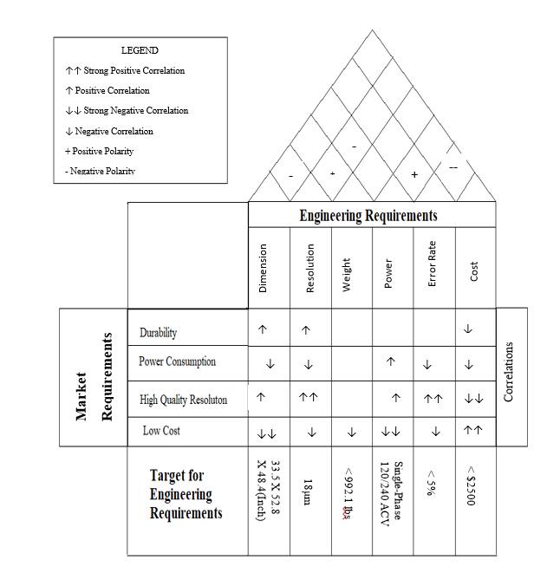

Figure 1: House of Quality

Hardware Flow

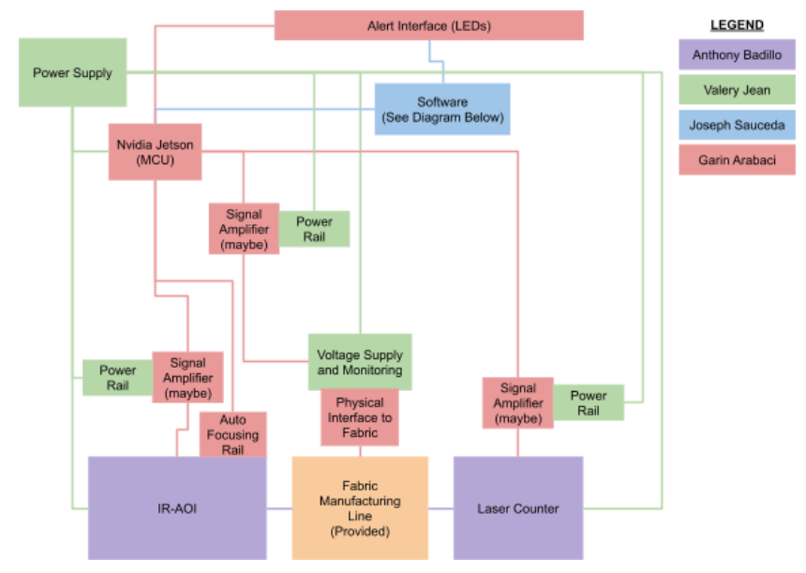

Figure 2: Hardware Block Diagram

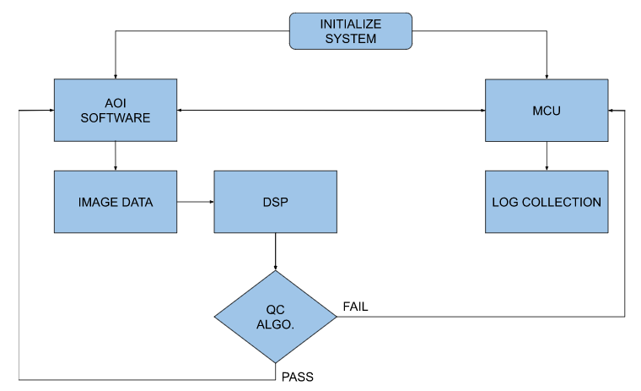
Figure 3: Software Block Diagram

Responsibilities

- Power Supply: Valery Jean
- Signal Amplifiers (if needed) (Rail Power): Valery Jean
- Signal Amplifiers (if needed) (Signals): Garin Arabaci
- IR-AOI: Anthony Badillo
- Auto-Focusing Rail: Garin Arabaci
- Laser Counter: Anthony Badillo
- Voltage Supply and Monitoring (For Fabric Testing Interface): Valery Jean
- Physical Interface to Fabric (For Fabric Testing Interface): Garin Arabaci
- Software: Joseph Sauceda
- MCU: Garin Arabaci
- Alert Interface (LEDs): Garin Arabaci

Prototype Illustration

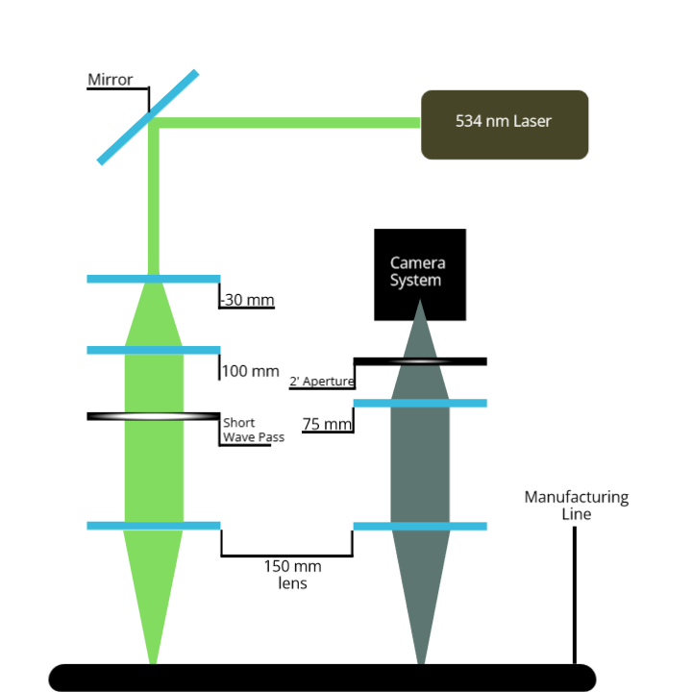

Figure 4: Prototype Diagram

Research and Product Selection

Creating a project this scale from scratch requires analysis of not only the product we are replicating, but also checking other relevant technologies that help guide us to create a foundation on which to build upon.

Similar Product Research
Current AOI Intellectual Property is heavily guarded by the manufacturers of such systems. In order for the team to develop our own homebrewed system, it is necessary to research the sub technologies that will be incorporated into our design by a case by case basis.

Microscopy Systems

Microscopes are capable of magnifying small to microscopic objects in order resolve an image that could not be capable with the naked eye. The general principle for the simplest microscope is a microscope objective lens, which gathers as much light from an object as possible. The concave lens nature of the objective magnifies an image along a tube or any other image housing, until it hits an eye piece. This eyepiece is able to focus an image in imaginary object space, meaning that it ‘floats’. Unless there is an accompanying camera system, the goal is for the user to align their eyes to the eyepiece to see the image.

Microscope objectives are qualified by their magnification power. It’s a generalized term that has varying degrees of definition, but the principal notion is as follows. The greater the magnification number, the smaller level of detail the system is able to resolve.

A baseline for relative magnification was made with one of the fabrics in our possession. We placed it under a 5x microscope objective, and the microscope was able to resolve an area of around 900 µm x 900µm. This was incredibly close to our target, but there was one fatal flaw. The working distance in order for the microscope to resolve the image required it to be around 26 millimeters from the surface of the fabric, meaning that it failed our spec of being 6 inches off the line. However, knowing that it is indeed possible to magnify our fabric clearly with relatively cheap optical parts, we knew the approach in designing our own telescopic system, which will be explained further below.

Thermal Imaging Systems
Another critical component to the AOI portion of the QC system is thermal imaging. The spectrum of light extends much further than the spectrum of light people can see. Thermal radiation lies beyond the 1200 nm wavelength, and it because of the properties of infrared light with its respective wavelength and frequency, the light generates heat in a classic ‘thermal vision’ sense. With the use of thermal detectors, which is expanded below, is able to map the different intensities of heat to form a resolvable image.

Knowing that thermal imaging is a growing and improving field in Optics, Securities, and Defense, we can use the core concepts from traditional thermal imagers and thermal cameras to build our own system with proper resolution in order to achieve our goal.

Relevant Data Inspections

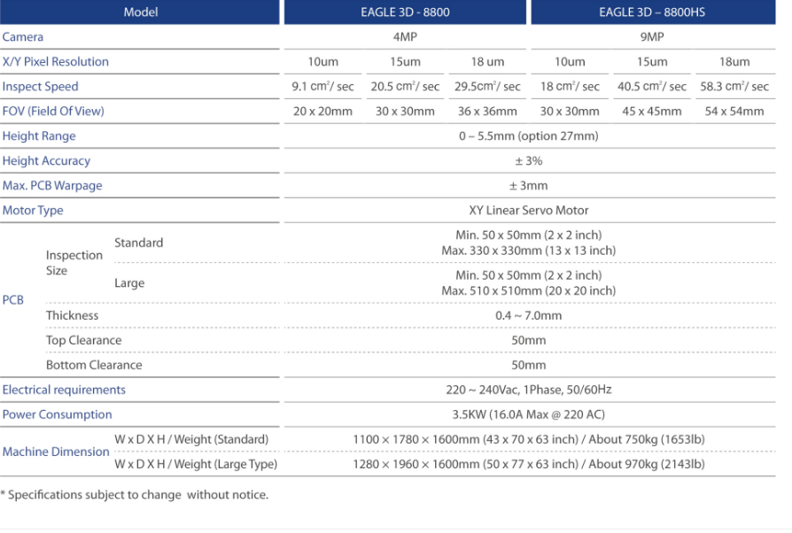

Figure 5: The technical sheet for a current AOI

Figure 5 shows the technical summary table for the Pemtron Eagle 3D 8800 and 8800HS AOI Systems. These systems can be used as the framework of success for the model that we want to use. As can be shown from the first four rows, we can focus on the imaging quality that the system provides; Camera, X/Y Pixel Resolution, Inspect Speed and the FOV. The key aspect that is shared across the board with these four is the high fidelity it creates when imaging for QC purposes. The large megapixel count in the camera systems, even on the lower end system at 4 MP, is imperative for a clear image to resolve. This is necessary because when imaging small PCBs there are countless points of failure that can occur. Poor soldering, physical defects on chips and resistors, and misplaced components need close inspection. This level of detail is critical for standards, especially when such standards have differentiations between multiple industries. The tolerance for defect is dependent on generalized standards for the industry a PCB is being created for, or even specific projects if the customer requires it.

To be able to hit all four listed criteria for well resolved images, especially in the thermal spectrum, we will need to use every possible imaging concept, equation, and fine tune our optical setup in order to properly form the best images possible.

Relevant Technologies

In order to properly create this project, multiple facets of optical systems and electrical systems must be married into a coherent system that will function the way we want. In order to achieve this feat, we must break down the multiple facets of each branch of the system, and further discuss the physical limitations and the capabilities of what we are looking to achieve. With this designated breakdown, the systems can then be optimized in such a manner that they will be capable of operating at full capacity.

Telescopic Lens Systems

Telescopes are an invaluable optical system that collects emitted light from an object at great distances and focuses the light into a resulting image that can be used for research or practical purposes. The method of collecting the light, as well as the optical design of said telescope is bountiful and numerous. The key to choosing the right telescope design is dependent on the purpose that one is trying to achieve.

Even with the multitude of assorted designs for telescopes, the principle of their optical functionality remains the same. An appropriately sized front optic is placed in front of the system to collect the light from a target body. The collected light is either then expanded or focused until it reaches an eyepiece, which will then create an image on either a sensor or wherever the viewer must place their eye. The image is then formed, and if all parts of the system are optimal, the resolution of the resulting image can then be used for whatever purpose necessary.

For the purposes of this project, a Galilean Telescope will be used. As Figure 6 shows, a Galilean Telescope can use a plano-concave lens to diverge the light from an object, and then uses a convex lens to collimate the light. The reason for this is due to the working distance necessary to fit our design parameters.

We are working in at a wavelength range of 1.7µm to 1.95µm, which is within the NIR range of light. Knowing this, we would need to not only find appropriately sized lenses with the correct focal length to create the correct image, but we would also need to make sure that the glass used would be able to focus light at that wavelength range.

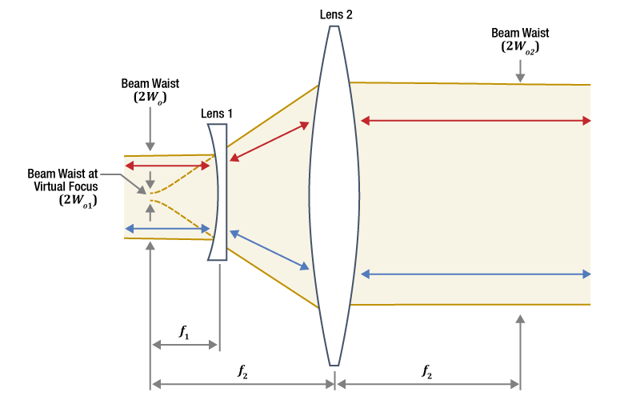

Figure 6: Galilean Telescope (Beam Expander/Telescope) diagram

Thermal Sensor

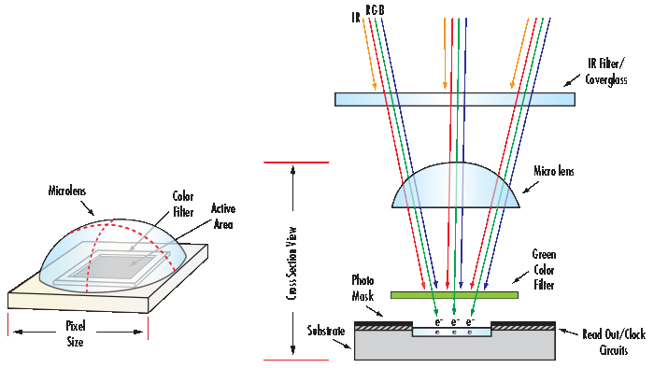

Figure 7: A generic sensor showing the process of imaging

Imaging the fabric that is already welded to the electrical bus will require thermal imaging. Visual light will not penetrate the manufactured piece under the fabric, so there would be no way to properly check the electrical connection of the fabric in this state. Due to this, a visual light camera would be an impractical fit.

The wavelength of NIR is within the range of 780 nm to 2500 nm, compared to visual light which is between 380 nm to 700 nm. This means that an IR sensor is necessary to use in order to get the type of image that we are looking for. Thermal cameras use the thermal radiation given off by a heat source, which can range from 3µm to 14µm, and uses the energy as it goes through a detector to process an image. Thermal detectors use a focal plane array, which is a two-way array of detectors ranging in micrometer size. The pixel resolution ranges from 1024 x 1024 pixels to 4096 x 4096 pixels. The two types of focal plane arrays are quantum detectors and thermal detectors. Quantum detectors use exotic materials, such as Indium antimonide (InSb), to measure photon absorbency. It is an expensive product with a degree of capability and accuracy outside the scope of this project, meaning that we will choose to use a thermal detector.

Thermal detectors use bolometers, which is a device that is electrically stimulated through the change in thermal radiation. The heat coming off the object creates this excitement that then translates to image formation, with the use of an absorption layer and a thermal reservoir. Because of how relatively inexpensive this is compared to quantum detection; it fills out criteria.

Microcontroller Unit (MCU)

The Microcontroller Unit is the first point of research for the control system of this project as it will be running the image processing algorithm required to interpret the data from the NIR-Camera. Since the target speed of the manufacturing line is one foot per second, and one foot of the Chromorphous fabric contains 360 threads, we could potentially be taking and processing 360 near infra-red photos per second. Given this potentially massive computing requirement, we will do our best to meet this with hardware but may have to resort to decreasing the number of tested threads or slowing down the manufacturing line. However, this is not something we will be able to quantify until the software is built. Since the processing requirements cannot be quantified estimated minimums have been made. At minimum the MCU should have a multi-core processor capable of greater than or equal to 1GHz clock speeds, greater than or equal to 2GB of RAM, and preferably a separate Graphics Processing Unit. In order to accommodate our initial NIR-Camera selection, our MCU will have to have support for the USB 3.0 standard. The MCU should also have an ethernet port to support connection to a Local Area Network (LAN) and beyond. Doing this will enable users to access the MCU and its collected data from any computer on the same network. In the same vein, to store this data for future access the MCU should have a substantially large storage. The NIR-Camera saves its images as a TIFF file format which has a maximum size of 4GB, so as a minimum the MCU should be able to store one max sized TIFF file. In the event that the storage of images depicting a failure becomes an issue, it could potentially be offloaded to another computer on the same network. A final consideration to consider for the MCU selection should be the preference and familiarity of our programmer Joseph. He expressed familiarity with raspberry pi MCUs so they will be given a bias if they are applicable.

Since our computation requirements are not currently quantifiable, the implementation of a secondary MCU will be done. This secondary MCU will have significantly lighter requirements as it is meant to take over as many simple processes as possible from the main MCU. This, however, will require communication between the main MCU and the secondary MCU which could be implemented through General Purpose Input Output (GPIO) pins that support communication protocol such as UART, I2C, and SPI. This functionality will be needed on both the main and secondary MCU. The GPIO pins on the secondary MCU specifically, have two requirements currently. They must be capable of sending and receiving a signal from the photodetector. This photodetector is our data collection method for the laser counter system. The returning signal may need amplification through an operation amplifier, but that has not been determined as of this time. What is anticipated is that this signal will be analog and require an Analog to Digital Converter (ADC) to help interpret the signal data. In order to maximize the resolution of the data we receive from the photodetector signal, the ADC should be capable, at minimum, of 10-Bit conversion. The second use of the GPIO pins on the secondary MCU will be for simple status LEDs. Currently, we will just need to run one RGB LED to receive green, yellow, and red status indicators. With green indicating no errors, yellow indicating minor errors, and red indicating critical errors that require halting production. This simply requires three GPIO pins and communication from the main MCU of detected errors. The secondary MCU will process error thresholds and change the status LED accordingly and report that status to the main MCU.

MSP430FR6989

One potential MCU would be the Texas Instruments MSP430FR6989. This came up as a potential MCU due to my personal familiarity with the controller in EEL 4742 Embedded Systems. However, upon inspection of the capabilities of the MCU, they do not meet several requirements. It features only a 16-Bit RISC Architecture with a 16MHz clock speed, only 2KB of RAM, and no GPU. This being nowhere near what we believe to be capable of processing 360 images per second. The unit does feature an impressive amount of GPIO pins at 83 total. These GPIO pin also include communication protocols. Specifically, 2 UART, 2 I2C, and 4 SPI. It can support 5 PWM channels for our LEDs. The MSP is also lacking in any USB ports let alone a USB 3.0. It also lacks in any ethernet port for connecting to a Local Access Network (LAN). Last of all, it also only has 128KB of storage, which is nowhere near even one TIFF file. Given the lacking computation power and ports, this would not be a suitable choice for the main MCU. However, its impressive number of GPIO pins, support for communication protocols, and 12-Bit ADC makes it a better choice for a secondary MCU. Although, it may prove to be overkill for what is needed from our secondary MCU.

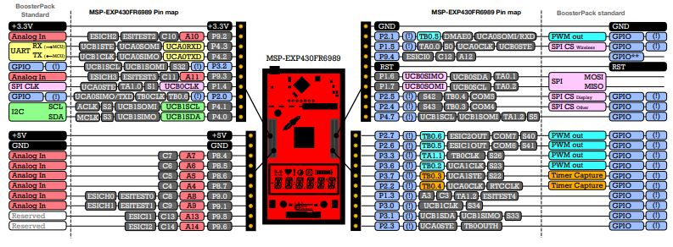

Figure 8: MSP-EXP430FR6989 BoosterPack Pinout Diagram (Texas Intruments Inc, 2013)

ESP32

My next thought was to use an ESP32-based board which I also had some familiarity with. These are extremely versatile boards like Arduinos, but with more functionalities built into a smaller form. In terms of computation power, it does better than the MSP, but it is still lacking. It features a Xtensa single or dual core 32-bit processor up to 240MHZ with 520KB SRAM. This once again, is not close to meeting our estimated minimums for computational power. Looking past computation requirements, it does meet our GPIO requirements with its 36 pins. Of which feature 3 UART, 2 I2C, 2 I2S, and 4 SPI, as well as a 12-Bit ADC. The pins can also support 16 PWM channels for the LEDs. However, that seems to be the only requirement met, as it lacks USB 3.0 capabilities which conflicts with our NIR-Camera. It does not feature an ethernet port, however its Wi-Fi capabilities do make up for that by allowing for a slower connection to a LAN. This Wi-Fi functionality could be useful for transferring our raw data directly to a computer for processing, and receiving the results, if a MCU with enough onboard computing power is not found. The ESP32’s Bluetooth and Wi-Fi could also be used to simply display the results of our inspections to a monitoring device if desired in the future. The board also features clocks and timers which could be used to match the rate of any control signals to the speed of the manufacturing line. We did not think this was going to be enough space or power to support processing IR images capable of one hundred microns at one foot per minute. So, given the concerns about processing power and interfacing with the device, we decided against an ESP32-based main MCU. However, once again this may fair better as the secondary MCU instead, and given its Wi-Fi and Bluetooth functionality, could allow for future features without any hardware modifications.

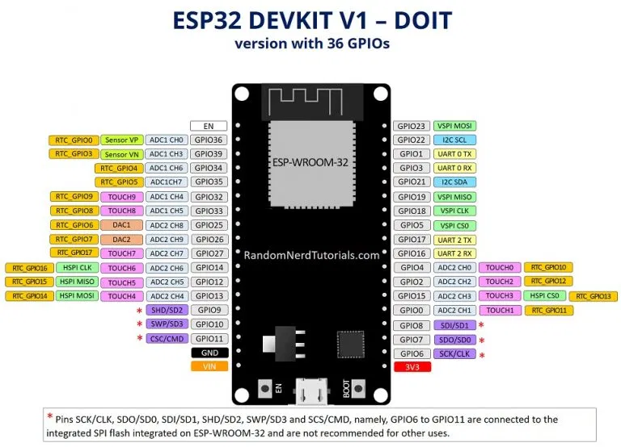

Figure 9: ESP32 on DEVKIT V1 Pinout Diagram (RandomNerdTutorials, 2022)

Raspberry Pi Pico

With Joseph’s familiarity with Raspberry Pi MCUs, I next looked at the Raspberry Pi Pico. This is a small and cheap MCU that could easily be surface mounted to a circuit board as a nice feature. The Raspberry Pi Pico features a dual-core ARM Cortex M0+ processor up to 133MHz with 264KB of SRAM. Featuring the same issues as the MSP and ESP32 microcontrollers, its processing power is not going to enough based off our estimates. The Pico also only features 2MB of memory which does not meet the maximum requirements of a TIFF file. The Pico does support USB; however, it is only up to USB 1.1 and not the minimum 3.0 that is needed for the NIR-Camera. So once again, the NIR-Camera alone invalidates another MCU. On the bright side, the Pico does have 26 GPIO pins and features 2 UART, 2 I2C, and 2 SPI communication protocols. The GPIO pins can also support 16 PWM channels for the LEDs. It also features a 12-bit ADC to accommodate our photodetector. It does not have ethernet capabilities however, the Raspberry Pi Pico W variant does feature Wi-Fi functionality. Once again, this would meet our requirements for the secondary MCU, but not the main MCU. Given its form factor, ability to be surface mounted to a circuit board easily, and GPIO capabilities it is a top contender for secondary MCU. Including Joseph’s familiarity with Raspberry Pi MCU’s, this is my current top pick for secondary MCU.

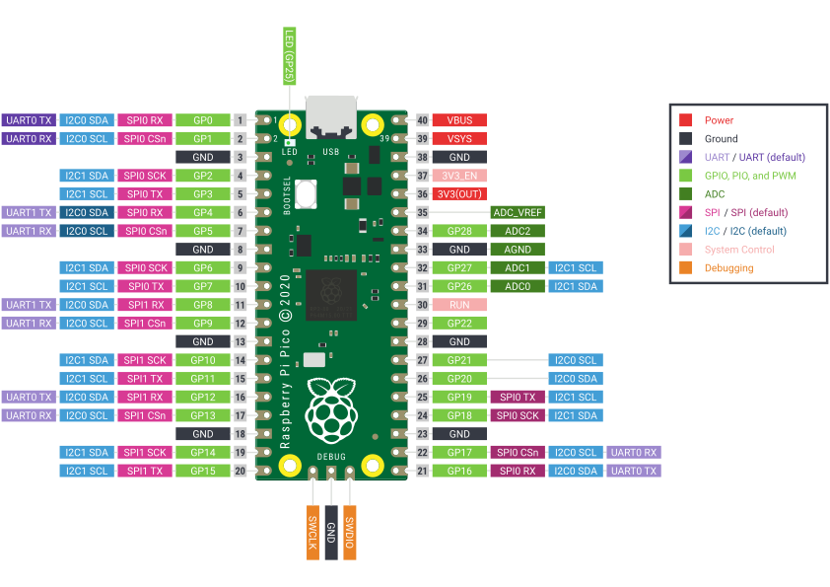

Figure 10: Raspberry Pi Pico Pinout Diagram (Raspberry Pi Ltd, 2012)

Raspberry Pi 4B

Raspberry Pi offers more powerful MCUs, so I then considered the Raspberry Pi 4B. MCU is an understatement as this can function as a full-fledged Linux computer. Regardless, it does manage to finally meet some of our tougher requirements. The Raspberry Pi 4B features a Quad-core 64-Bit ARM Cortex A72 at 1.5GHz with 2 and 4GB LPDDR4 RAM options! It also features VideoCore VI 3D Graphics. Now we finally have a processer with a significant number of cores running above 1GHz with access to more than 2GB of RAM. The board also has a dedicated graphics processor which we may be able to utilize for our image processing. In terms of data storage, the Raspberry Pi 4B offers us a new solution of a microSD card slot. The largest microSD card it can take is 32GB due to the drive formatting needing to be FAT16 or FAT32. However, this can be worked around to use exFAT formatted drives allowing for upwards of 128GB. The Raspberry Pi 4B also has 2 USB 3.0 ports. So, this is also our first MCU so far that can support our NIR-Enhanced CMOS Camera and the TIFF file format. In terms of ports, it also has a gigabit ethernet port so that we can connect to a LAN. On top of meeting our estimated minimum computation requirements, the same board also features 28 GPIO pins. These pins can support 6 UART, 6 I2C, and 5 SPI communication protocols and 2 PWM channels. However, is does not have an onboard Analog to Digital Converter at all. Due to this lack of ADC, the secondary MCU is needed even more. As some added benefits, the board features Bluetooth and Wi-Fi capabilities for future additions. The dedicated GPU also allows for dual displays up to 4Kp60 resolution. This board does manage to meet all our estimated computational requirements, further research will be done to see if more computational power is possible. Otherwise, this is the top pick for main MCU.

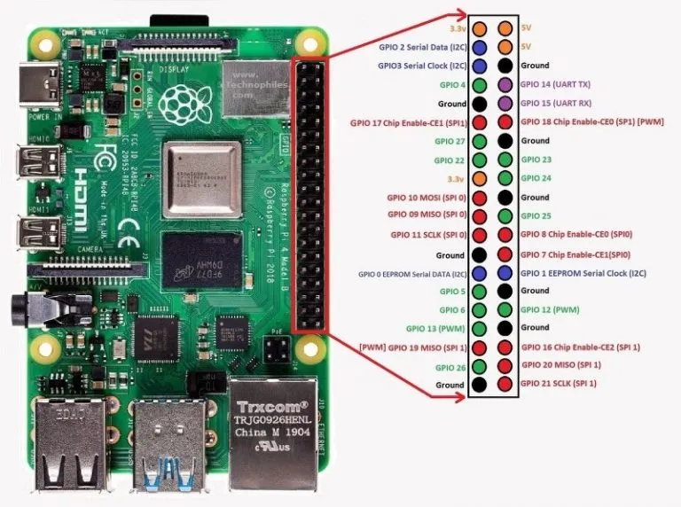

Figure 11: Raspberry Pi 4B Pinout Diagram (eTechnophiles, 2021)

NVIDIA Jetson Nano

When searching for MCUs specialized in image processing I came across the NVIDIA Jetson Nano and its Developer Kit Board which seems purpose built for our application case. It has the capability to run multiple neural networks in parallel for several image processing applications in a relatively compact for. Most importantly, since this is a NVIDIA based system if we need even more computational power, the software we design for it should be easily compatible with any NVIDIA graphics cards allowing the software to potentially run with the strongest graphical processors available. This alone was reason for me to rank this above the Raspberry Pi 4B for main MCU, but it also manages to meet all our main MCU specifications.

The NVIDIA Jetson Nano Developer Kit features a Quad-core ARM A57 at 1.43GHz with 2 or 4GB of 64-bit LPDDR4 RAM. While this is slightly slower than the Raspberry Pi 4B’s 1.5GHz CPU, the Jetson Nano features a 128-core Maxwell GPU. This is miles ahead of the Raspberry Pi 4B’s VideoCore VI 3D which is geared towards running displays rather than image processing in a headless environment (no display). The Jetson Nano module alone is capable of 5 to 10W of power draw. Which does not include any of the peripherals on the Developer Kit. When accounting for the total power draw the Jetson Nano Developer Kit is capable of, it comes out to 5V at 5A or 25W total. This compared to the Raspberry Pi 4B’s 15W max power draw is a substantial increase in power for a substantially stronger GPU. While it is not necessary, the Jetson Nano does have HDMI and Display ports capable of 4Kp60 video. The NVIDIA Jetson Nano Developer Kit also features a microSD card slot capable of reading exFAT drive formats. Because it can read exFAT it can utilize 64GB or higher SD cards. The Jetson Nano Developer Kit also has 4 USB 3.0 ports. This in combination with the large microSD card make the Jetson Nano the best MCU for supporting the NIR-Camera we have selected. Further, it also features Gigabit Ethernet using the 10/100/1000 BASE-T Ethernet standard with a RJ45 female connector for cat5 or higher network cables. Giving the Jetson Nano the capability to transfer up to a Gigabyte of data per second to a LAN. Now, in terms of GPIO options, the Jetson has the same capabilities as the Raspberry Pi 4B with 28 GPIO pins from a 40-pin header. Including UART, I2C, I2S, and SPI communication protocols and lacking an ADC.

So, we now have a significant amount of image processing power, connection interfaces, GPIOs, and several helpful resources since it has a large community of users. We can also utilize the JetPack Software Development Kit (SDK) feature. This SDK is specific to Jetson and allows us to utilize AI such as TensorRT, cuDNN, CUDA Toolkit, VPI, GStreamer, and OpenCV. All of which are built into the Jetson Linux [L4T]. With this abundance of positives, the only downside would be its higher than anticipated cost of $259.56 (as of 6/11/2022). With all those positives, we decided on using the NVIDIA Jetson 2GB Developer Kit as our main MCU.

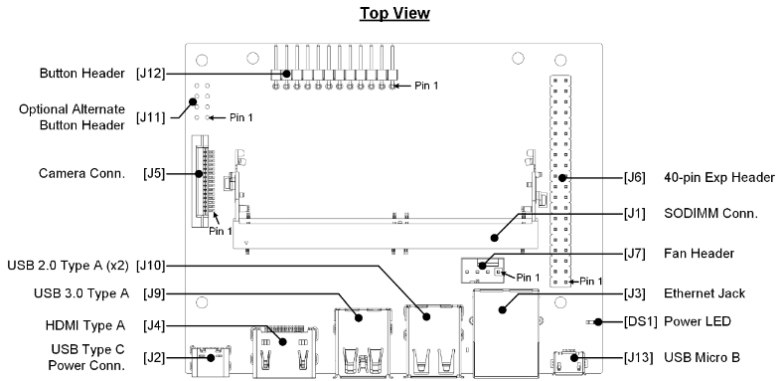

Figure 12: NVIDIA Jetson Nano Developer Kit Layout (NVIDIA Corporation, 2022)

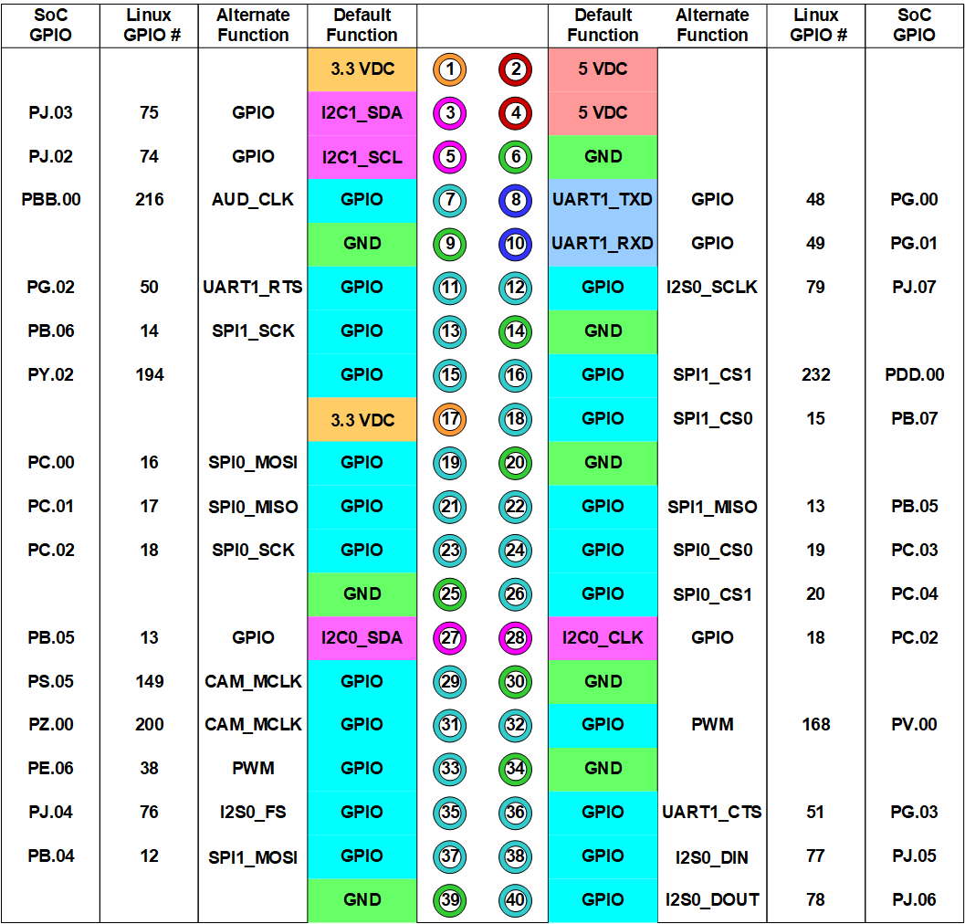

Figure 13: NVIDIA Jetson Nano 40-pin header Pinout Diagram (NVIDIA Corporation, 2022)

Secondary MCU

The NVIDIA Jetson Nano is our main MCU has the purpose of processing the image data it is fed by the NIR-Enhanced CMOS Camera via USB 3.0. However, even with its Quad-core ARM-A57 at 1.43GHz CPU and 128-core maxwell GPU, we still may not be able to process 360 TIFF images per second. So, to further reduce the burden on this MCU a secondary MCU was also purposed. This secondary MCU would handle the less intensive processes, such as reporting the status based off errors identified by the main MCU using a SPI communication protocol between the two MCUs (currently). It would also handle driving the PWM signals for an RGB LED or 3 separate LEDs. It will also have to be capable of sending a simple signal to the photodetector. Finally, the secondary MCU will have to include at minimum a 10-Bit ADC to interpret the signal received from the photodetector in order to count the number of threads via our laser counter system. With these specifications in mind, the Raspberry Pi Pico is the best fit. Its form factor is compact, it allows for through hole or surface mounting to a control system PCB, it has a Wi-Fi variant, and is extremely cheap from just $4 to $6 for the Wi-Fi variant. Another significant factor in this decision is Joseph’s familiarity and preference with the Raspberry Pi environment. Since this is the secondary MCU running simple calculations, we do not want to spend more time than is necessary developing its software. Once again, the selection for secondary MCU is the Raspberry Pi Pico.

Main and Secondary MCU Selection and Comparisons

Table 3: MCU Selection Comparison

 | MSP430FR6989 | ESP32 | Raspberry Pi Pico (Secondary) | Raspberry Pi 4B | Jetson Nano (Main)
CPU Cores | 1 core | 1 or 2 core | 2 cores | 4 cores | 4 cores
CPU Speed | 16 MHz | 240 MHz | 133 MHz | 1.5 GHz | 1.43 GHz
Memory | 2 KB | 520 KB | 264 KB | 1, 2, or 4 GB | 2 or 4 GB
GPU | N/A | N/A | N/A | VideoCore VI 3D | 128 core Maxwell
GPIOs | 83 pins | 36 pins | 26 pins | 28 pins | 28 pins
Communication Protocols | UART, I2C, SPI | UART, I2C, I2S, SPI | UART, I2C, SPI | UART, I2C, SPI | UART, I2C, I2S, SPI
ADC | 12-Bit | 12-Bit | 12-Bit | N/A | N/A
PWM | 5 Channels | 16 Channels | 16 Channels | 2 Channels | 2 Channels
USB3.0 | N/A | N/A | N/A | YES | YES
Ethernet | N/A | N/A | N/A | YES | YES
Storage | 128 KB | 16 KB | 2 MB | microSD | microSD
Power Maximums | 3.3V/1.6mA [0.005W] | 3.3V/0.5A [1.65W] | 5V/100mA [0.5W] | 5V/3A [15W] | 5V/5A [25W]
MISC | Low Power Modes | Bluetooth/Wi-Fi | Wi-Fi Variant | Bluetooth/Wi-Fi | Dedicated GPU, AI

Electronic Fuse (eFuse)

The NVIDIA Jetson Nano will be requiring a lot of power in order to utilize its entire processing ability. However, powering the Jetson Nano to enable this while also protecting the device from any power issues will involve current limiting. I have decided to apply this current limiting by making use of Electronic Fuses or eFuses. eFuses sense the voltage across a known resistor to obtain a current value. With this current sensing, it can then drive a field-effect transistor (FET) to implement the current limiting along with other functionalities.

Once again, an eFuse uses an integrated FET to provide active current protection during fault conditions. eFuses make use of a power switch for load current modulation and a current sensor both tied into control logic. The figure below details this in a block diagram format. The current threshold can easily be varied by controlling the I_{LIM} pin from the eFuse with a R_{LIM} resistor. By allowing the current threshold to varied in this fashion, a wide range of current limiting is possible.

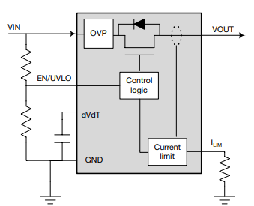

Figure 14: Electronic Fuse Block Diagram (Texas Instruments Inc., 2019)

In our case we need these eFuses to implement a 2.5A maximum on each of the 5V pins going into the NVIDIA Jetson Nano’s J6 40-pin. Given the amazing documentation behind Texas Instruments products, I selected an eFuse from TI that meets the specifications of this application. Specifically, we have an input voltage of 5V and a current output of 2.5A. This matches the attributes of the TPS25200 from Texas Instruments (found on Digi-Key). This eFuse allows for a voltage input from 2.5V to 6.5V, continuous load current output of 2.5A, soft start capable, and various voltage protections as well. With the eFuse selected next would be designing for it and calculating values such as the R_{LIM} to achieve our desired thresholds. However, this will be done in the design stage as we know at this point that this eFuse is capable of meeting our needs. It is worth noting we will be needing one of these per 5V line going to the Jetson. Also of note, is that the selected eFuse also features a FAULT pin that is active low. So, this can be sent to the PICO as additional data to log when a fault is detected without power supply.

Auto-Focusing Implementation

When the topic of Auto-Focusing was introduced I immediately thought of using a system I was very familiar with since we wanted this auto-focusing system to be capable of 0.1mm movements. Which would involve micro-stepping with a stepper motor for this very fine resolution. This is similar to what is used on many of the 3D printers I have built, used, and repaired. In a similar fashion to those 3D printers, I wanted a bi-polar, 2-phase hybrid stepper motor with at least 200 steps per revolution (step angle of 1.8°). To find this, I referenced the stepper motors I currently use on my Prusa i3 MK3S 3D printer, which are NEMA17 1.8° Stepper Motors. These motors are widely available and equivalent variants are found online for around $13. In the interest of cost savings, I decided to go with the spare stepper motors of a similar specification that I am already in possession of. These stepper motors are NEMA17 RB Step Motors with the following statistics.

Table 4: Stepper Motor Statistics

Model # | Holding Torque | Rated Voltage | Shaft | Step Angle | Motor Length | Rated Current
42SHDC3025-24B | 40 N·cm | 3.96 V | Ø 5 mm Single | 1.8° | 40 mm | 0.9A

Stepper Motor Drivers

With the motor out of the way, next was to select the most important part, the Stepper Motor Driver. Through some research, I was presented with three options: Allegro A4988, TI DRV8825, and Toshiba TB6560AHQ. The TI DRV8825 turned out to be the most inconsistent, with its micro stepping showing large jumps in step angle at the half-steps and full-step. It did show less deviation between loaded and unloaded testing thanks to its high output current of 2.2A per phase. However, given that our goal is accuracy this was not a viable option. The Toshiba TB6560AHQ was better than the TI DRV8825 with consistent micro-steps through the half-steps, but its accuracy falters at the upper full-step position. It also features a larger output current of 3A but showed larger deviations between loaded and unloaded testing with less accuracy under load as well. This accuracy issue along with the overkill of being able to drive four motors, this option was not viable as well. Finally, The Allegro A4988 on a Pololu Stepper Driver Breakout Board does the best with accuracy throughout the entire range of steps. Despite having the least output current at only 2A, its deviation between loaded and unloaded is comparable to the other two controllers. The Allegro A4988 is also the cheapest at only $11.45, while the Toshiba is $53.99, and the TI DRV8825 is $18.95 (prices as of 6/16/2022). With all that, the clear option is the Allegro A4988 Stepper Motor Driver on a Pololu Breakout Board.

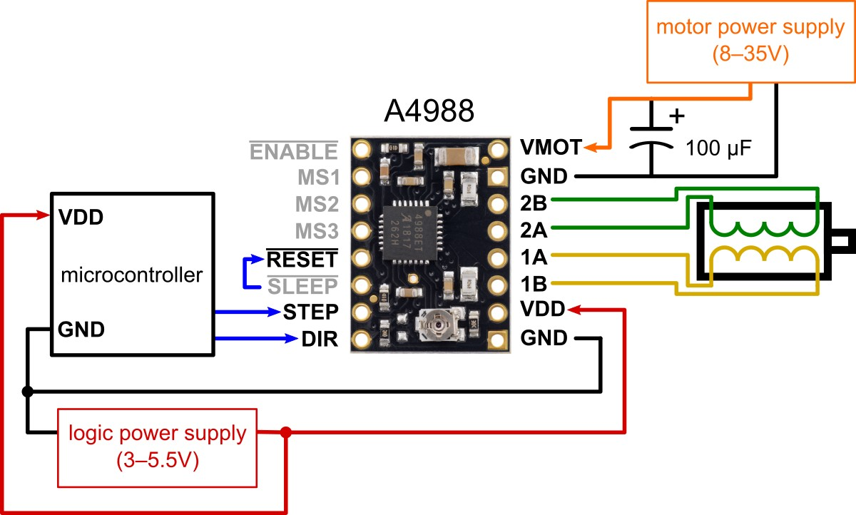

Figure 15: A4988 Driver on Pololu Carrier Board Wiring Diagram (Pololu Corporation, 2001)

Table 5: Stepper Motor Driver Comparison

 | Allegro A4988 (Selected) | TI DRV8825 | TB6560AHQ
Min Motor Voltage | 8V | 8.2V | 4.5V
Max Motor Voltage | 35V | 45V | 34V
Continuous Current | 1.2A per phase | 2.2A | 3A per phase
Max Current | 2A per phase | 2.2A | 3A per phase
Min Logic Voltage | 3V | 1V | 4.5V
Max Logic Voltage | 5.5V | 3.5V | 5.5V
Micro-steps | Full, 1/2, 1/4, 1/8, 1/16 | Full, 1/2, 1/4, 1/8, 1/16, 1/32 | Full, 1/2, 1/4, 1/8, 1/16

Lastly is to confirm that the selected products are capable of theoretically achieving our desired resolution of 0.1mm. Assuming we use a belt driving system with a linear motion, we can calculate the steps per mm with:

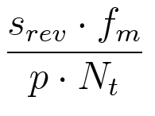

Where Srev is the number of steps per revolution of the motor (200), fm is the micro-stepping factor of the driver (16), p is the pitch of the belt (2mm), Nt is the number of teeth on the pulley of the motor shaft (16). With these values, we get 100 steps per millimeter or a resolution of 0.01mm. With this setup, we will actually exceed the desired specification without a significant cost increase to the overall project. We need a stepper motor ($0 to $13), Driver Board ($11.45), 2GT Belt ($0 to $12.99), and T16-2GT Pulleys ($0 to $5.99) totaling at max $43.43.

Implementing the Photodetector

In order for our Laser Counter System to translate its data to our secondary MCU we will need to implement a lot of circuitries. First, is the photodetector which will take in the light from the laser and detect the differences from each thread passing by. Specifically, we will be using a photodiode to detect this. Given the sensitivity of this sensor, it will be connected to our PCB via a coaxial cable of the SMA size. However, this coaxial cable will be actively shielded against noise. Finally, the photodiode’s output (cathode side) will be pulled to ground via a load resistor. Before that load resistor, the wire will branch, and the voltage signal will go through filtering and amplification as needed. We will explore the requirements of this filtering and amplification later in our research.

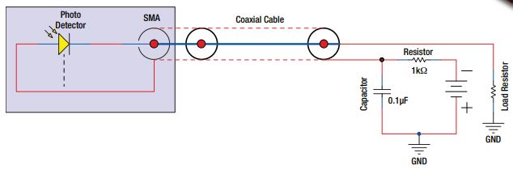

Figure 16: Recommended Circuit Diagram for SM05PD2B Photodiode (Thorlabs, Inc., 2017)

What is a Photodiode

A photodiode is a form of sensor that converts light energy into electrical energy. This light can be converted into either voltage or current specifically. This is possible because the photodiode is a form of semi-conductor with a PN junction. This PN junction has an intrinsic region between the P-type and N-type material in which the photons from the light interact. Typical materials for this semi-conductor include Silicon (Si), Germanium (Ge), Indium Gallium Arsenide (InGaAs), and Indium Gallium Arsenide Phosphide (InGaAsP). Some photodiodes even feature optical filters and a built-in lens. Given that photodiodes are essentially the opposite of light emitting diodes (LEDs), their electrical symbol is the same as a LED, but with the arrows pointing inward, as shown below.

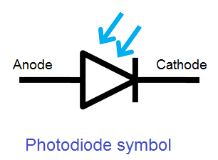
Figure 17: Photodiode Electrical Symbol

When light illuminates the PN junction of the photodiode, electrons and hole pairs are formed. This happens when the photons of the light hit the diode’s depletion region and energizes its atoms. These subsequent pairs then begin to move towards their respective region, with electrons to the cathode and holes to the anode. Then, by reverse biasing the diode we can utilize this to allow voltage to pass through the diode and be subsequently measured.

In our case, the photodiode produces a current at its anode which is calculated by the incident light power (P) and the wavelength (λ). The responsivity (R_{λ}) is derived from the responsivity curve of our photodiode, and allows us to estimate the amount of photocurrent we will get. This can be modified into voltage with the addition of a load resistor (R_{L}) from the anode to ground.

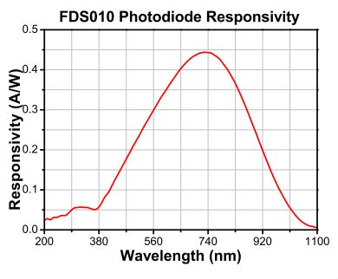

Figure 18: Responsivity of SM05PD2B Photodiode (Thorlabs, Inc., 2017)

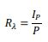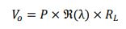

We know our wavelength of light entering the photodiode to currently be 632.8 nm. However, we do not currently know the incident light power we are expecting the laser to reflect off the Chromorphous fabric and the backing of the manufacturing line. This should provide two incident light power values that we want to measure as voltage. Since we do not currently know these numbers, determining the photocurrent (I_{p}) is not possible. We can estimate the Responsivity to be about 0.35 A/W. Lacking the incident light power also means we are unable to determine the output voltage, and subsequently an adequate load resistor value. This will have to revisited once more information is available. Once this information is available, we can divide the Responsivity by the incident light power to find our photocurrent. With the photocurrent we can multiply it against a reasonable load resistor value to obtain our output current. This will inevitable be a small value and require amplification in order for the Raspberry Pi Pico’s 12-Bit ADC to be able to read it.

12-Bit Analog to Digital Converter

The Raspberry Pi Pico features a 12-Bit ADC which we will be utilizing in order to read the output voltage of the photodiode and subsequently count the number of threads passing by our unit. First, we need to determine the resolution of the ADC on board. The resolution of an ADC can be defined as the smallest input voltage at the analog pin that an ADC can identify. Now, the minimum and maximum digital values of the ADC are determined by the number of bit it is capable of. In our case the Pico has a 12-Bit ADC which translates to digital values from 0 to 4095. The ADC on the Pico is also designed for 0 to 3.3V of input, meaning 0V correlates to a digital 0 and 3.3V correlates to a digital 4095.

However, this ADC is found in the RP2040 chip on the Pico and does not feature an on-board reference. To remedy this, the power supply of the chip is used as reference. This is known as the ADC_AVDD pin and the supply is generated by the SMPS 3.3V with an R-C filter of 201Ω into 2.2μF. Because of this solution, the output accuracy of the 3.3V SMPS is not reliable and the ADC_AVDD is susceptible to noise interference. We have a few options to minimize this issue. We can change the offset at the expense of more noise by changing the resistance between ADC_VREF and the 3V3 pin. However, the increase in noise would not be acceptable in our high accuracy case. Instead, we can drive the SMPS mode pin high and therefore force the power supply into PWM mode and reduce the ripples of the SMPS at light load. This will overall reduce the power efficiency of the board at light load, but at high load this makes no difference. Since our project already features a power supply circuit board, it may be the best option to isolate the ADC_VREF pin. The R7 resistor on the Pico is 0603 SMT resistor and can be easily removed. By removing this resistor, the reference voltage of the ADC will be isolated, and we can provide our own stable reference voltage. Since we need to supply 3.3V to power the Pico as a whole, we can take a separate line of 3.3V to pin 35 (ADC_VREF) and its corresponding ground to pin 33 (AGND) and eliminate this potential inaccuracy in our ADC measurements.

Now, assuming we supply a stable 3.3V voltage reference to the ADC we can continue calculating the resolution. The resolution can be calculated as: Resolution = reference voltage/2^(number of bits) or resolution = 3.3V/2^12 which equals 0.8mV. So, for every 0.8mV passed to the ADC it can increment its corresponding digital counter. This also means, whatever voltage we get from the photodiode will have to be amplified in order be reasonable read at a 0.8mV minimum. Once we know the voltage values we expect from the photodiode, we can check that against our AD voltage range of 0-3.3V and amplify accordingly.

LEDs using PWM Channels

We wish to use 3 colors to signify the status of our inspection machine. With green meaning no errors, yellow meaning some errors, and red meaning too many errors so halt production. The thresholds for these values will be set in software and can be adjusted easily. In order to find the relevant pins on the Raspberry Pi Pico for PWM, another pinout diagram was required and shown below. With this pinout, it is clear there are 8 pairs of A and B signals. Upon further investigation into the Raspberry Pi Pico’s PWM channels we found that it has 8 PWM blocks. Each PWM block provides an A and B output, allowing each block to drive two PWM pins. With a total of 16 PWM output pins available. That makes it so every GPIO pin on the Pico is capable of PWM output, but since there are 26 GPIO pins some overlap. Some GPIO pins feature the same block and letter PWM output, but only one of those duplicate GPIO pins can be active at a time. For example, pin 1 and pin 21 cannot both drive a PWM signal at the same time since they are both designated as PWM_A[0].

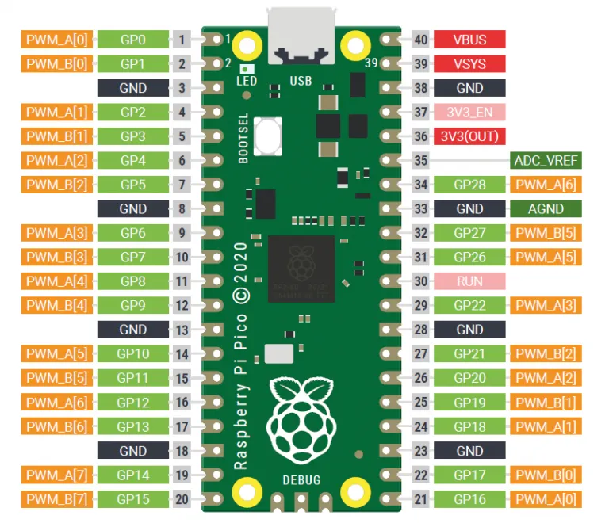

Figure 19: Raspberry Pi Pico PWM Pinout Diagram (Raspberry Pi Ltd, 2012)

Through Hole vs Surface Mount Components

Keeping in mind that this project will be on a manufacturing line and requires contact with the manufacturing equipment, the structural integrity of the components on our printed circuit boards (PCBs) is in question. While this is an optical based inspector, we need to energize the threads of the Chromorphous fabric as it passes through our inspector in order to create infrared radiation detectable by our NIR-Enhanced CMOS Camera. Since we require a physical connection to the manufacturing line, and since this manufacturing line has not been created as of this time, the conditions of the line are unknown. It can be assumed however that the physical connection to the manufacturing line will transfer constant vibrations to our device and ultimately our PCBs. With this now in mind, before any minor PCB components such as resistors and capacitors can be selected their installation type needs to be considered.

Through Hole Mounted (THM) components offer a stronger connection between the component and the board, allowing for a stronger mechanical connection. THM components are typically used in high reliability applications to ensure a connection through all layers of a PCB. Military and Aerospace application typically use THM components thanks to its resistance to environmental stress. However, the process of drilling holes into a PCB does raise its costs significantly and slows down board production in a manufacturing setting. THM components also take up more board space and lower board density. This stronger mechanical connection between the board and components lends components such as connectors to be THM. This is the same situation for larger size capacitors and inductors, where THM components will be used to ensure their connection to the board both mechanically and electrically.

Surface Mounted Technology (SMT) are components that are mounted directly onto the surface of a PCB and is the most common components used today for general electronics. SMT does not require holes to be drilled through the PCB and therefore can be mounted on both sides of the same PCB. The smaller form factor of SMT components allows for a significantly higher board density. With SMT, Integrated Circuits (ICs) arose in popularity due to their small form factor and high density of functionality. In constant low vibration cases, SMT components actually have the advantage in connection since their smaller size and lower profile components carry less inertia. These advantages along with the efficiency in mass production, has led to SMT being used in more than 90 percent of PCBs today.

In conclusion, we will have to implement the same as most PCBs today and use both THM and SMT. While a majority of our components will focus on SMT components due to its strength in constant vibration environments, our connectors and larger size components will be THM. We will need to implement terminal blocks to connect the control system PCB to the power supply PCB and these will be THM given their high potential for mechanical stress. As a side note, Garin Arabaci’s experience with both soldering and reflowing, makes the difficulty of assembly an irrelevant factor in deciding THM or SMT.

Power Supply
One of the major aspects for this project's implementation is to produce a power supply for the device. This power supply provides electric energy to the other electrical components comprised by the device. As one of the requirements, our device will need to be powered under an input voltage of 100 to 240 V AC. Normally, a power supply device can convert one form of signal AC (alternating current) or DC (direct current) to another form of signal. It can also regulate (reduce or increase) the same signal according to the need.
The power supply plays a vital role in our scheme. Its objective it is not only convert the power signal from one to another but also to regulate the power that is going to those other components because nowadays electronic devices are sensitive any fluctuations of the power can cause a malfunction or a failure of the entire device. For this reason, in the following section we will investigate what type of regulators can be best fit to our design.
Since we will have an input AC voltage source for our design to be converted in DC voltage power; we will need to go a set of process where we might use all the following components a transformer to step down the AC voltage, a bridge rectifier of diodes that can convert the AC to DC power, filtering to maintain the DC voltage to flow smoothly, and finally a regulator.
The purpose of rectifiers is to transform the AC (alternating current) to DC (direct current). Usually, there are three main types of rectifiers half-wave, full-wave, and bridge rectifier. However, all rectifiers do not convert efficiently the AC signal in the same way. The figures below are examples of bridge rectifier made with four diodes in close- loop and a resistor load, and the signal of the AC (Alternating Current) and the rectified output waveform
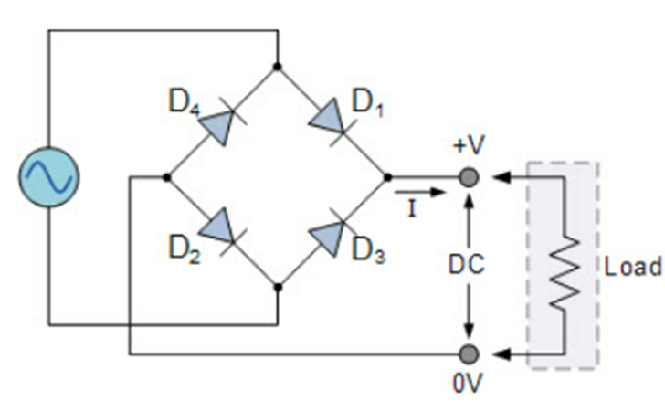
Figure 20: Bridge Rectifier
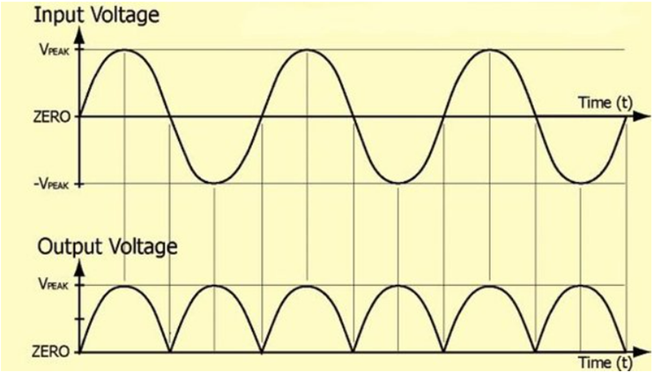
Figure 21: Bridge Rectifier Waveform
The rectified waveform from the above figure showed there are voltage variations on the obtained DC voltage named ripple. The easiest way to reduce that ripple is to connect smoothing capacitors across the load. The figure below gives a different result of the ripple after having a capacitor connected in the circuit.
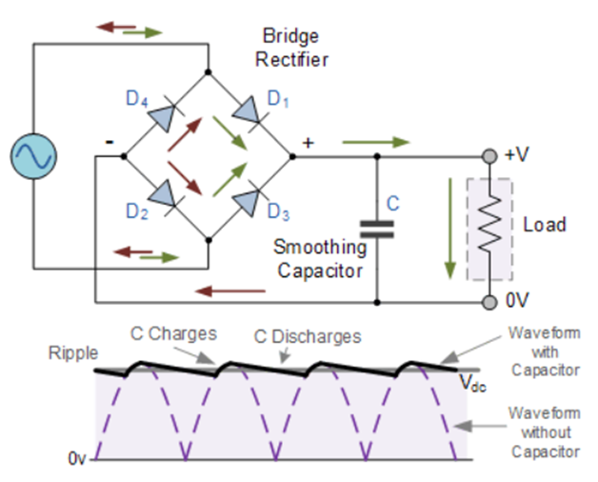
Figure 22: Capacitor in line with Bridge Rectifier

Voltage Regulators

Voltage Regulators
A voltage regulator is an essential component that can play a key role in the AC/DC converters. A voltage regulator is a solid-state semiconductor device that can provide reliable performance in terms of providing a constant or a stable DC voltage supply because electronics today require a high consistency of DC voltage that needs to be supplied. An example of voltage regulator is the family of 78XX where 78 means a positive output DC voltage and the XX represents the amount of voltage that regulator can provide like 7805 is a positive 5V DC supply, the 7812 means a stable positive 12V DC supply and so forth.
The following image is an example of a complete power supply made with a full-wave bridge rectifier containing a 7805-voltage regulator. In sum, that power supply can convert an input AC voltage up to 230V AC to an output of 5V DC supply.
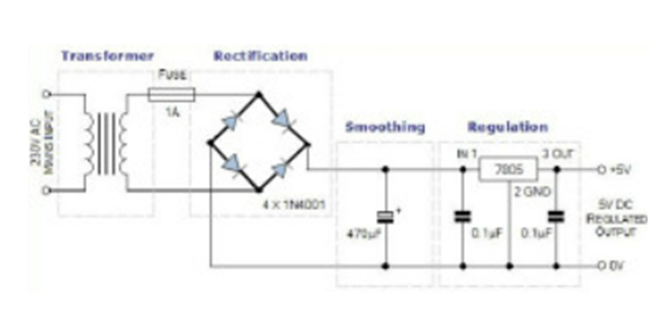
Figure 23: Power supply using Bridge Rectifier

How does a Voltage Regulator work?
Voltage regulator is to rectify or to maintain a constant voltage across the load. In other words, it will keep the output voltage within the range that is coming from the power supply in an adequate mode for other components that it will be supplying.
Other parameters including quiescent current, switching frequency, thermal resistance, and feedback voltage may be relevant depending on the application. Quiescent current is important when efficiency during light-load or standby modes is a priority. When considering switching frequency as a parameter, maximizing the switching frequency leads to smaller system solutions.
Additionally, thermal resistance is critical to remove heat from the device and dissipate it across the system. If the controller includes an internal MOSFET, then all losses (conductive and dynamic) are dissipated in the package and must be considered when calculating the maximum temperature of the IC.
Feedback voltage is another important parameter to examine because it determines the lowest output voltage that the voltage regulator can support. It is standard to look at the voltage reference parameters. This limits the lower output voltage, the accuracy of which impacts the accuracy of the output voltage regulation.
To select the proper voltage regulator, we must first understand their key parameters such as VIN, VOUT, IOUT, system priorities (e.g., efficiency, performance, cost), and any additional key features, such as power good (PG) indication or enable control. Once we have defined these requirements, use a parametric search table to find the best device to meet the desired requirements. The parametric search table is a valuable tool for us, as it offers distinctive features and packages available to meet the required parameters for our application.

Type of Voltage Regulators
So far, we have talked about what a voltage regulator can do and how it works. For many situations we need to know what type of voltage regulators to use for the intended or appropriate case. In the following sections, we will distinguish the major types of regulators with their advantages and disadvantages. There are two types of voltage regulators: Linear and Switching.

Linear Voltage Regulator
A linear voltage regulator is an IC (Integrated Circuit) device that works at a constant DC voltage operating point. Linear regulators can be described as a straightforward design configuration where they can be used to step-down voltages. Linear regulators utilize an active pass device (such as a BJT or MOSFET), which is controlled by a high-gain operational amplifier. It appears an exceptionally desirable choice in terms of simplicity, it is an extremely low power device with low noise, and it is also cheaper. Some of the disadvantages of this device are it can only step- down the output DC voltage and it is inefficient because of its power dissipation.
The following figure shows a basic configuration of a linear voltage regulator. We can see that regulator schematic diagram is composed of a NPN transistor, an operational amplifier, and other passive elements like resistors and capacitors to perform the output regulation. The operational amplifier senses the passive elements and provides feedback in the pass device (transistor) to regulate the output voltage via a voltage reference. In other words, the op-amp will adjust the output voltage and maintain its input terminals at the same voltage where V+ and V- are equals.
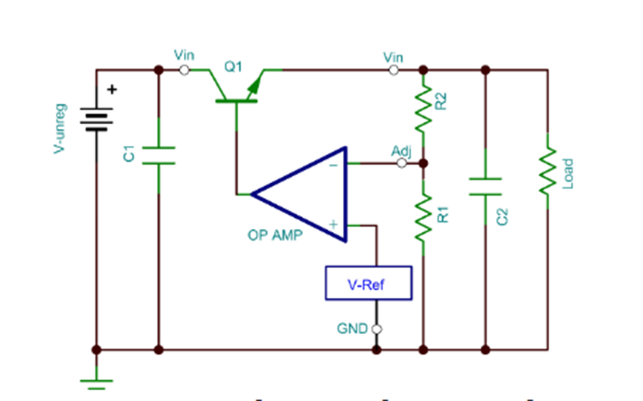
Figure 24: Operation Amplifier

The following table provides an overview of the advantages and disadvantages of the linear voltage regulator.
Table 6: Liner Voltage Comparisons
Advantages | Disadvantages
- Simple circuit configuration  - Few external parts  - Low noise | Poor efficiency  Consideration heat generation  Only step-down (buck) operation

Type of Linear Voltage Regulators
There are three major types of linear voltage regulators
1- Low Dropout (LDO) Regulator
2- Quasi LDO Regulator
3- Standard (NPN Darlington) Regulator
There are a couple of significant differences between those regulators that need to be considered. The first one is about the dropout voltage when the minimum voltage drop is required across the regulator just to maintain the output voltage regulation. The second one is the ground pin current where the standard regulator has the lowest ground pin current while the LDO has the highest ground pin current. It is usually unwanted to have an increased ground pin current because it is a wasted current and it always brings excess heat to the device. They differ from each other by the structure of the pass element devices. Let us see some characteristics about them.
LDO
The LDO is made only with a single PNP transistor for the pass device. The voltage across that regulator requires a minimum voltage drop to maintain the regulation. Consequently, the ground pin current of this regulator is the highest among these three types of regulators.
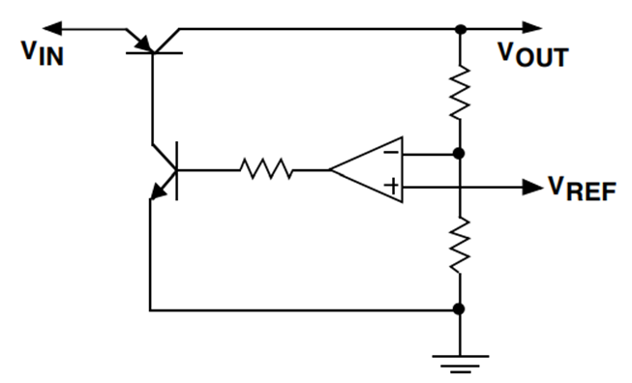
Figure 25: Low-Dropout Regulator

Quasi LDO
The quasi LDO is a combination of the LDO and the Standard regulators. This type of regulator uses both NPN and PNP transistors for the pass device. In contrast to the LDO, the dropout voltage for the quasi LDO is higher than the LDO, but it is lower compared to the Standard. Therefore, the ground pin current for the quasi LDO is lower than the LDO and relatively the same as the Standard.
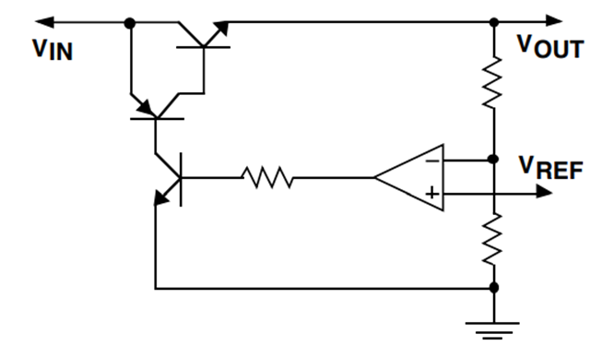
Figure 26: Quasi Low-Dropout Regulator
Standard
The pass device for the Standard regulator is made of NPN Darlington transistors configuration and the dropout voltage of this regulator is the highest and the worst among those three types. However, the ground pin current is the lowest and the best.
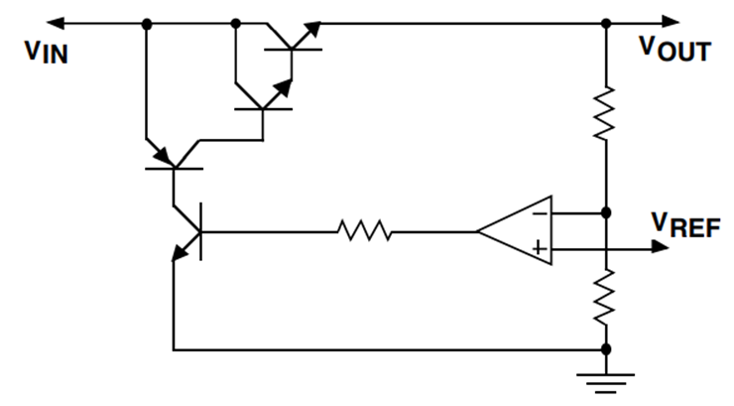
Figure 27: Standard Regulator

The following figure is a summary of these three types of regulators where they differ by their pass device configuration.
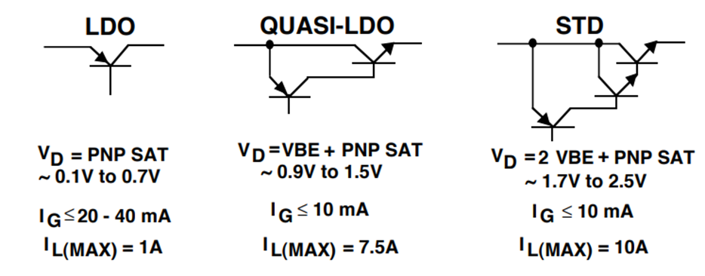
Figure 28: Summary of Regulators

Switching Regulator
Switching regulator also known as switched mode power supply (SMPS) is another type of regulator converter of voltage. In contrast to linear regulator, switching regulator is much more efficient and more reliable in terms of modulation availability, complexity and compacity. They can be either step-up or step-down. It is using temporary storage energy and after to release that power to the output voltage with different values. The way it works is when the transistor is on there is current flowing with low voltage. When the transistor is off there is no current and any high voltage is blocked at this point it behaves as an ideal switch. Those switching regulators come with distinct types: buck (step-down), boost (step-up), and buck/boost (step-down/up) switching regulators. Figure is a typical switching regulator.
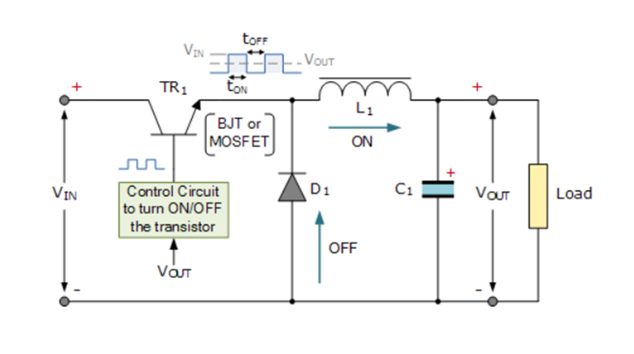
Figure 29: A basic Switching Regulator Configuration
The following table provides an overview of the advantages and disadvantages of the switching voltage regulator.
Table 7: Switching Voltage Regulator Comparisons
Advantages | Disadvantages
- High efficiency  - Low heat generation  - Boost/Buck/negative voltage operation possible | - More external parts required  - Complicated design  - Increased noise
Buck Regulator
It is to step-down the voltage regulators mean that is to take a high input voltage and then transform it to a lower one as output voltage. It works similarly to a linear regulator. The only exception is that it has better efficiency and has less power dissipation.
Boost Regulator
It is to step-up the voltage regulators. In contrast to buck regulators and linear regulators, it takes a low voltage and converts it to a higher output voltage. This type of regulator works differently compared to linear regulators and buck regulators because of the configuration that allows a greater output voltage than the input.
Buck/ Boost Regulator
Another type of regulator is buck/boost regulator, this is a combination of buck converter and boost converter. It works in both ways by step-down or step-up the voltage regulator with a broad range of the input voltage, the output can be more or less than the input voltage.
Table 8: Comparison of Linear and Switching Regulators

 | Linear Regulator | Switching Regulator
Design Flexibility | Buck | Buck, Boost, Buck-Boost
Complexity | Low | Medium to high
Size | Small to medium, larger at high power | Smaller at similar higher power (depending on the switching frequency)
Total Cost | Low | Medium to high – external components
Ripple/Noise/EMI | Low | Medium to high
Efficiency | Normally low to medium-high for low difference between V_{IN}-V_{OUT} | High
V_{IN} Range | Narrow (depending on power dissipation) | Wide

Consideration of Voltage Regulators
TI-WEBENCH platform has a large variety of voltage regulators in that we can find one to match with our design. To select the appropriate one, WEBENCH sets specific parameters that can drive us to the right regulator we want. These parameters such as the frequency, the BOM count, the BOM cost, the topology, and the efficiency of the regulator will help us to find the most appropriate regulator that can best fit our design.
The UCC28740 isolated-flyback power-supply controller provides Constant-Voltage using an optical coupler to improve transient response to large load steps. Constant-Current regulation is accomplished through Primary-Side Regulation techniques. This device processes information from opto-coupled feedback and an auxiliary flyback winding for precise high-performance control of output voltage and current. An internal 700-V startup switch, dynamically controlled operating states, and a tailored modulation profile support ultra-low standby power without sacrificing startup time or output transient response.
The LM5023 is a quasi-resonant pulse width modulated (PWM) controller containing all features needed to implement a highly efficient offline power supply. The LM5023 uses the transformer auxiliary winding for demagnetization detection to ensure critical conduction mode operation. The LM5023 features a hiccup mode for overcurrent protection with an auto restart to reduce the stress on the power components during an overload. A skip cycle mode reduces power consumption at light loads for energy conservation applications (ENERGY STAR®, CEPCP, and so forth). The LM5023 also uses the transformer auxiliary winding for output overvoltage protection; if an OVP fault is detected the LM5023 latches off the controller.
The UCC2863x targets high-power, primary-side regulated flyback converters. The ability to operate in both CCM and DCM makes the device suitable for applications with a wide power range. The peak power mode allows transient peak power delivery up to 200% of nominal rating, with only a 25% peak current increase, maximizing transformer utilization. The transformer bias winding is used to sense output voltage for regulation, and for low-loss input voltage sensing. Advanced sampling techniques allow CCM operation and deliver excellent output voltage regulation performance for opto-coupler-less designs at power levels of 100 W and above.
The UCC28742 off-line flyback controller is a highly integrated, 6-pin secondary-side regulated PWM controller for efficient AC-to-DC power supplies. It is an isolated-flyback power-supply controller that provides Constant-Voltage using an optical coupler to improve transient response to large-load steps. This device processes information from optocoupled feedback and an auxiliary flyback winding for high-performance control of output voltage and current. The UCC28742 employs advanced control algorithms to achieve high operating efficiency and performance. The drive output interfaces to a MOSFET power switch. Discontinuous conduction mode with valley-switching reduces switching losses. Modulation of switching frequency and primary current-peak amplitude (FM and AM) keeps the conversion efficiency high across the entire load and line ranges.
The LM5021 off-line pulse width modulation (PWM) controller contains all the features needed to implement efficient off-line single-ended flyback and forward power converters using current-mode control. The LM5021 features include an ultra-low (25 µA) start-up current, which minimizes power losses in the high voltage start-up network. A skip cycle mode reduces power consumption with light loads for energy conserving applications (ENERGY STAR®, CECP, and so forth). Additional features include under-voltage lockout, cycle-by-cycle current limit, hiccup mode overload protection, slope compensation, soft-start and oscillator synchronization capability. This high performance 8- pin IC has total propagation delays of less than 100 ns and a 1-MHz capable oscillator that is programmed with a single resistor.

Table 9: Potential Considerations of Converters
Converter | UCC2874 | LM5023 | UCC28632 | UCC28742 | LM5021
Efficiency (%) | 79.5 | 80.5 | 75.4 | 78.1 | 81.4
BOM Count | 29 | 37 | 21 | 32 | 45
IC Cost ($) | .38 | .42 | .79 | .24 | .64
Frequency (kHz) | 61.71 | 50.71 | 60 | 62.14 | 129.75

After much consideration, we want to use LM5021. Even if it is expensive, it is not either the most expensive or the cheapest one compared to others. We chose this one because its efficiency is good. When it comes to electronic design we need to stick with quality and economic constraints as the market requirements. In LM5021, the price for the BOM and the efficiency match perfectly to the needs of our design. The figure below is the WEBENCH schematic configuration of this converter.
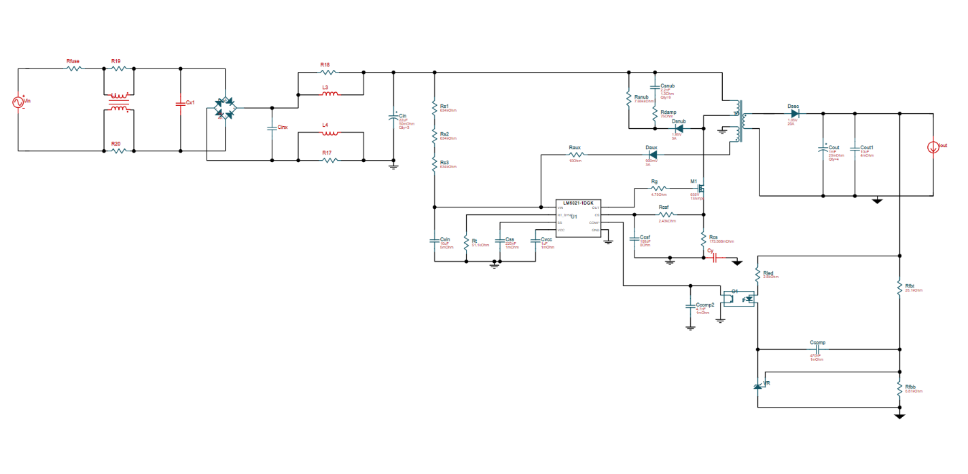
Figure 30: WEBENCH Generation Based on LM5021

The figure below illustrates the efficiency of this regulator where the efficiency is maximizing around 81.5% when the input voltage is 240 V.
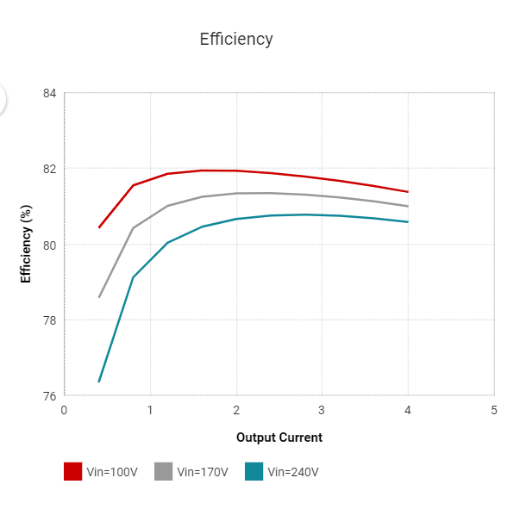
Figure 31: Converters Efficiency Graph

Separation of Power and Control Circuits

Given the large amount of power needed to supply our optical systems, we deemed it best to make separate PCBs for the control circuitry and power circuitry. This decision is founded on two main reasons: Noise Interference and Convenience.

Any unwanted signal that interferes and corrupts the parameters of the original message signal is called noise. In our design, noise is something that we do not want in the processing of signal. Therefore, those noises can come to two distinct types of sources the external source and internal source. To have a reliable performance of our design, it is imperative to eliminate those noises in the system. One of the best ways is to put filter in the system. Another way is to use an amplifier.

In terms of convenience, the duties of controls and power have already been split between the two Electrical Engineering Majors in this group. By separating the two systems physically, it allows for development of them both to happen, relatively independent of each other. Should a revision or issue arise with the control’s portion of the PCB, that would not require the rebuilding of the power supply PCB, and vice versa. We deemed this to be a significant and reasonable factor in our decision to make two separate PCBs.

Amplifier

According to our design schematic, there are several components that will need to be powered with different voltages. We found that amplifiers are especially useful in many functions of setting up output voltages. For this reason, we want to use a kind power rail amplifier to energize those components. An amplifier is not only to amplify a small input signal but also to reduce or eliminate noise that is coming from the input source. Usually, an operational amplifier is made of two input pins and one output pin that results in the voltage difference between the two input pins. Generally, there are three main types of operational amplifiers that can come into consideration in our design depending on the component’s voltage requirements inverting, non-inverting, and the unity gain buffer. In our case, we are focusing more on non-inverting amplifier that will give us a positive gain.

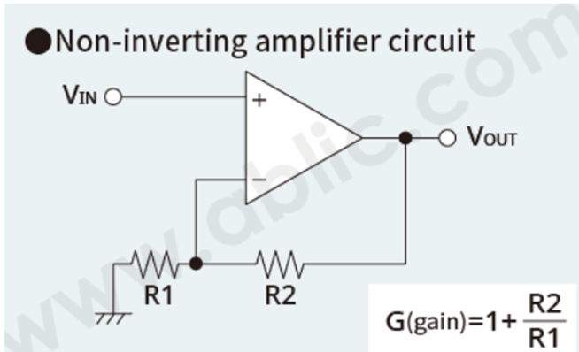
Figure 32: Ideal of Non-Inverting Amplifier Circuit
The unity gain buffer is sometimes called voltage follower circuit and gives the same output voltage as the input voltage.

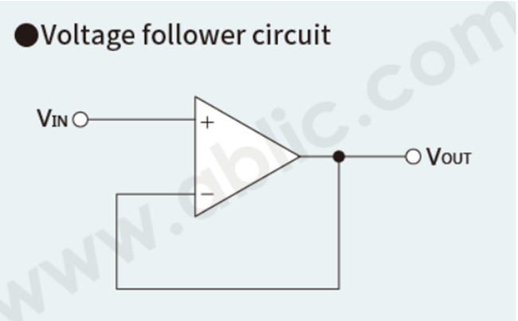
Figure 33: Ideal of Unity Gain Buffer Circuit
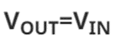

Filtering

In this section we would like to introduce an electronic filter in our design because of noise. Before that, let us see what noise is and where it comes from. Electrical signals carry both desired and undesired frequency signals. Those undesired frequencies are called electrical noise. Electrical noise has negative effects on electronic circuits. It causes some interferences with the primary data and corrupts the parameters of this data signal. This issue is coming from the environment or the internal components of the circuits because, nowadays, integrated electronic circuits are extremely sensitive to noise. For our project this is something that needs to be considered despite the system being. The sources of noise might come everywhere from both external and internal of the components.

External Source

That noise usually happens by a medium or a channel of communication. This type of noise can be easily removed just by staying away from that interference signal. Atmospheric noise, solar noise, and industrial noise are some of the examples of external sources noise.

Internal Source

This type of noise can be generated by the components themselves while in operation. Here are some examples of internal sources of noise, thermal agitation noise and shot noise. our design can be affected by both sources. That is the reason we can introduce a filter system to reduce the amount of noise or disturbance that comes from the input power source and the components themselves. Because in electronic signal processing filtering frequency signals is especially important. There are dissimilar categories of filters that can be applied for different scenarios in filtering signals. They are low-pass filters that eliminate high frequencies and allow low frequencies. High-pass filter allows high frequencies and eliminates low frequencies. Band-pass filter allows a narrow of frequencies. Band-stop filter eliminates a relative narrow of frequencies. In other words, choosing a type of filter will depend on what type of components and which frequency signals need to be attenuated. The one that we are focusing on the most is the low-pass filter which allows us to block some high frequencies.
The one that we are focusing on the most is the low-pass filter which allows us to block some high frequencies. There are two types of low pass filters active and passive, and both have their advantages and disadvantages. A typical or an ideal passive filter is shown in figure 34 below. It can be implemented by using only passive components resistors or capacitors, and inductors without active elements such as an operational amplifier and cannot do signal amplification. This type of filter does not require any input energy source. In fact, the way it works is since there is no implemented amplifier the signal amplitude cannot change thus there is no gain. Usually, the output voltage is less than the input voltage.

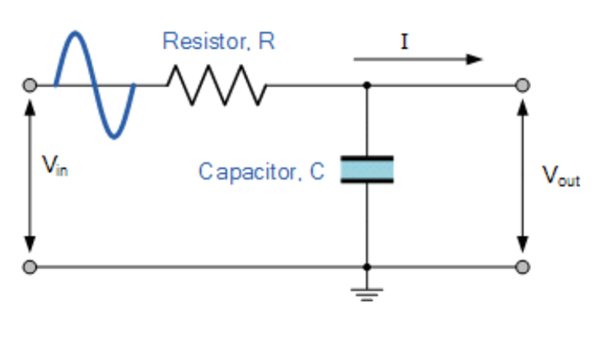
Figure 34: Ideal passive low-pass filter

An active filter can be implemented to filter the signal at the same time to apply gain in other to amplify signal because active components that have been used are op-amp and/or transistor and other passive elements (resistors, capacitors, and inductors). In contrast to passive low filter this one requires input power source
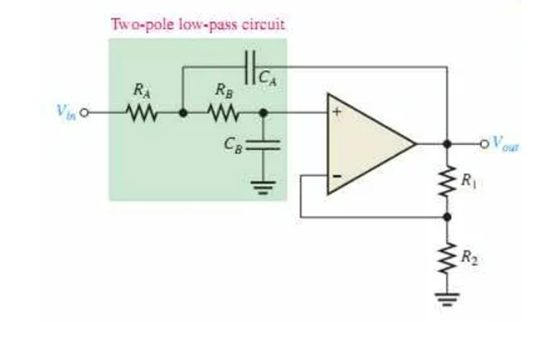
Figure 35: Second order Ideal Active low-pass filter

There are several existing types of electronic filters. The most used are Butterworth, elliptical, Chebyshev, and Bessel filters. Their implementation is in cascade by using the basic first order active filter and one or several second order active filter depending on the order. They can be either low-pass or high-pass filters according to what frequencies that need to be attenuated. When designing those filters, it has been required to find the poles ‘locations just to know which order of filter that need to be implemented. In our design, a such of implementation needs to be studied to see which can best fit our project. Let us see some features about them since low-pass filter is our priority. In Texas Instruments we are finding some of their characteristics interesting.
Butterworth filter, the response for this type of filter is maximally flat regarding the magnitude, and the gain for the passband has optimized flatness. The cutoff frequency was attenuated at -3dB, so above that the attenuation dropped to -20 dB/decade/order. For the square wave, the overshoot is moderate.
Chebyshev filter, the way this type of filter is implemented, has made to have ripple in the passband. On the other hand, after the cutoff frequency the stepper should roll off, that is how this filter was designed and we can that the overshoot is more than the Butterworth filter.
Bessel filter, this type of filter gives some characteristics less stress than the previous ones. It has some similarities to Butterworth but not everything. It is maximally optimized flat time delay meaning at constant group delay. Its phase response is linear while the transient response is excellent when the input has been set to pulse. In addition, -3dB point is the cutoff frequency. The following graph shows the different gain for each filter that was described above for the frequency response and their time transient

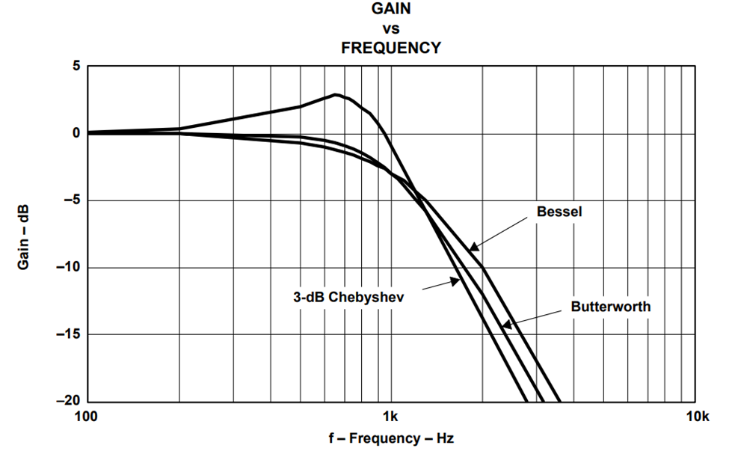
Figure 36: Second-Order Butterworth, Bessel, and 3-dB Chebyshev Filter Frequency Response

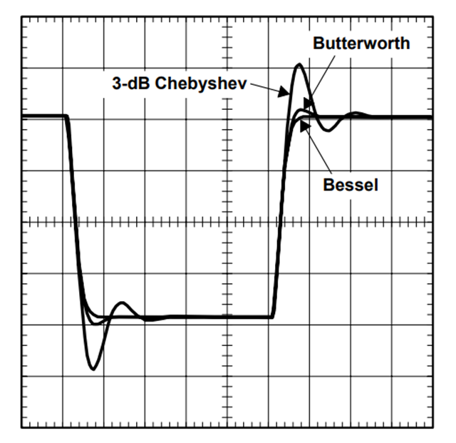
Figure 37: Transient Response of the Three Filters

For the previous reasons we can make our filter selection regarding the project factors.

Voltage Divider

Voltage divider is a simple passive circuit that is quite common in electronics. Its purpose is to turn a large voltage into a smaller one. The way it works is to use two resistors in series power up by an input voltage and the output voltage will be a fraction of the input. That is the reason it has been called voltage divider, the result is the ratio of the combination of the input voltage and the resistors in series. The following equation is a mathematical representation of it.

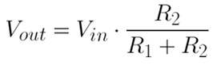

The voltage divider circuit can be represented as follows and they are the same.

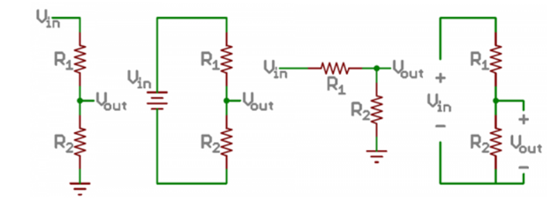
Figure: Different Circuits Representation of Voltage Divider

Such a circuit can be implemented in our design within the line that goes the ADC converter because that power line carries a 5V DC however the ADC converter requires a maximum of 3.3 V DC. By using a voltage divider, we can produce that requirement. This is a special case where we can use the voltage divider to supply this component. Other cases are not recommended. Voltage divider cannot be used as power supply to a load risk of burning resistors. The typical application of it is to have the output voltage as a voltage reference.

PCB Enclosure

One of the most important aspects of our project is the safety and the security of the PCB after design. We all know that electronics and electrical components are very vulnerable under certain environmental conditions. Not because the device will be installed indoor means we do not need to think about safety instead there are many things that can happen to the device if it is not protected against water or other exposure such as dust and elevated temperature. Those conditions can harm and contribute to the failure of the device. For this reason, we want our design to go to a safe enclosure that can follow certain conditions of standard requirements according to the needs. The National Electrical Manufacturers Association (NEMA) has developed rating standards for electrical enclosures to ensure safety, protection, compatibility, and proper function for electrical components. To select the right enclosure for our design we will follow some rating standards guidance that NEMA has defined for the appropriate needed enclosure. Those factors such as protection rating, certification approval, size, access needs, cost, environmental temperature, and corrosion resistance will help us to choose the right enclosure.

Size

The size will tell us the dimensions by providing the width, the length, and the depth of the enclosure. Without the components dimensions we cannot choose the appropriate enclosure. Also, with this type of circuit we need to choose a wider range dimension of enclosure so that air can flow easily just to avoid excessive heat within the components. That equipment’s electrics cannot work properly under extremely elevated temperatures. We will review our device dimensions including PCB, MCU (Microcontroller Unit), and power supply to the right enclosure selection.

Access Needs

The access needs give the accessibility of the components whenever any changes, maintenance, troubleshooting, and repair need to be performed. Normally, a cover or a front door is the proper way to be accessed. Those covers or doors can be secured by using latches, clamps, handles, or screws. It is necessary to lock that cover or door to provide safety and security. Obviously, we do not want any children and uncertified people to access those components because electricity is extremely dangerous when there is a high voltage across the power supply

Cost

As part of our constraints, cost plays an important aspect of selecting enclosure because we do not want to go over budget in a sense. Even price and quality come sometimes to challenge in making choice decisions. Usually, quality of products goes to high expense where inferior quality is less expensive. Our choice will still depend on what we think is more affordable.

Temperature

Temperature is a capital factor in choosing an enclosure. Those integrated circuits (IC) are extremely sensitive under elevated temperatures. For better performance of our device, it is important to choose a very wide range of enclosures just to the airflow goes through the components. Most of the elements that form the circuits produce heat in the system. Since the device will be indoor installed, an enclosure with ventilation would be appropriate.

Corrosion Resistance

This type of rating protection is not applicable to our needs because we will not have our device exposed to rain, harsh weather, or other outdoor environments hazardous that can affect the performance and the safety of the device. Corrosion can happen under those circumstances, but in our case, we do not need to consider that.
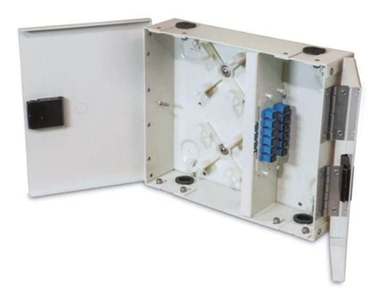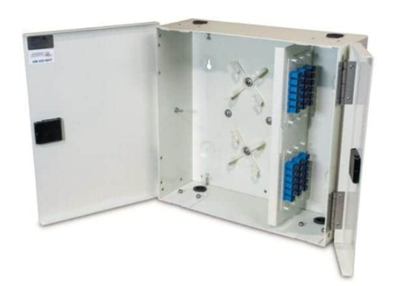
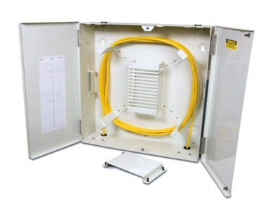
Figure 38: Pictures of AM-202, AM-206, and AM-50-SDC Enclosures respectively

After searching for enclosure safety for our design, we found a few interesting optional enclosures that could be used for our system. In American Products, we have considered three enclosures the AM-202, the AM-206, and the AM-50-SDC as NEMA type 3R rating protection enclosure one can be selected for our design. They were made with aluminum outside structure and fiber optic inside. They can be wall mount installation. In addition, they have been tested under the NEMA rating protection and they provide good aspects of safety and protection for electrical components including excellent corrosion resistance. The following table will summarize the difference between them.

Table 10: Comparison of the Enclosures
Enclosure | Rating | Size in inches | Cost in $ | Construction
AM-202 | NEMA 3R | 10.4X12.5X3 | N/A | Aluminum
AM-206 | NEMA 3R | 15.1X15.9X5.3 | N/A | Aluminum
AM-50-SDC | NEMA 3R | 21.5X21.5X6.5 | N/A | Aluminum

Heat sink
A heatsink is a passive heat exchanger that transfers heat. The heatsink is typically a metallic part which can be attached to a device releasing energy in the form of heat, with the aim of dissipating that heat to a surrounding fluid to prevent the device overheating. In many applications, the device is an electronic component (for example CPU, MCU, GPU, ASIC, FET etc.) and the surrounding fluid is air. The device transfers heat to the heatsink by conduction. The primary mechanism of heat transfer from the heatsink is convection, although radiation also has a minor influence.

There are many designs for heatsinks, but they typically comprise a base and several protrusions attached to it. The base is the feature that interfaces with the device to be cooled. Heat is conducted through the base into the protrusions. The protrusions can take several forms, including plate fin, copper round pin, and elliptical fin.

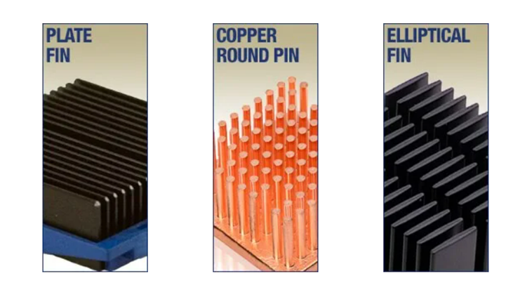
Figure 39: Examples of Heat sink

Heat sinks are usually constructed from copper or aluminum. Copper has a high thermal conductivity, which means the rate of heat transfer through copper heatsinks is also high. Whilst lower than that of copper, aluminum's thermal conductivity is still high and it has the added benefits of lower cost and lower density, making it useful for applications where weight is a major concern. The potent thermal conductivity is measured at 235 W/m-K. Aluminum material has been used for pure thermal conductions due to its low density and good corrosion resistance. On top of that it is not expensive. Copper, on the other hand, is an excellent element for thermal conductivity, its potent is 400 W/m-K better than aluminum and can possess corrosion and antimicrobial resistance. It has been employed in industrial works such as power plants, solar systems, and more. However, it remains expensive compared to the aluminum as seen in the following Table.

Table 11: Comparison of Heat sink Materials

Material | Specific Heat [J/g*oC] | Thermal Conductivity [W/m*K] | Cost | Weight (amu)
Aluminum | 0.9 | 235 | Cheap | 26.98
Copper | 0.385 | 400 | Expensive | 63.55

Terminal Blocks

Once the design is powered from an AC voltage outlet, there will be a couple of things that need to be considered. Wires or cables and connectors play a significant role in the power supply. In our project, it is not only the power supply that is going to use connectors but also there are other components that will be connected to the PCB and the MCU required connectors. In that sense, it is very necessary for us to use the appropriate wires and connectors regarding the voltage that will be across the components with respect to the standard requirements of our project design.

Wires and Cables

In this concept of electrical power, electrical wires and cable have the same purpose just to carry electrical current. The only difference between wire and cable is that wire is made of one single electrical conductor while cable uses a group or bundle of multiple of wires. The reason we mention that is according to the AC outlet standard of the walls in US for example a two-phase power requires two poles and ground connection. Specially, for our power supply we will need a cable with a single phase and a neutral that will go along the outlet and the power supply terminal connector block. For this type of connection usually a 12 AWG gauge wiring will be profitable. The following figure is an example of a 12 AWG gauge 8 feet long polarized wire that can be used for our device, and it is standing under NEMA standard of requirements.

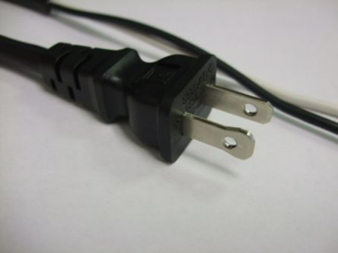
Figure 40: 12 AWG gauge 8ft long Polarized wire

Connectors

The terminal block for the input power supply can be a 12 AWG according to the the cable that will be connected to the main power and the output terminal connector can be a smaller range of gauge or a USB port can be preferable depending on the PCB and the MCU. Even though our design will require more terminal blocks and USB connectors because for example the AOI camera requires USB connection. On the section of design testing there will be more detailed regarding to the setting and the connection of the components. The following figure is an example of the input terminal block for the power supply that we will use. This is a through hole screw-leaf spring, wire guard 12-30 AWG gauge wire connector with a maximum capacity of 300 V 16 A.

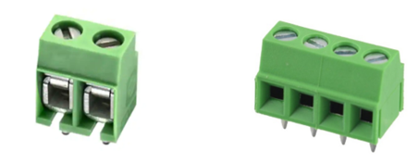
Figure 41: 12 AWG and 16AWG Terminals Blocks

Machine Learning

During the process of design, machine learning was introduced to assist in deciding the outcome of the manufacturing process verification. With machine learning, the system could be trained to detect a specific result and evaluate the result in an efficient and speedy manner. Machine learning encompasses many different algorithms, each with its own strengths and weaknesses. The system will require speed and accuracy during service and upon further research three techniques were settled on to allow the system optimum performance. The three algorithms chosen to assist the system in verification are neural networks, decision trees and support vector machines. Depending on research gathered, only one algorithm can be applied to the system in the final implementation.

Artificial Neural Networks

Artificial Neural Network (ANN) are derived from the biology of interconnected neurons. When these neurons are combined together, they form a network capable of performing logical calculations. Artificial Neural Networks have been around for at least 70 years, but only recently have they become very important due to advances in hardware and software. These advances in technology have given Artificial Neural Networks the opportunity to demonstrate exceptional performance in many classification and prediction tasks.

In an artificial neural network, decisions are based on inputs processed through multiple layers of interconnected inputs and outputs. Depending on the number of layers, an artificial neural network can be considered a shallow neural network or deep neural network. A deeper neural network will provide more accurate results but also require more processing power and time. For this project, the research will adhere to a shallow network design since the time constraint eliminates using a deep neural network because the size of the dataset and time required to train the model. When building an artificial neural network, the size of the network does change the operation of the model. For the project, experimenting with selecting the most efficient size will be part of the software development phase.

Most of the time an artificial neural network uses forward propagation to compute results but can use a more complex method of learning. The use of backpropagation in a multilayer artificial neural network strengthens the algorithm beyond most models. Essentially, the algorithm will minimize errors by fine-tuning weights associated with previous errors to achieve the best result. This allows the model to excel in many complex learning tasks.

In order to perform favorably, an ANN requires a few hidden layers that can adapt to perform various logical computations. The input layer can utilize various input sizes if necessary. The output layer can, also, adjust to produce more than one output depending on the classification task. While, hidden layers can also grow and shrink in depth and size depending on necessity of the job. Hardware will play a limiting factor in very large artificial neural networks. Overall, they are a very accommodating models to use with many strengths and some weaknesses. The weakness in an ANN is the more complex the network the larger the dataset required for proper training. By extension, it will also require a lot of time to train. The key to this algorithm is tuning the hyperparameters to help achieve an optimum solution.

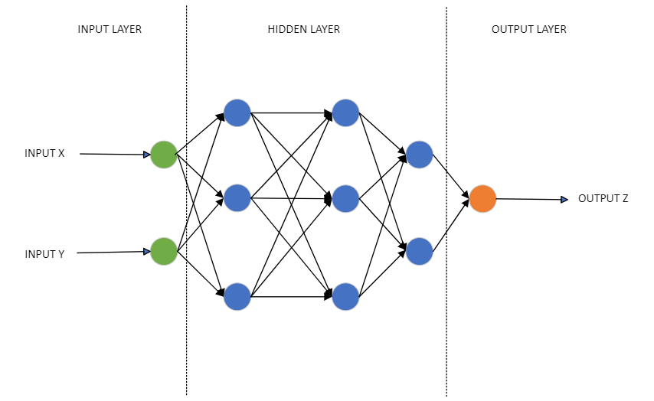
Figure 42: Artificial Neural Network Diagram

Decision Trees

A Decision Tree (DT) is essentially a binary tree that can make quick decisions on data due to the structure of the algorithm. It can perform both classification and regression jobs. The tree structure allows for fast results due to the ability to eliminate half the results with each successive descent in level. The overall speed of the algorithm makes it ideal for the image processing required in the project. Especially since, the algorithm makes predictions using an impurity equation on the features of the data. The following equation represents the Gini impurity associated with the default setting of the machine learning algorithm.

$$G_{i}=1- \sum_{k=1}^{n}{p_{i,k}^{2}}$$

Some of the weaknesses associated with using Decision Tree are the tendency to overfit and sensitivity to variation in the data. Overfitting can lead to poor results since the model is not generalizing well to new data. In turn, this will lead to inferior results and outcomes. The data used must also not contain outliers that can affect training the model properly since they can bias the algorithm. By restricting the algorithm’s hyperparameters, overfitting can be minimized through regularization. Overall, a Decision Tree algorithm may prove to be more effective than a neural network once development is over and testing commences.

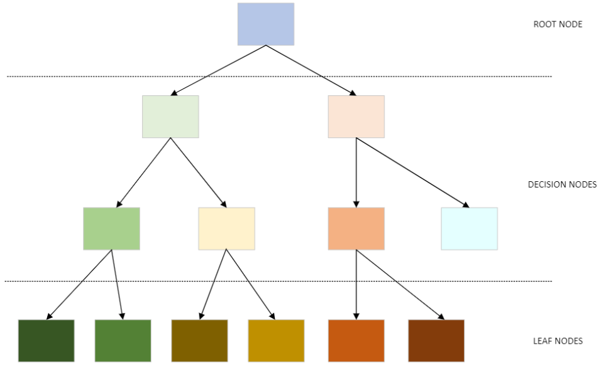
Figure 43: Decision Tree Diagram

Support Vector Machines (SVM)

Support Vector Machine refers to a machine learning model that offers performance and versatility when dealing with complex datasets. The central idea behind a Support Vector Machine lies in its ability to classify a model using specific decision boundaries that represent the support vectors. Support Vector Machines essentially try to identify the best hyperplane that separates distinct datasets. These hyperplanes are designated by a small set in the data that allows for the greatest separation while extending the distance between any dissimilar datasets. If a boundary is not found, the use of higher dimensions, using a kernel trick, can allow the algorithm to achieve a solution. Any solution is possible with an increase in dimensionality but at the detriment of increasing complexity. The increase in complexity can lead to a reduction in efficiency.

A few weaknesses associated with Support Vector Machines are working with large datasets and training times. The algorithm can handle small to medium datasets. Furthermore, the larger the dataset the slow it is to train the machine learning algorithm. With these drawbacks, configuration of the algorithm’s hyperparameters will need to be adjusted to maintain responsiveness and speed during classification. At the same time, this approach can add more time and not offer better results than previously discussed machine learning algorithms. In conclusion, a Support Vector Machine may not be the most viable option for use in the project design. Nonetheless after the development stage, if time permits, it could be worth prototyping a system to determine whether it could be practical.

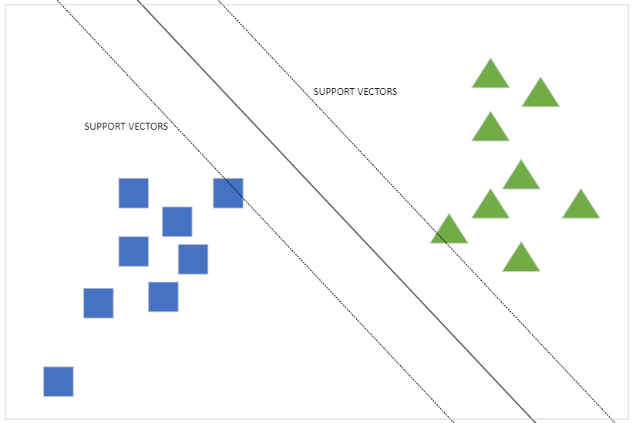
Figure 44: Support Vector Diagram

Machine Learning Summary

Although other types of machine learning algorithms exist, the group focused on researching learning models that would best benefit the design of the system. By combining previous experience from class learning and minor project implementations, the algorithm chosen to support the design would most likely be a Decision Tree model. When comparing each machine learning algorithm, the project would benefit the most due to the necessary feature size capability, time to train and data size required by the algorithm. If time allows, an artificial neural network implementation could also be tested to provide a way to verify the choice of going with a decision tree algorithm.

Table 12: Machine Learning Algorithm Comparison
Machine Learning Algorithm | Feature size capability | Training Time | Dataset size
Artificial Neural Network | Medium | Long depending on complexity | Medium to Large
Decision Tree | Medium | Small to medium | Medium to Large
Support Vector Machines | Large | Medium to Long | Small to Medium

Digital Signal Processing (DSP)

Digital Signal Processing is another method that will be utilized in the system. In order to achieve high accuracy and low errors, the images will need to be standardized. By standardizing incoming images, the system will be able to make quick and efficient decisions about the manufactured fabric quality. DSP helps the process by allowing the system to perform multiple steps of pre-processing such as color adjustments. image segmenting and noise filtering.

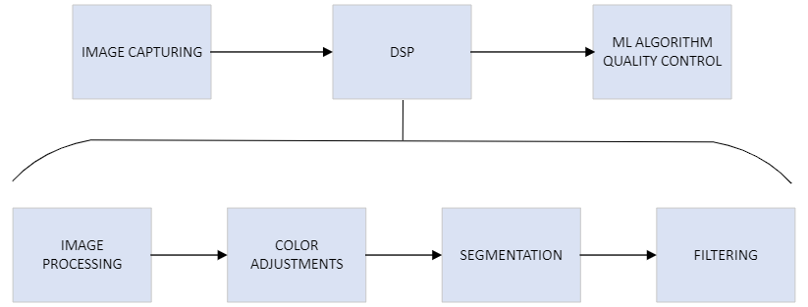
Figure 45: DSP Diagram

When an image is first acquired by the system camera, it will not always have the best data qualities present for accurate decisions to take place. One of the first actions is to manipulate the coloring in order to provide consistent data to the machine learning algorithm. By removing unnecessary colors and adjusting to grayscale, the image can be simplified to produce a more workable image. The conversion to grayscale allows most image data to be retained while removing superfluous data. It allows for the machine learning algorithm process to happen with more speed by removing the need to read excess data. This should contribute to the overall speed of the system along with segmenting and filtering.

With image segmentation, the system will now have a grayscale image, but the area of interest needs to be identified in the image to give the machine learning algorithm data for processing. Segmentation will allow the system to distinguish the artifacts of the image. The process to determine the artifact will rely on finding the best approach whether segmentation is performed by outline, texture, or shape. In essence, some initial testing will be required to determine which technique will provide the best results. This step is crucial since it will lead to a more refined image allowing the algorithm to perform competently.

Finally, noise filtering will allow the process to be complete and ready for the machine learning algorithm. Any image will automatically acquire noise during the capture phase during various conditions. To reduce the possibility of interference from a noisy image, each image will also undergo a filtering process to minimize noise. Experimenting with filtering will help to achieve the best image data to feed to the machine learning algorithm. Overall, DSP will assist in speeding up the overall procedure of determining whether the image will pass or fail.

Web Server

In order to maximize functionality, a web server will be engaged in the system to assist in displaying configuration and status information. The web server will be accessed through a standard ethernet port using Hypertext Transfer Protocol. By implementing a web server, the specifics of the system will be accessible to the users through a limited graphical user interface. The main advantage to utilizing a webserver is to offload extra features to a secondary device to avoid affecting the computation limitations of the main microcontroller unit. Data from the main process will be retrieved by the secondary device and managed on the backend of the hardware. Essentially, the web server component will provide support to the overall project and maintain a separate space from the main project components.

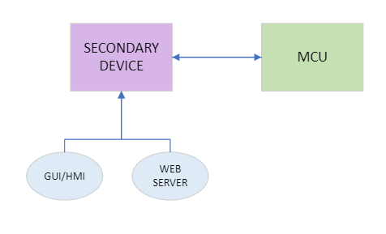
Figure 46: Web Server Diagram

Graphical User Interface/HMI

A Graphical User Interface (GUI) will be deployed in the system to assist in creating a user-friendly environment for readings along with a Human Machine Interface (HMI) for minor configuration changes. A graphical user interface is mainly used to present information in a visual form therefore making it easier for user understanding. A GUI is a visual benefit to any system since it provides common information without a user having to interact with the low-level portion of the system. The use of a graphical user interface will allow the system to display relevant information providing a more focused panel to be displayed to the user. The visual graphic will depict the current running status of the system along with other important data.

On the human machine interface side, the system will provide a minor controls interface that can allow for changes during deployment. The HMI will allow for user interactions between device components using a mouse and keyboard. This added control will prevent the user from operating lower-level systems that could affect the overall project in a negative manner. The HMI will be used to create a protective ring to isolate the user and project while still maintain the ability to make changes safely. The project will develop specific functions to embed in the HMI such as a reset or reboot feature.

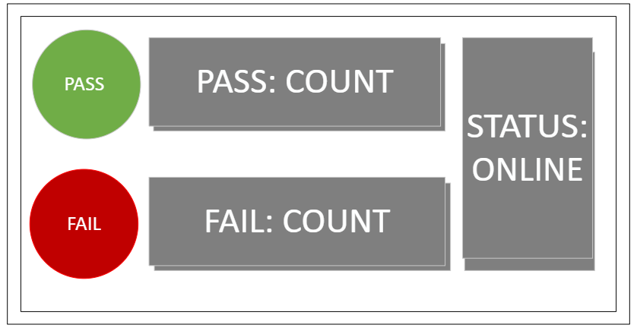
Figure 47: GUI/HMI Mockup Diagram

Virtual Machine (VM)

Virtual Machines (VM) will be utilized in the project to take advantage of programming multiple systems so that they could be used for testing in the software space. A virtual machine allows the virtualization of computer hardware in a software container. With this kind of virtualization, the development of software components can commence without the actual hardware. By using a virtual machine, multiple independent modules can be developed and tested without interference from other software components. It will also help during simulation of individual cases during testing. Another strength to this approach allows for quicker development helping to ease the time constraint encountered while producing the project. This will also lead to an increase in overall productivity while saving time for other aspects of the project. In essence, virtual machines will help to speed-up development along with gaining more time to ease the period necessary for testing and correcting bugs in the system.

Design Standards and Constraints

Standards
Many different projects utilize many different technologies standards. The combinations of these technological standards allow for the creation of new devices with the combinations being almost limitless. This section will discuss the standards that were researched and implemented for the project design.

Serial Peripheral Interface (SPI)

The Serial Peripheral Interface is a simple serial communication method designed by Motorola. Due to its ease of use and flexibility, it was widely adopted and has become widespread in many devices. Although, it, technically, is not a hard standard compared to other communication protocols, it does provide good functionality when using it for communication between devices. The drawback to SPI comes from vendor differences that have been adopted into the standard. These variations hinder usage at times since SPI terminology may differ from device to device.
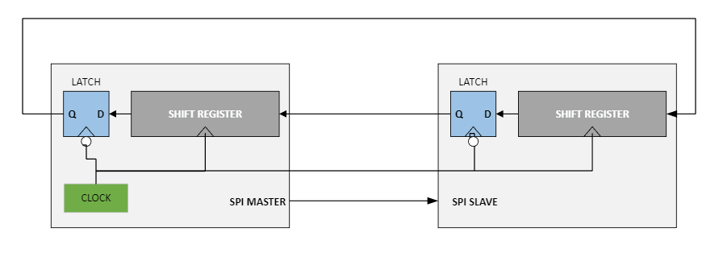

Figure 48: SPI Connection Diagram

Serial Peripheral Interface communication takes place synchronously meaning with a shared clock between two or more devices. The clock is generated by the master to sync communication between devices over 4 wires. The bus is capable of full-duplex transmission but can also use half-duplex if necessary. A master device generates the clock for both devices to communicate and synch. During operation, a master and device exchange data through shift registers. While data is sent to the master, data is also sent to the device which allows for full-duplex transmission. With this communication scheme, the system will be able to communicate using another method if hardware limitations prove to be an issue.

Universal Asynchronous Receiver/Transmitter (UART)

One extensively used technique of communication between devices is universal asynchronous receiver/transmitter or UART for short. This type of communication protocol relies on asynchronous communication meaning no clock is shared between the transmitting and receiving device. In this configuration, two devices can share one or two lines to deliver serial data either in half-duplex or full-duplex mode.

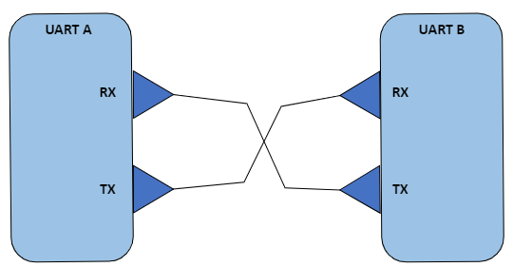

Figure 49: UART Communication Full-Duplex

By using serial transfer, one bit is sent at a time in a stream from a transmitter to a receiver. The single bit stream transfer method is a simple scheme that is very popular with many communication protocols. For UART communication to work properly, both communicating devices must identify the start and stop of a serial bit stream. A clock does not exist to time the data, so framing is used as a unit of transmission to help devices identify a block of data. To frame data, the line is normally held at a high voltage right until the beginning of transmission. The start of any transmission using UART begins with a 1 cycle pull to low then everything preceding will be the data block. Depending on preconfigured settings such as baud rate and stop bit, the receiver should be able to read the data block sent by the transmitter.

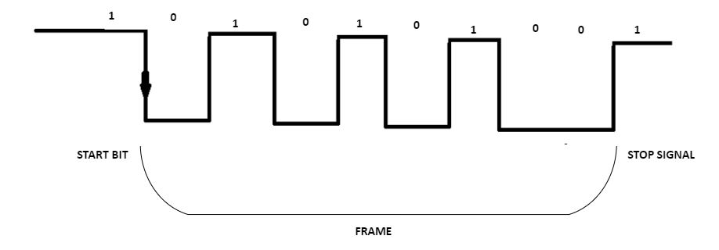

Figure 50: UART Frame

The UART protocol does employ some basic error detection mechanisms to assist in transmission. One configuration selection provided for UART error correction is the use of a parity bit. It can be used to detect a 1-bit error. Also, flow control can be configured to manage the speed of the transmission to the transmitter from the receiver. Overall, the protocol will assist the project with communication between minor data streaming devices such as motor controls.

C Language

The C language is a general-purpose programming language that is versatile enough to program anything from a simple application to complex operating systems. It was created by Dennis Ritchie in 1972. After some time, it became a formal standard maintained by ISO/IEC JTC1/SC22. For the project, an embedded version of C will be used to manage certain aspects that will be defined during prototyping of the project. The C language will help to build and interface between low-level hardware and device driver software. With the ability to handle low-level hardware, the C language should provide the throughput necessary for the system by maintaining speed and accessibility between multiple application programming interfaces. C will handle intersystem communication along with external system intercommunication. Due to its flexibility, it should provide the necessary data types to process a data stream while communicating with other APIs to allow for smooth fast calculations and decisions. Many APIs exist for the C language that should provide the necessary interfaces for use with other programming languages.

Python

Python is an interpreted programming language that has gained significant influence recently due to its versatility. It can be utilized in many different applications ranging from standalone programs to machine learning systems. This versatility should benefit the project since the language can be used in a varied of situations.

Initially, Python was created by Guido van Rossum as an extensible language which could be adapted to assist other languages and libraries. It runs on a multitude of operating system types whether Windows or Linux. Of course, Python is very attractive due to cost and the ability to handle machine learning tasks that will be necessary in the project. One of the main reasons for utilizing Python is due to its growth in machine learning tasks. The various machine learning libraries available in Python allow for many different approaches to solve any solution. The group will take advantage of python’s machine learning libraries to produce the project. Also, a graphic user interface for the project will also be developed using Python.

MATLAB

MATLAB is a proprietary programming language capable of numerical computations utilizing matrices and modeling. It was initially developed by Cleve Moler before being rewritten in C for porting to IBM desktops. MATLAB can perform multiple functions due to its extensive library and toolset. The MATLAB toolset features an image processing library that will benefit the project when handling incoming images during quality control checking of the production line. The adaptability of the MATLAB toolset should suit the hardware and provide the necessary speed.

Laser Standards – Safety and Classifications

The American National Standards Institute (ANSI) is a nationally recognized group that sets industry standards across many industrial fields. These standards are developed by industry experts and volunteers to create a set of homogenized standards for industry within the country. When it comes to the field of optics, and other industry that use optics in their day-to-day functions, the ANSI Z136 series covers what must be looked out for, and guidelines for safe use.
Much of the ANSIZ136 Series will be acknowledged and followed at some capacity by our team, but standards such as Standards for Safe Use of Lasers in HealthCare (Z136.3) and Safe Use of Laser Outdoors (Z136.6) will not be used.

It is the responsibility of all to properly respect all high-powered lasers. In our case specifically, it is the OSE students’ job to make sure that they provide guidance to the members of the team who may not have any laser safety training. The laser is to be respected, not to be pointed at any individual, and it is the responsibility of all members of the team to never look directly into the path of the laser. These are common procedures and expectations that have been extrapolated from not only the ANSI Z136.1, but as well as mandatory Laser Safety classes that have been taken from the OSE student.

ANSI Z136.1 – Safe Use of Lasers, declares the four classes of lasers, as well as all sub classes. Those classes are Class 1, Class 2, Class 3R, Class 3B, and Class 4. In regards to our specific semiconductor laser that we may choose to use long term, Class 3B lasers are rated as such when their power output exceeds 5 milliwatts but does not exceed 499 milliwatts. Class 3B lasers can cause irreparable eye damage through direct or specular reflection viewing. It is extremely advised, if not required for most institutes and industries using them, that users and individuals within the vicinity must wear appropriate goggles. The goggles that are required must be designed for a specific wavelength, with attenuation capabilities if a full block of the wavelength is not possible. While it is recognized that Class 3B lasers do not tend to cause a fire hazard, it must be noted that operating within a research environment with material with no known interactions with the laser can still pose a threat. Mindfulness to such situations must be acknowledged.

Optical Performance Standards

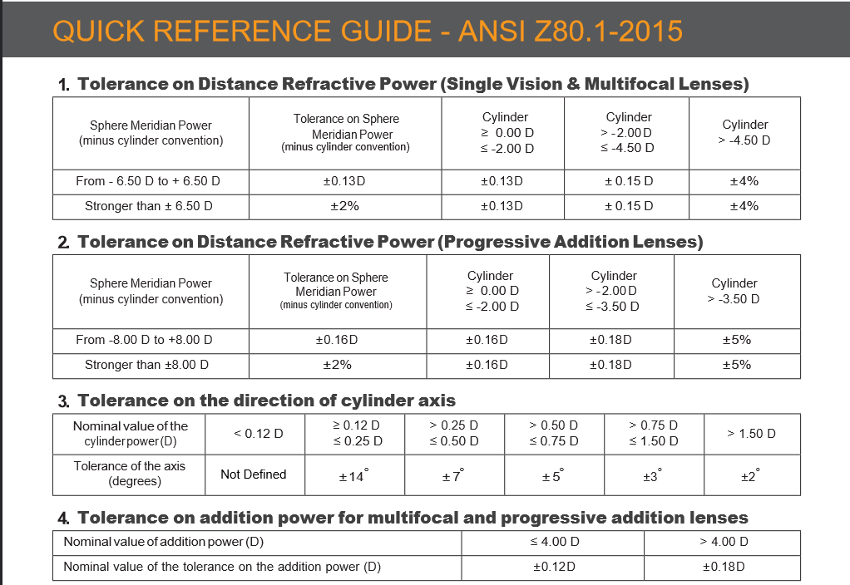
Figure 51: A sample of ANSI Z80.1 in regards to the standards in optical glass

The scope of this project goes above and beyond the development of actual optical glass. But the above standards are still something to be considered. Because there is great chance that we are developing a multiple lens system, we should be responsible in looking at the tolerances and margin for error that can accrue from combining multiple surfaces into one system.

These guidelines and benchmarks will be imperative for our troubleshooting methods, and it will give us a great leg to stand on should we encounter a problem with no immediate means to understanding what is exactly happening.

For example, if we are having an issue with the total optical power of the system being different in practice than what we are experiencing in the field, we would look to see the above tolerances to for the relevant system were are trying to emulate. Knowing this information, we will create checks and troubleshooting procedures at every conceivable failure point that may cause us to have incorrect imaging capabilities.

Standard-A USB 3.0 connector

The Universal Serial Bus 3.0 standard is one everyone is familiar with to some degree as it is used for countless devices for countless applications. In our case, the NIR-Enhanced CMOS Camera we will be using to image the threads as they are electrified sends data and receives power through one USB 3.0 male connector. USB is a standard defined by the industry for cables and connectors that supply power or power and data. It was first established in 1996 and is maintained by the USB Implementers Forum (USB-IF). This Forum is a nonprofit organization founded by the industry at the time Compaq, Digital, IBM, Intel, Microsoft, NEC, Nortel and has expanded to include HP, Apple, and Agere Systems.

As noted, this connector and cable standard allows for the transfer of data and power through (in our case) 9 pins. A row of 4 pins is used for backwards compatibility for USB 1 and 2, and a row of 5 pins are the new pins for the higher functionality of USB 3.0. As a note, these connectors are signified on both the male and female sides with a standard Pantone 300C blue color to signify USB 3.0. These added pins allow for USB 3.0 to transfer data at a nominal rate of 5.0 Gbit/s but specifies realistic expectations of 3.2 Gbit/s in practice. This data is transferred digitally using one-byte segments that use 8b/10b encoding to minimize electromagnetic interference. The scrambling uses a free-running linear feedback shift register to also help check against transmission errors.

The standard also specifies the values relevant to power transmission. While a maximum cable length is not explicitly specified, the practical length is 10ft. These cables are also required to be copper cabling at AWG 26. This will (like old USB standards) provide 5V nominal. The current provided can be a minimum 150mA for one-unit load (0.75W) and maximum 900mA for six-unit loads (4.5W). In USB Battery Charging Specifications it can provide up to 1.5A (7.5W), however this is not applicable in our current use case.

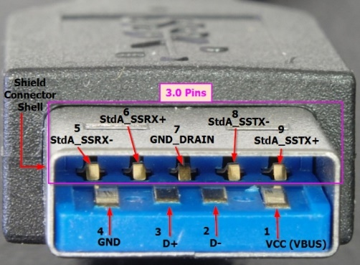

Figure 52: Standard-A USB 3.0 Male Connector (Unconventional2, 2014)

TIFF Image File Format

The Tag Image File Format (TIFF) is a type of file formatting for saving highly complex images. It was created by the Aldus Corporation in 1986 and is now managed by Adobe Inc. The latest version being TIFF 6.0, was released by Aldus Corporation in 1992 and is the base line for TIFF formatted files. There is area few minor extensions from this baseline that include TIFF/EP (ISO 12234-2), TIFF-F (RFC 2305), TIFF/IT (ISO 12639), and TIFF-FX (RFC 3949). The file extension for TIFF is “.tiff” or “.tif”. This file format does lend itself to our application given the formats capability to store a lot of meta data related to each pixel and can contain multiple images as subfiles. It gets its name by applying this meta data as tags and sorting them in an image file directory. All this allows for us to extract more data from each picture our NIR-Enhanced CMOS Camera takes. Given the increase in meta data, the file format has a maximum size around 4GB.

Gigabit Ethernet (IEEE 802.3ab)

The NVIDIA Jetson Nano Development Kit we will be utilizing as our main MCU, is capable of Gigabit Ethernet. Ethernet in general was researched by Xerox PARC in the 1970s evolving from just 10MB/s to 100MB/s to finally 1000MB/s. The 1000MB/s or Gigabit Ethernet was first standardized by the Institute of Electrical and Electronics Engineers (IEEE) in 1998 as IEEE 802.3z via optical fiber. The first copper cable base specification was IEEE 802.3ab in 1999 for Gigabit Ethernet using unshielded twisted pair (UTP) category 5 cabling. Specifically, the NVIDIA Jetson Nano Developer Kit is capable of 10/100/1000 BASE-T Ethernet standards through a RJ45 female port. We will anticipate using the maximum speed possible given the potentially 4GB large TIFF files we will be processing, storing, and reporting on. This max speed being the 1000 BASE-T or IEEE 802.3ab standard for Gigabit Ethernet over copper-based wiring. Networks running this standard are required to use Category 5 cable or better, at a recommended maximum length of 330 feet.

Category 5 Cabling

Since our main MCU will be using Gigabit Ethernet via the IEEE 802.3ab standard, we will need to utilize a Category 5 (Cat 5) cable to connect it at full speed to a Local Access Network (LAN). The Category 5 Cable standard is defined by multiple entities giving us ISO/IEC 11801, IEC 51156, and EN 50173 standards. All of which specify the same cabling standard with ANSI/TIA/EIA-568-A and TSB-95 specifying the performance requirements for the cable up to 100MHz. This cable commonly connects to an 8P8C modular (also known as RJ45) connector using punch-down blocks as specified by ANSI/TIA-568. The connector then follows the T568A or T568B scheme for terminating the cable into the connector. Internally the cable is a twisted features 8 wires and 4 pairs. With this standard in mind, will obtain a Cat 5 or higher (Cat 5e, Cat 6) cable in order to utilize our Gigabit Ethernet port effectively.

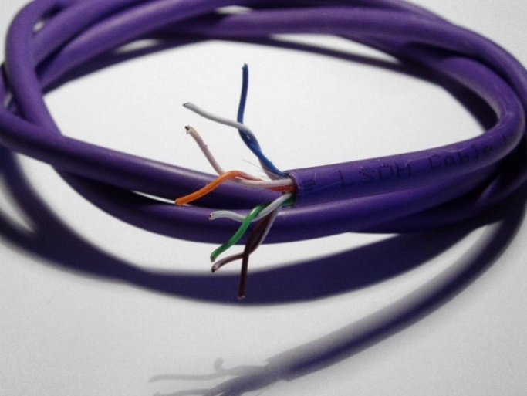

Figure 53: Stripped Category 5e Ethernet Cable (Wheeler, 2007)

Constraints

One of the core values that an engineer has is the capabilities of overcoming constraints, whether it be design, cost, or environmental. These constraints can make an simple project become something of a challenge. With the relative cost that most effective AOI systems have, what we are asked to do with the budget, time and resources at hand create many constraints.

Economic and Cost Constraints

Cost Constraints are one of the biggest issues that the team could endure. Because the research team that is helping to fund us is also trying to design their primary manufacturing system, it means we have less in order to design this system. Some members of the team have been needing to order parts themselves, and as larger parts of the project need to be made, there’s a fear that we will not be able to afford it in the end.

The HeNe laser design, should we stick with it, would quickly balloon out of control. Research has shown that even a 21 mW laser from an industry leading optics manufacturer is quoted around $3,000. This is just over a sixth of our entire budget, so being able to replicate the capabilities of our semiconductor laser seems nigh impossible. IR lenses within an affordable range have size limitations. Many of the products that were researched that would fit our specifications were well outside the means of what we could afford if they fit the dimensions of our project. Some lenses cannot be found at the focal length we need them to be compared to the more broadband uncoated NBK-7 lenses we decided on. This means that they are so niche that it would need to be special order, and that is something that we just cannot afford.

With the economics of a possible budget looming over all decisions, the cost of the project initially appeared extreme due to the price associated with some hardware component. During planning, it became apparent that any additional cost would compound the economics issue.

A key tenet, during software development, was to minimize cost whenever possible. Mostly every development tool utilized tries to eliminate overall costs. It proved to be very simple since many development tools require no real dollar investment. The project could reasonable be accomplish with current student computer hardware. The cost for these tools relies more on time to install and configure than on currency. The only real economic constraint on software was when the constraint of time took priority. Only one instance was observed when time was more of a priority than the economics with software development.

In contrast, the economics of hardware was a difficult situation to balance. The goal was to provide an adequate hardware solution for multiple components without overwhelming the economic budget. A chief concern was whether the hardware chosen would satisfy the requirements sufficiently or did the choice overestimate the obligations that were being put forth by the project. The answer to that statement would not be given till after project completion and testing. In essence, the decisions on economics related to hardware were the best choices possible with the available information at the time.

Time

Due to the limited period available, time was another major constraint during every development stage. Since Senior Design 1 was started during the summer term, the team loses a few weeks which compresses the rest of the time line for the project. The reduced time affected both hardware and software development.

Concerning the software side, development using various tools required time and effort to research and configure. The research needed to find the appropriate development environment combined with building the configurations restricted the process. After some research into machine learning development, it was found that relying on certain libraries over others was a justified economics cost that would save time in reaching the goal of project completion. Overall, the main software components had to be fully functional in comparison to support software of the project. Any extra features would have to be prioritized as secondary if time became a major constraint toward the end of the project.

With hardware, the constraint of time was very noticeable especially with the current state of the supply chain. It has only been a few years but still many components are difficult to obtain in a reasonable amount of time. Lead times can reach into next year which is untenable for project completion. The advisors stressed ordering parts as soon as possible to accommodate supply chain delays. If time constraints proved too detrimental, hardware sacrifices will be made to keep the major portions of the project viable.

Health and Safety Constraints

The two greatest health and safety constraints are electrical dangers, and dangers from the Class 3-B laser that we could very use. High voltage, or exposed wires can pose an incredible risk to anybody near the machine. Improper grounding can cause a plethora of issues that can result in injury or death to any user or passerby near the system. Any individual, whether an observer or authorized user of the system, should be able to interact with the system without fear of risking their life due to poor electrical design. If the team does determine that there is a possibility of electrical shock, due to design constraints or time, it is our responsibility to create proper warnings and signage that brings awareness.

Our Class 3B laser also needs to be recognized as a constraint and a health hazard with the utmost priority. The speed in which permanent damage that could occur should anything ever happen that brings the optical axis of the laser to the same plane as a normal eye level cannot be overstated. Therefore, our team must be responsible, and duty bound to create protections should this ever happen. Preliminary talks have the team discussing if the system should be weighed down to prevent any sort of tipping. Should the team also create a fail-safe where if the system recognizes it’s lifting or tipping, that there’s an emergency cutoff to kill the power to the laser immediately. Would we need to create a barrier that keeps anybody from seeing the specular reflection of the laser at any given time? Should we create a procedure manual with in-depth instructions when around the laser counter during operation, while giving the system maintenance, or even the removal of the system from its operating zone? We understand that these are not physical constraints to the designing the system. They do not prevent us from getting to our end goal. But they do create a constraint on time, and a constraint on the efficiency of our design process, and possibly our budgetary constraints.

We also must recognize with our laser that we may very well need to inform the government of what we own. Class 3B lasers are regulated by the Department of Health, Bureau of Radiation control. This distinction of the specified Department is why this was not included in the political constraints category. Once this machine becomes operational and is ready to be installed, we will need to make sure the registration is finalized before any further procedure. Not doing so risks liability.

Effectiveness

There is a concern about how effective this device will be once it is finished and has passed the demo stage. The undertaking of the design, complete with the complex challenges that each major will have to overcome, means there are large margins of error that can occur at any given stage or portion of this project.

However, it must be noted that while on a true one to one comparison the effectiveness will most likely have a severe hit in quality, the cost effectiveness ratio between our machine and a stable producers machine will be exponential. AOIs have a tendency to approach the $50,000 to $200,00 price range. Since this is a brand-new technique in using an AOI, though, if a company was contacted to outsource this project, that budget would exponentially balloon as well. We can think of it like this. Assuming that the marquee hardware price alone is $200,000, there would need to be even more invested into the project because of the new design that is not standard for the companies, as well as time being sank into the development of the software AI. Remembering that this machine is being built to be future proofed to correlate to the expansion of the Chromorphous Team, there should be real ‘bang for your buck’ when the final results are looked at.

Ethical

There was a momentary thought on how we would affect the industry of current AOI systems. Being able to design a system that usually costs tenfold more than what we are given the budget on, were we about to change the entire landscape of how AOIs are perceived. Summary analysis of such questions quickly told us no. Many of the core features that are used in current AOI systems simply cannot be obtained in our project, either due to conflicts or scope. What we realized was we were developing a new, cheap, specified system that fit specific constraints without bloat, such as 3-D imaging, high resolution of digital image zoom, and a wireless communication with other AOI systems.

We then thought about how sustainable this could be for future endeavors for other project teams. Would they need something like our design, and would we be taking away from current ‘competitors’? Again, we decided this wasn’t the case. AOI systems are niche products that are tailored to a specific type of customer. A grand majority of the time, if a team or company needs an AOI system, they are creating volumes of product that needs absolute precision and speed. That comes with being able to afford the high dollar markup that AOIs are sold for. Likewise, any company that could afford our design probably doesn’t need it. They do not require machine learning and software capable of determining autonomously if their product passes QC checks. This project that we are designing just so happened to fill a specific niche that not many individuals could fulfill in their own industry, thereby fulfilling our ethics analysis.

Political and Social Constraints

Socially, there’s a simple constraint of what our project will help create indirectly. The Chromorphous Research Team is creating smart clothing with the help of patented technology and design. This smart clothing will give users in the future the ability to wear what they want, in the sense of being able to show off custom designs of their choice once the product gets to that point. With that, there could very well be an uptick in social frenzies, as people have the chance to wear their voice at the touch of a button. Unlike regular clothes that have a static image, this smart fabric can change the game in social activism, freedom of speech and gaining attention to a cause in areas where it was once thought impossible. However, this constraint also falls apart after further analysis to the issue. The Chromorphous Team if needed, could save money down the line to invest in an industrial quality AOI. And therefore, from there, these same constraints could be put upon the AOI supplier. There comes a time when it must be understood that light interaction with something that can become bigger than anybody thought does not incur guilt on the party that was barely involved. Our system is one small part in a bigger machine that’s been going on for years. If it wasn’t our team that did this, it would be somebody else down the line. There’s only so much speculation into such scenarios that one can do productively before the entire idea becomes moot.

It could be said that in terms of political constraints, they follow closely to what was mentioned before under the social constraints paragraph. In the same tone as people having a new way to show their voice, we would be indirectly helping to accelerate our society to that position. People being able to speak out against the government, either locally, all the way to internationally, would be able to be done because of what we did to help it become realized. We believe, however, that the same result within this particular framework of political constraints. We are but one part to a greater machine, and the value we are providing to this said constraint is too miniscule compared to all other variables. In terms of political constraints, in regards to government intervention with our product directly, we do not see being any issue. Our project is a simplified version of an industrial machine on a budget, and we do not believe anybody outside of our immediate space would take much notice.

Environmental

Our environmental constraints directly tie into what our carbon footprint is. With the fear of climate change predictions from decades ago finally becoming real during our lifetime as of this writing, we must step back and think about what this product is doing to the environment as a whole. Our product draws power, and with the run time that is eventually going to be asked from it, it will continue to draw power around the clock. The question is if we have a responsibility to limit our consumption as a team, and if we need to scale our electric use.

The AOI and the Laser Counter need power to run, and there’s not much of a way to prevent their minimum power draw from being dampened. This is an unfortunate fact of life, and a fact of how this device will physically work. However, we realized through our design that we are not producing any more electricity than some current AOIs, the manufacturing line this will be used on, and even the warehouse space that this project will eventually live in. We are but a small sliver on the carbon footprint pie, and we realized that while it would be amazing to run a green system, it is just not possible. Furthermore, it isn’t any more impactful than run of the mill electrical systems used in everyday manufacturing systems.

Design

At the beginning of Senior Design 1, we produced an initial diagram of our purposed system design. With the completion of initial research, we will be revisiting this diagram and using it as the basis for our design processes. We have accounted for certain aspects of our design to be able to happen in parallel, such as the Controls PCB and the Power PCB.

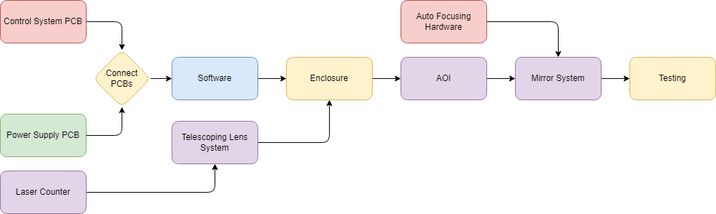

Figure 54: Design Flow Diagram

Control System PCB Design

The controls system seems like a logical first step in the project design process. While this is the system with a high potential for a lot of changes, it is also the system that connects all others. With the main processing unit selected being the NVIDIA Jetson Nano it will get minimal connections to the control system PCB. What it needs specifically will be 4 traces to a 4-terminal block for power from the power supply PCB and 4 traces to the secondary MCU the Raspberry Pi Pico. With this being the extent of the connections to the NVIDIA Jetson Nano that will be the starting point of my schematic. I will be using my Education License edition of Autodesk Fusion 360 to create my schematic and future PCB Gerber file. It should be noted that since the NVIDIA Jetson Nano Developer Kit is designed to be a standalone unit, it would not obviously fit onto a PCB. To remedy this, I will be adding a 40-pin header to the Control System PCB and use a 40-pin ribbon cable from this header to the J6 40-pin header on the Jetson Nano Developer Kit. For the purposes of this schematic and PCB design, the Jetson will be referenced by a 40-pin header. This is over kill, given that we will only be utilizing 7 pins. However, the alternative would be using sporadically placed single jumper cables, which would be unreliable, flimsy, and unprofessional. For that reason, a 40-pin ribbon cable will be used to interface the Jetson Nano Developer Kit to the Control Systems PCB. In order to make the schematic as easy to follow and well defined, I had to create a custom device in a custom library of a 40-pin header’s electrical symbol (with labeling), PCB footprint, and 3D CAD model. The result of which is show below.

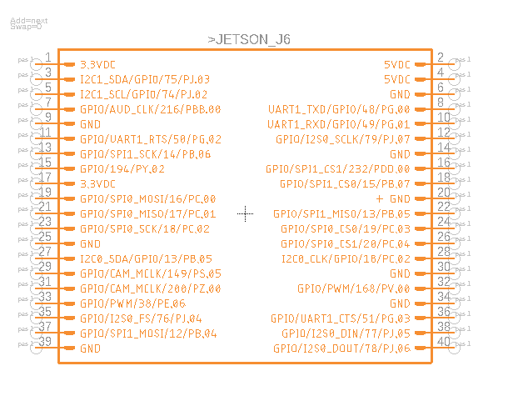

Figure 55: NVIDIA Jetson Nano Developer Kit J6 40-pin Header Symbol

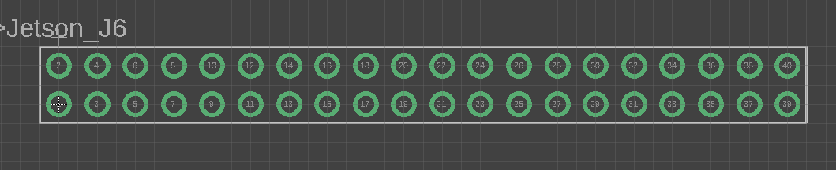

Figure 56: NVIDIA Jetson Nano Developer Kit J6 40-pin Header PCB Footprint

With the symbol and footprint well defined for the Jetson Nano, next was to import a standard 4-terminal block model. This was easily found in existing Eagle libraries. Lastly, was to find or create a device with a well-defined symbol and surface mounting points for the Raspberry Pi Pico. Luckily I was able to find one within a publicly available Eagle Library.

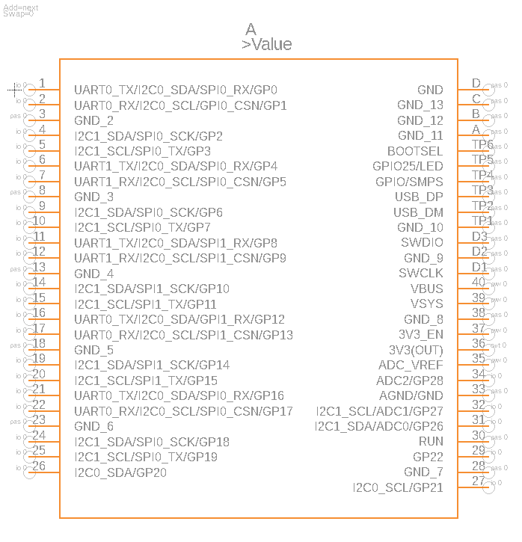

Figure 57: Raspberry Pi Pico Symbol

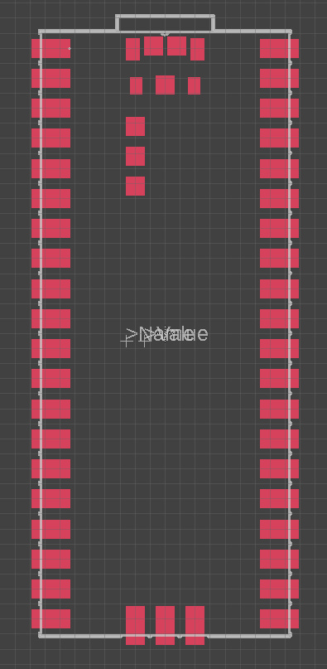

Figure 58: Raspberry Pi Pico PCB Footprint
With all the necessary devices created and defined within Fusion 360, I created a new electronics design and began version 1 of the Control System PCB. I made the following connections in the schematic between the NVIDIA Jetson Nano Developer Kit’s J6 40-pin header and the Power1 4-terminal block and the Raspberry Pi Pico.

Table 13: Main MCU Connections on Control System PCB
Jetson J6 Pin | Destination | Destination Pin | Description
2 | Power1 | 1 | +5VDC [2.5A Max]
4 | Power1 | 3 | +5VDC [2.5A Max]
6 | Power1 | 2 and 4 | GND
19 | Pi Pico | 21 | MOSI for SPI
21 | Pi Pico | 25 | MISO for SPI
23 | Pi Pico | 24 | SCK for SPI
24 | Pi Pico | 22 | CSN for SPI

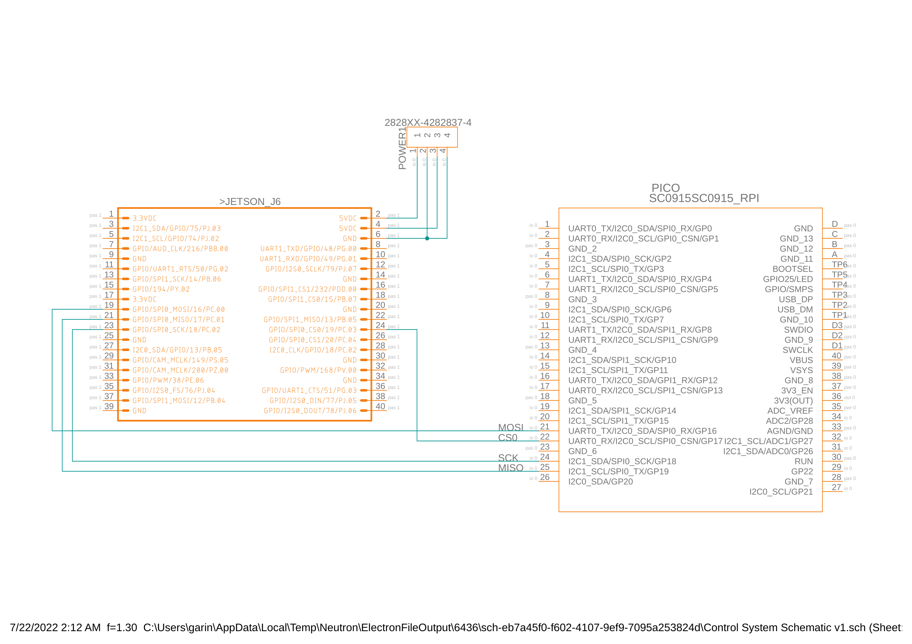

Figure 59: Control System Schematic V1

With all the schematic connections made for the NVIDIA Jetson Nano, our main MCU, next is to finish the connection points for the Raspberry Pi Pico our secondary MCU. This will be a significantly more involved process as we will need to implement 3 PWM channels and utilize the 12-Bit Analog to Digital Converter for the photodetector circuitry. We wish to use 3 colors to signify the status of our inspection machine. With green meaning no errors, yellow meaning some errors, and red meaning too many errors so halt production. Since we want this to be visible from outside the PCB enclosure, these will be through hole mounted. Since we are through hole mounting the LEDs, we decided to also make 3 of them with each being 1 color. Given the complexity of the photodetector circuitry, I will for the time being simply connect the sensor to the ADC directly and apply the necessary filtering and amplification in the next revision of the schematic. Also, given the previously mentioned issue that will cause us to isolate the reference voltage of the ADC, I will for the time being connect it to the same 3.3V and GND supplying power to the Pico. We will be using some LEDs that we already have on hand. The red, yellow, and green LED or D4, D3, D2 (respectively) are all 3mm size requiring 20mA at 2-2.2V. Because of this requirement for the LEDs, the closest resistor value is 68Ω. Subsequently, I have defined R2, R3, and R4 to be 68Ω 5% 1/4W Axial resistors. I also decided to use the A output of different PWM blocks to avoid any potential issues from using the same PWM block.

Table 14: Secondary MCU Connections on Control System PCB

Raspberry Pi Pico Pin | Destination | Destination Pin | Description
1 | R2 | N/A | Green LED
3 | D2, D3, D4 | Cathode | GND
4 | R3 | N/A | Yellow LED
6 | R4 | N/A | Red LED
21 | Jetson Nano J6 | 19 | MOSI for SPI
22 | Jetson Nano J6 | 24 | CSN for SPI
23 | Power2 | 2 | GND
24 | Jetson Nano J6 | 23 | SCK
25 | Jetson Nano J6 | 21 | MISO for SPI
33 | Power2 | 2 | GND
35 | D1 | Cathode | +3.3VDC Schottky
38 | Power2 | 2 | GND
39 | D1 | Cathode | +3.3VDC Schottky

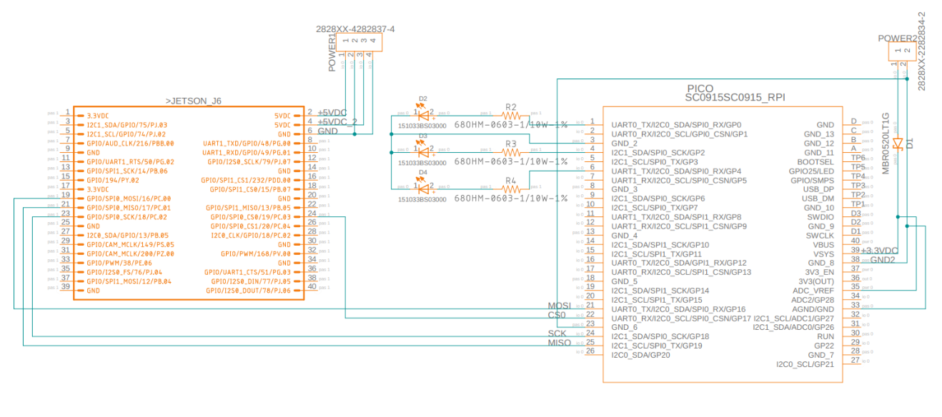

Figure 60: Control System Schematic V2

At this point in the Control System PCB design, the last couple things to implement are the Schottky Diode to power the Raspberry Pi Pico, a stable 3.3V reference voltage for the Raspberry Pi Pico’s 12-Bit ADC, the protection circuitry for powering the Jetson Nano, and the photodiode and its supporting circuitry. With a key issue being the unknown incident light power values when our laser reflects off the Chromorphous fabric’s threads and when it reflects off the backing of the manufacturing line. This issue alone would change the values of several components on the PCB, such as the resistors and capacitors used to filter the returning signal and support an operational amplifier in amplifying the signal to a high enough voltage level for our 12-Bit ADC to read. Since this is a very hard to obtain value, and one we may only discover once a test circuit is made via a breadboard and the laser and photodiode are properly positioned, a workaround must be explored. The solution to move forward with PCB design, despite the guarantee for a change in component values, is to convert all component to through hole mounted components. This way, when the values have been identified, the corresponding component can be easily found as through hole resistors and capacitors are readily available both online, on campus, and in my personal possession. On top of this, if the components are THM and we happen to require value changes, the iteration to the control system PCB can be made rapidly compared to waiting for a new SMT component version to arrive via the mail or otherwise. Another method I will implement to account for this two through hole connections. This signal will most definitely require some form of analog signal modification using an op-amp, but I am unable to identify what is needed (either amplification or reduction). By implementing a double jumper point, I can implement what is needed on a separate mini-PCB and send it a signal via one jumper and receive the signal back at the other jumper. Pin 1 of this 2-pin jumper will be tied to pin 36 of the Pico which outputs 3.3V to be used as the biasing voltage of the photodiode (this voltage may need to be changed in the future). Then, pin 2 of this jumper will be tied to pin 34 of the Pico which is an input pin to the 12-Bit ADC in order to read the signal received from the photodiode.

In the case of the Schottky Diode for the Raspberry Pi Pico the selection is easy. Since the Pico can be powered via the VSYS pin with 1.8V to 5.5Vs, we will use 5V to match the voltage required for the NVIDIA Jetson Nano. This 5V also correlates to the 5V the Pico would get if it was powered via USB. For this reason, based on the diagram of the Raspberry Pi Pico’s power chain, we can use an equivalent Schottky Diode to MBR120VLSFT1G. The through hole version of this is known as 1N5817-TP which is a 20V 1A fast recovery diode. After this diode will also follow a voltage divider to step the 5V down to 3.3V in order to be used by the ADC_VREF pin of the Pico. This 3.3V will act as the reference voltage of ADC found in the Pico and will require the removal of resistor R7 (as labeled by the Raspberry Pi Pico diagrams). This will also involve tying the ground of the 5V line to pin 33 (AGND) on the Pico. The voltage divider will involve the 5V signal going into a 1kΩ resistor, then into pin 35 of the Pico (ADC_VREF) and into a 2kΩ resistor which then connects to the GND of the 5V supply.

In the case of the protection circuitry for the NVIDIA Jetson Nano’s power pins, we need to protect both pins as each one only accepts 5V with a 2.5A maximum. I want to allow the Jetson to pull current from the entire range of 0 to 2.5A, but not more. In order to enforce this, I will make use of an electronic fuse (eFuse). This integrated circuit (IC) is only available as a surface mount component and currently is the only one on the PCB aside from the Pico. I will be using the Texas Instruments TPS25200DRVT which is an eFuse allowing for 2.5V to 6.5V (5V in our case) and a current output of 2.5A. Following the data found on the datasheet we have a few values to determine and will be utilizing the simplified schematic provided on the datasheet.

Finally, for the Auto-Focusing system, it is assumed only one stepper motor is needed. With that only one A4988 Stepper Motor Driver Carrier will be implemented along with one 4 terminal block in order to connect the NEMA 17 stepper motor. The 4-terminal block (STEPPER1) to connect to the stepper motor is arranged however I see fit. For simplicity, I will connect 2B of the A4988 to pin 1 of STEPPER1, 2A to pin 2, 1A to pin3, and 1B to pin 4. The A4988 requires two power inputs VDD and its GND and VMOT and its GND. VDD is the supply to the logic circuit of the A4988 and can be from 3V to 5.5V. In this case I will utilize pin 36 of the Pico which is a 3.3V out and the GND from 5V. VMOT is the supply for the stepper Motor and takes 8V to 35V. In our case the NEMA 17 stepper motor selected requires 12V which comes from pin 3 of POWER1 from the power supply PCB. Its associated GND is on pin 4 of POWER1. Between this 12V and GND I will use a 100µF electrolytic capacitor close to the A4988 to protect it from voltage spikes. After this it is required to configure micro step resolution of the A4988 using MS1, MS2, and MS3. Using the table below, we can see that all 3 pins must be pulled high to our logic voltage in order to set our desired resolution of sixteenth steps.

Table 15: A4988 Stepper Motor Driver Carrier Microstep Resolution Configuration

MS1 | MS2 | MS3 | Microstep Resolution
LOW | LOW | LOW | Full Step
HIGH | LOW | LOW | Half Step
LOW | HIGH | LOW | Quarter Step
HIGH | HIGH | LOW | Eighth Step
HIGH | HIGH | HIGH | Sixteenth Step

In order to set these 3 pins high, first they will be bridged together on the PCB, then connected to the 3.3V already being supplied to A4988 from pin 36 on the Pico. This is our logic I/O voltage for the Pico, 3.3V. The A4988 chip features three pins for controlling its power states which are RESET, SLEEP, and ENABLE. Given that we will not be varying the power states of the A4988, we will use the simple always on configuration which leaves the ENABLE pin open and ties the SLEEP pin to the RESET pin. Finally, the STEP and DIR pins are left, which control what the controller is telling the stepper motor to do. This communication is done via the UART protocol and must be given to pins on the Pico which are UART capable. In our case, that will be pin 16 (UART0_TX) and pin 17 (UART0_RX).

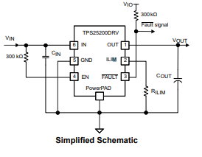

Figure 61: TPS25200 5-V eFuse Simplified Schematic (TPS25200 Datasheet)

First of all and most importantly is R_{LIM} which is determined by knowing our desired maximum current limit. It is also noted in the datasheet that the recommended 1% resistor range for R_{LIM} is 33kΩ ≤ RILIM ≤ 1100kΩ to ensure stability of the internal regulation loop. In our case that value is 2.5A or 2500mA and using the equation provided in the datasheet below

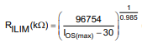

When using 2500mA for I_{OS(MAX)} I get a value of 41.42193kΩ. This resistor value needs to be a precise as possible so, I rounded up to the nearest standard resistor value with a ±1% tolerance which is a 42.2kΩ resistor. By rounding up our maximum current value will be slightly lower than 2.5A and therefore we will have to use the same equation but solve for I_{OS(MAX)} now. Using a 42.2kΩ resistor for R_{LIM} we get an I_{OS(MAX)} of 2455.14mA or 2.46A. Using the equation found in the datasheet below, we can determine the nominal current I_{OS(NOM)} and the minimum current I_{OS(MIN)}

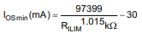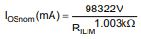

This gives us an I_{OS(NOM)} of 2303.89mA or 2.3A and an I_{OS(MIN)} of 2152.04mA or 2.15A. The other values we need to determine are simply stated in the datasheet. For C_{IN} a 0.1µF or greater ceramic bypass capacitor is specified so a 0.1µF capacitor will be used. For C_{OUT} the graph found below is provided in the datasheet for determining an appropriate value.

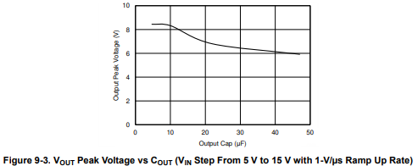

Figure 62: TPS25200 5-V eFuse V_{OUT} vs C_{OUT} (TPS25200 Datasheet)

Using the graph, I determined 50µF to be a reasonable value to limit our peak output voltage. It is also noted that this should be a low ESR ceramic capacitor. We already know V_{IN} to be 5V from our power supply and V_{OUT} to be 5V required for the Jetson Nano. V_{IO} is the voltage of our I/O logic, which for the PICO is typically 3.3V. With these values we have determined and been provided, two eFuses can be implemented into the Control System Schematic in order to protect the power pins of the NVIDIA Jetson Nano from an overvoltage or over current events. It is also worth noting the details of the voltage protection, which can be summarized by the graph below.

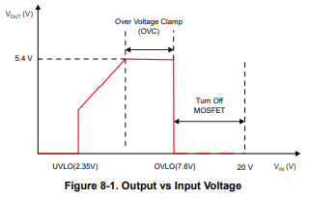

Figure 63: TPS25200 5-V eFuse V_{IN} vs V_{OUT} (TPS25200 Datasheet)

At this point, all expectations of the Control System PCB have been accounted for and the schematic needs to be updated to reflect this. Below is a table of all the connections that need to be made, and below that will be the third version of the Control System Schematic.

Table 16: All connections made in version 3 of the Control System Schematic
Origin | Destination | NET | Description
POWER1-PIN-1 | R6 | +5V | 5V to U1 enable pull up resistor
POWER1-PIN-1 | U1-PIN-6 | +5V | 5V to U1 Vin
POWER1-PIN-2 | U1-PIN-7 | GND_5V | PowerPAD to GND for heatsinking
POWER1-PIN-2 | U1-PIN-5 | GND_5V | U1 Grounding
POWER1-PIN-2 | C4 | GND_5V | U1 C_{IN}
U1-PIN-6 | C4 | +5V | U1 C_{IN}
POWER1-PIN-2 | R11 | GND_5V | U1 R_{LIM}
POWER1-PIN-2 | C2 | GND_5V | U1 C_{OUT}
U1-PIN-2 | R11 | ILIM_1 | U1 Current limiting resistor
U1-PIN-1 | C2 | +5V/2.5A_1 | U1 Regulated 5V/2.5A max
U1-PIN-1 | JETSON_J6-PIN-2 | +5V/2.5A_1 | Regulated 5V for Jetson
POWER1-PIN-2 | JETSON_J6-PIN-6 | GND_5V | Grounding for Jetson
U1-PIN-3 | R10 | U1_FAULT | U1 fault pull up
U1-PIN-3 | PICO-PIN-10 | U1_FAULT | Pico read U1 fault
R10 | PICO-PIN-36 | PICO_+3.3V | 3.3V from Pico
POWER1-PIN-1 | R7 | +5V | 5V to U2 enable pull up resistor
POWER1-PIN-1 | U2-PIN-6 | +5V | 5V to U2 Vin
POWER1-PIN-2 | U2-PIN-7 | GND_5V | PowerPAD to GND for heatsinking
POWER1-PIN-2 | U2-PIN-5 | GND_5V | U2 Grounding
POWER1-PIN-2 | C3 | GND_5V | U2 C_{IN}
U1-PIN-6 | C3 | +5V | U2 C_{IN}
POWER1-PIN-2 | R9 | GND_5V | U2 R_{LIM}
POWER1-PIN-2 | C1 | GND_5V | U2 C_{OUT}
U2-PIN-2 | R9 | ILIM_2 | U2 Current limiting resistor
U2-PIN-1 | C1 | +5V/2.5A_2 | U2 Regulated 5V/2.5A max
U2-PIN-1 | JETSON_J6-PIN-4 | +5V/2.5A_2 | Regulated 5V for Jetson
POWER1-PIN-2 | JETSON_J6-PIN-6 | GND_5V | Grounding for Jetson
U2-PIN-3 | R8 | U2_FAULT | U2 fault pull up
U2-PIN-3 | PICO-PIN-9 | U2_FAULT | Pico read U2 fault
R8 | PICO-PIN-36 | PICO_+3.3V | 3.3V from Pico
JETSON_J6-PIN-19 | PICO-PIN-21 | MOSI | SPI0 MOSI
JETSON_J6-PIN-21 | PICO-PIN-25 | MISO | SPI0 MISO
JETSON_J6-PIN-23 | PICO-PIN-24 | SCK | SPI0 SCK
JETSON_J6-PIN-24 | PICO-PIN-22 | CS0 | SPI0 CSN
JETSON_J6-PIN-25 | PICO-PIN-23 | GND_SPI | Grounding for SPI
PICO-PIN-1 | R2 | PWM_A[0] | Green LED
R2 | D2 | N$4 | Green LED
D2 | PICO-PIN-3 | GND_LEDS | Ground for LEDs
PICO-PIN-4 | R3 | PWM_A[1] | Yellow LED
R3 | D3 | N$5 | Yellow LED
D3 | PICO-PIN-3 | GND_LEDS | Ground for LEDs
PICO-PIN-6 | R4 | PWM_A[2] | Red LED
R4 | D4 | N$6 | Red LED
D4 | PICO-PIN-3 | GND_LEDS | Ground for LEDs
POWER1-PIN-1 | D1 | +5V | Schottky Diode
D1 | PICO-PIN-39 | +5V_PICO | Protected 5V to PICO
POWER1-PIN-2 | PICO-PIN-38 | GND_5V | Grounding for PICO
D1 | R1 | +5V_PICO | 3.3V divider R1
R1 | PICO-PIN-35 | 3.3V_REF | 3.3V for ADC_VREF
R1 | R5 | 3.3V_REF | 3.3V divider R2
R5 | POWER1-PIN-2 | GND_5V | Grounding of divider
PICO-PIN-36 | JP2-PIN-1 | PICO_+3.3V | 3.3V supply for Photodiode PCB
PICO-PIN-34 | JP2-PIN-2 | ADC | ADC input from Photodiode PCB
PICO-PIN-33 | PICO-PIN-38 | GND_5V | Grounding for ADC
PICO-PIN-9 | U3-PIN-DIR | UART0_TX | Stepper motor direction
PICO-PIN-10 | U3-PIN-STEP | UART0_RX | Stepper motor intervals
U3-PIN-SLEEP | U3-PIN-RESET | N$20 | Always on state
MS1 | PICO-PIN-36 | PICO_+3.3V | Configuration high
MS2 | PICO-PIN-36 | PICO_+3.3V | Configuration high
MS3 | PICO-PIN-36 | PICO_+3.3V | Configuration high
U3-PIN-VDD | PICO-PIN-36 | PICO_+3.3V | Logic power for U3
U3-PIN-GND | POWER1-PIN-2 | GND_5V | Logic grounding U3
U3-PIN-VMOT | POWER1-PIN-3 | +12V | 12V for motor
U3-PIN-GNDMOT | POWER1-PIN-4 | GND_12V | Grounding for motor
U3-PIN-VMOT | C5 | +12V | Motor capacitor
U3-PIN-GNDMOT | C5 | GND_12V | Motor capacitor
U3-PIN-2B | STEPPER1-PIN-1 | 2B | PHASE 2B
U3-PIN-2A | STEPPER1-PIN-2 | 2A | PHASE 2A
U3-PIN-1A | STEPPER1-PIN-3 | 1A | PHASE 1A
U3-PIN-1B | STEPPER1-PIN-4 | 1B | PHASE 1B

Table 17: Control System Schematic V3 Component Values

Name | Value
C1 | 50μF
C2 | 50μF
C3 | 0.1μF
C4 | 0.1μF
C5 | 100μF
D1 | 1N5817-TP
D2 | LED Green
D3 | LED Yellow
D4 | LED Red
R1 | 1kΩ
R2 | 68Ω
R3 | 68Ω
R4 | 68Ω
R5 | 2kΩ
R6 | 300kΩ
R7 | 300kΩ
R8 | 300kΩ
R9 | 42.2kΩ
R10 | 300kΩ
R11 | 42.2kΩ
U1 | TPS25200DRVTDRV6
U2 | TPS25200DRVTDRV6
U3 | A4988

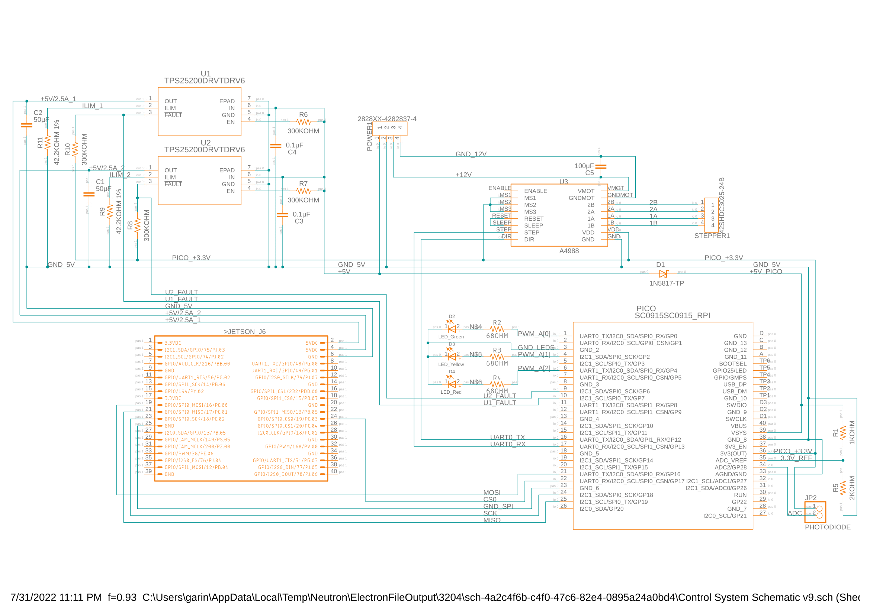

Figure 64: Control System Schematic V3
From this schematic in Fusion 360, I am also able to create a PCB layout and subsequent Gerber file to be used for manufacturing in the near future. The layout of the Control System PCB V1 which is based off Control System Schematic V3 is found below.

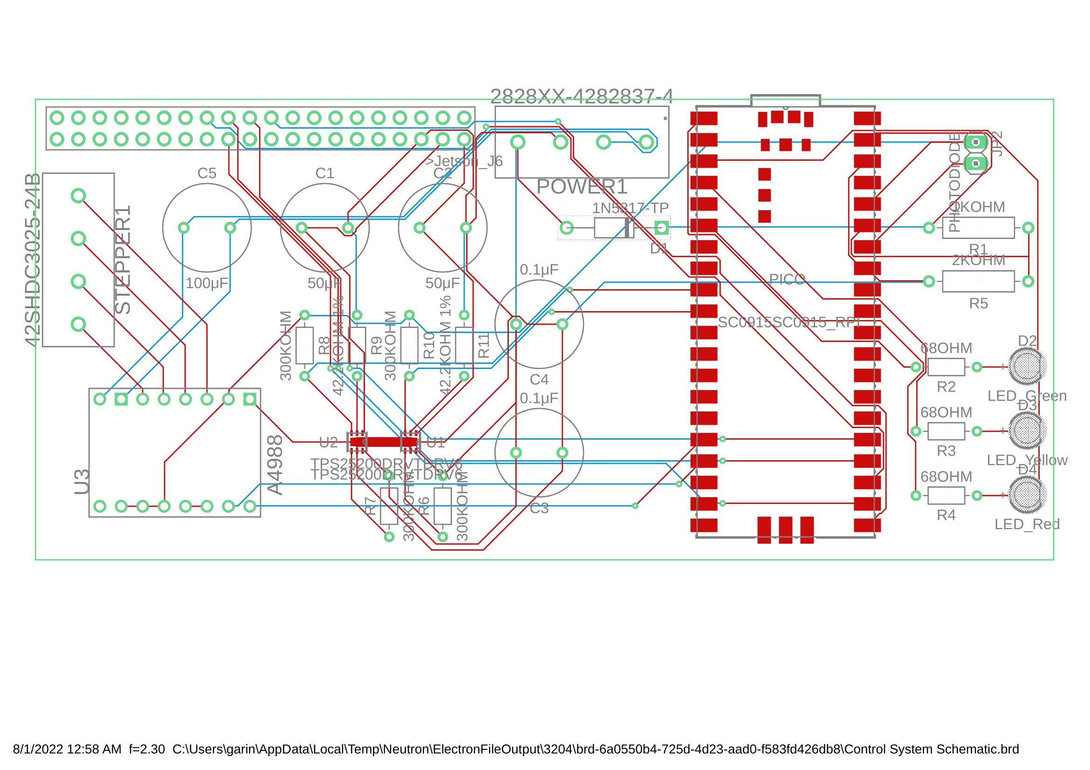
Figure 65: Control System PCB V1

After making some manual routes to ensure certain components that are specified to be as close to each other as possible have been routed, I then made use of the “Autorouter” tool in Fusion 360 and resulted in the above pictured PCB layout. There are several improvements that still need to be made and several issues that arose. The PCB features 173 pads, but 12 Vias which I would like to minimize. The issue stems from the size and through hole nature of the capacitors and resistors for U1 and U2 specifically. If the time frame allows for it, these components should be switched to SMT components which would greatly decrease the overall footprint of the board. Another issue which can be solved in the next attempt at optimization, is the led positioning. I attempted to make all external access points on one side of the PCB such as the Pico’s MicroUSB slot, the Power Supply connection points, the Jetson 40-pin connector. However, after looking at the render of the PCB generated below, this may not be the best layout and may be illogical. Depending on the enclosure design and the location of this enclosure relative to the other components in the project, certain things may require rearrangement. For example, I know the Pico’s MicroUSB slot, and the LEDs should be visible from outside the overall device, but the Power Supply PCB connection at POWER1 may require routing from the opposite direction. Same goes for the STEPPER1 connector and JP2 connector. This design will require further revisions as the overall design of the project matures.

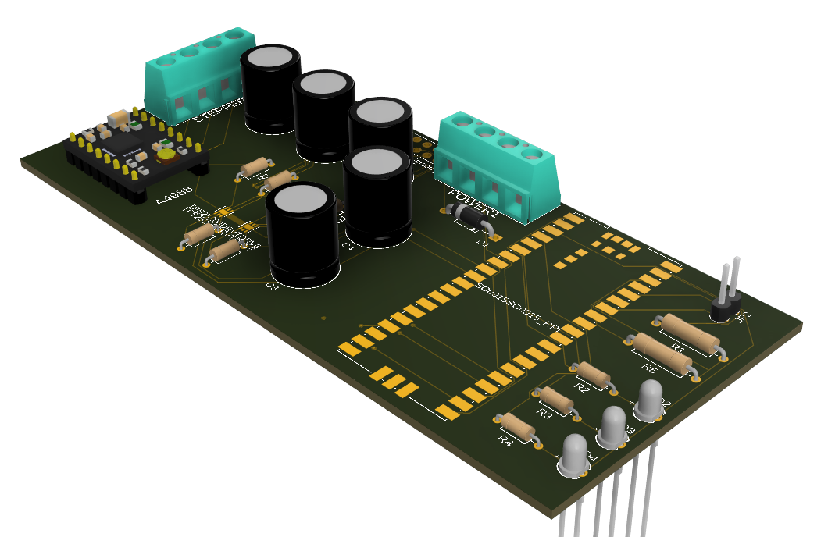

Figure 66: Control System PCB V1 Render

It is also worth noting that this Control System PCB V1 is missing other vital features such as mounting holes and test points.

After receiving the first physical boards for revision 1 of the Control System PCB, some issues became apparent. The eFuses where too small to reflow to the board by hand. This issue alone was grounds for a new board revision. However, I decided to also include a potentiometer to act as a voltage divider going to two jumper pins to supply power to the fabric from our power supply rather than a battery. The new schematic is shown below.

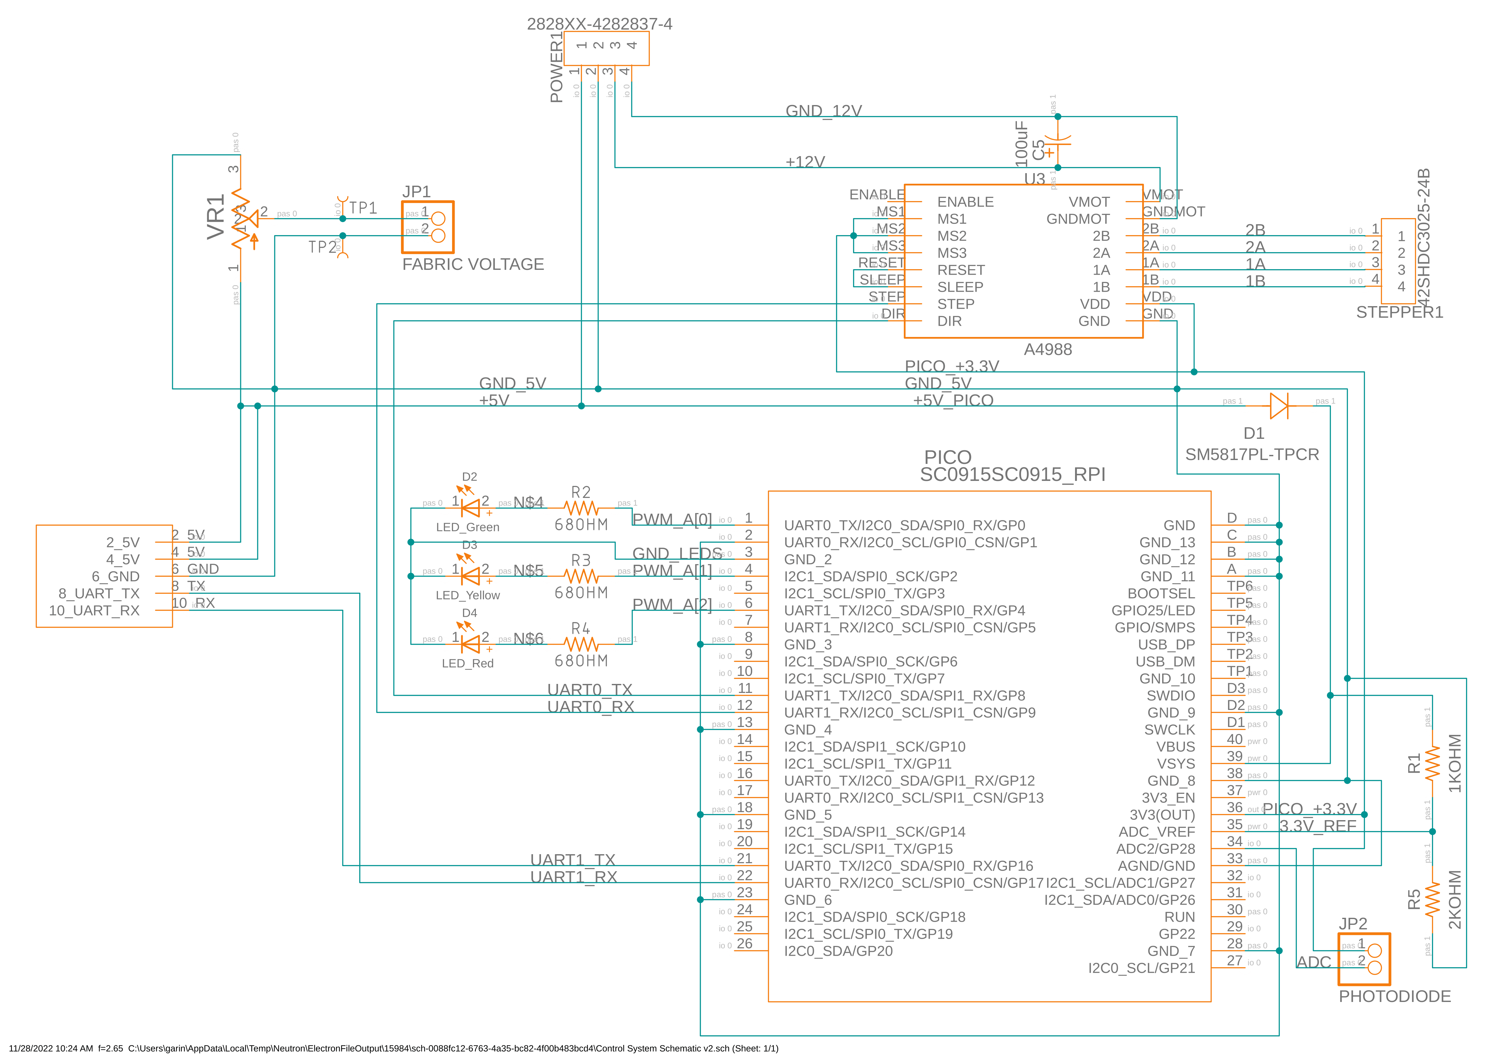
Figure 67: Control System Schematic V4
Version 4 of the control system schematic is highly simplified compared to its previous versions and has added functionality. The potentiometer added is connected directly to the 5V input terminal and is a 10kΩ potentiometer for dividing the voltage from 0V to 5V. In order to test this voltage value before applying it to the fabric, test points 1 and 2 where implemented to aid in this. With test point 1 (TP1) being the positive voltage, and test point 2 (TP2) being the negative voltage. Pictured below is the footprint of the PCB that was sent to be manufactured.

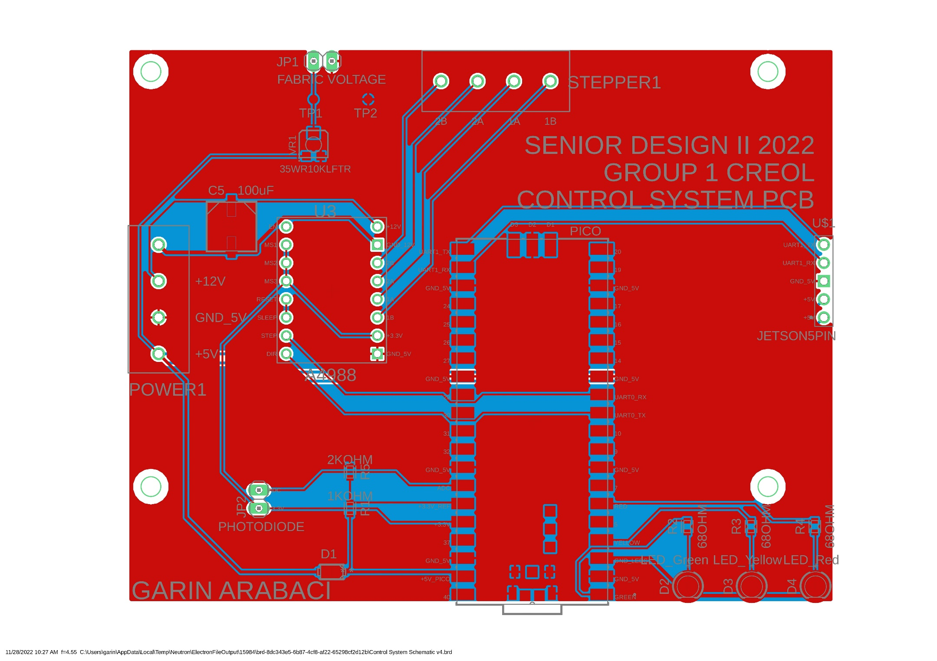
Figure 68: Control System PCB V2

Power Supply PCB Design

As we follow our project requirements, there are two major components that need to be powered with different voltages that will bring us to design two types of power supplies: one will be the AC (Alternating Current) to DC (Direct Current) converter and the other one the DC-to-DC converter. As we are making one single unit system the AC to DC converter will give power to the DC-to-DC converter. The reason is we need to energize the Control System PCB with a 5V DC supply at 5A, while the stepper motor needs a 12V DC supply at 2A.

In the case of AC to DC converter, we used the LM5021 regulator from the TI (Texas Instruments) WEBENCH design. It is a pulse width modulation (PWM) controller which made with lot of features such as high efficiency of implementation, single-ended flyback and forward power converters using mode control, also has low start up current by reducing the loss of power in the high voltage start up network. This power supply system can range from less than 100V to 240V AC or more and can deliver an output voltage of 12V at 4A. This power supply will be used to energize the stepper motor and the DC-to-DC converter. The following figure is the Eagle design schematic. It allows us to create the PCB layout for the power supply.

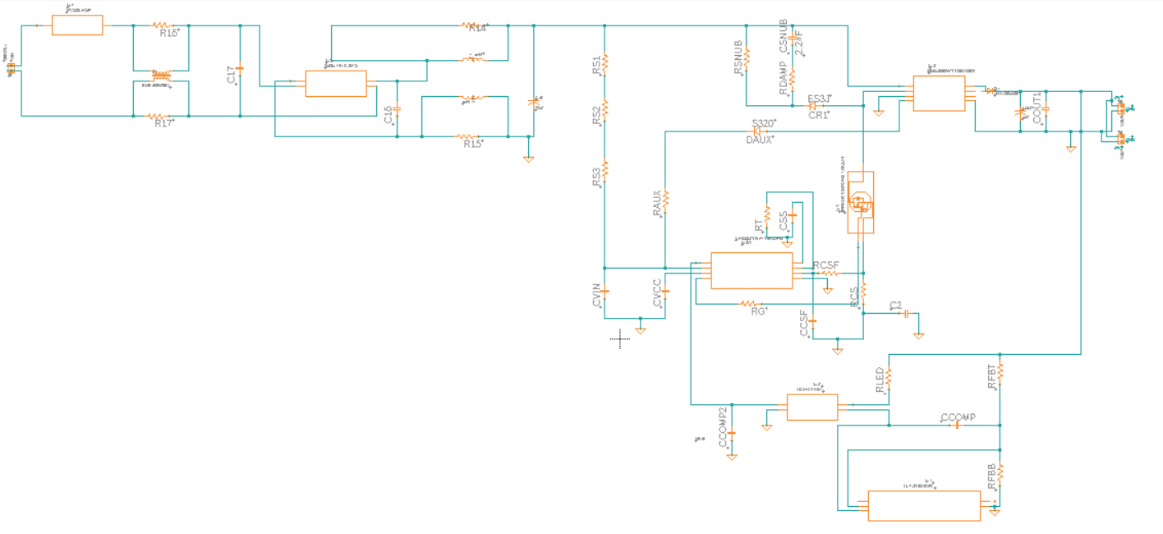
Figure 69: AC-DC Power Supply Schematic from Fusion 360 AutoDesk

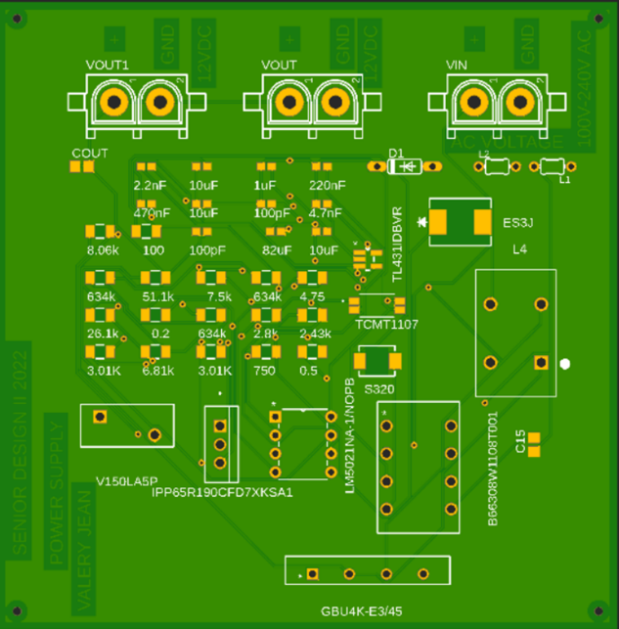

Figure 70: The AC-DC Power Supply PCB

The second power supply is using a DC-DC buck converter that can convert a 12V DC to 5V DC at 5A that the Jetson NANO requirement. This power supply will take its 12V input from one of the outputs of the AC-DC power supply that we mention above. This converter's design comes from the Texas Instruments WEBENCH design for implementing this power supply. The TPS54561-Q1 is the regulator that we used for this power supply. This device has notable features such as it is a step-down regulator with an integrated high-side MOSFET which means it can survive up to an input of 65V at 5A. Power is Good for output monitor Undervoltage and Overvoltage. When the voltage is dropping under 4.3V the device is locked out. Also, it has high efficiency at light loads with pulse-skipping eco-mode MOSFET.
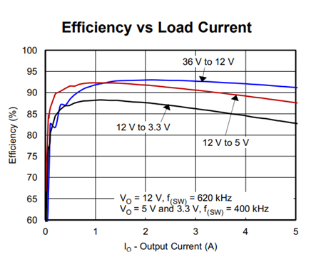
Graph of the efficiency versus the load current

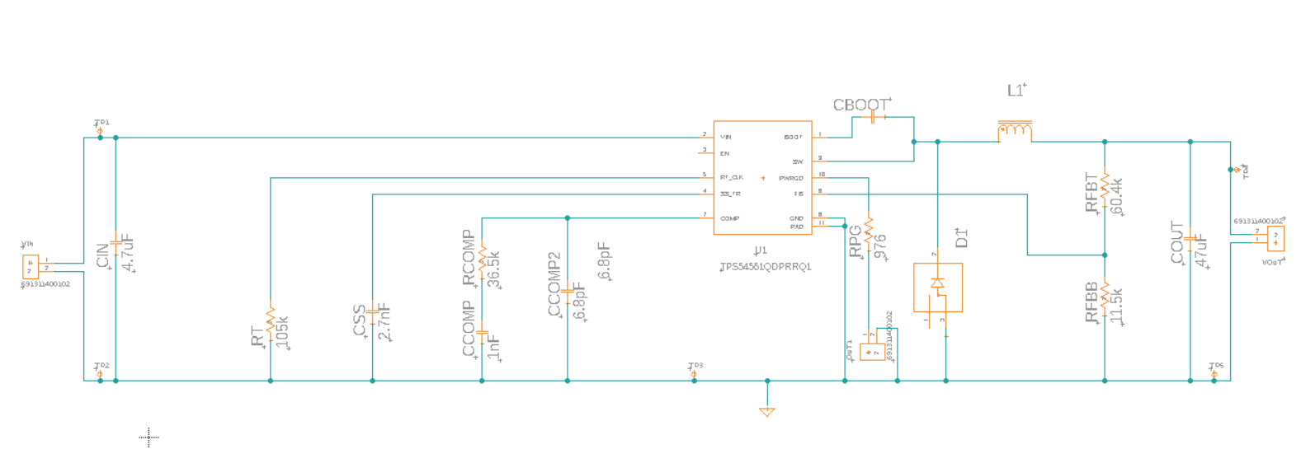

Figure: Power Supply Schematic from Fusion 360 AutoDesk

The following figure represents the DC-DC power supply PCB for our design.

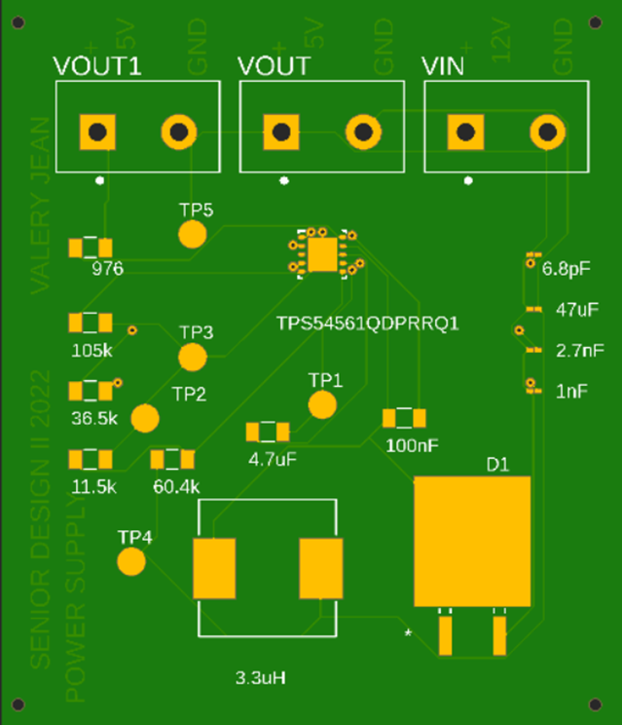

Figure 71: The DC-DC Power Supply PCB

In lack of getting the selected regulator to encounter an excessive cost issue, we can still use the complete design power supply that represents in the figure below. This DC-DC power supply can provide the same features as the selected one. The connection, the input voltage and the output voltage including the current are still the same as we expected to maintain our design requirement. Because of the actual situation where there is a war crisis, products come from various locations of the world. Most of the regulators are not available in stock. It will take an exceedingly long time to get shipping. For this reason, we can consider this power supply as an alternative solution to our design.

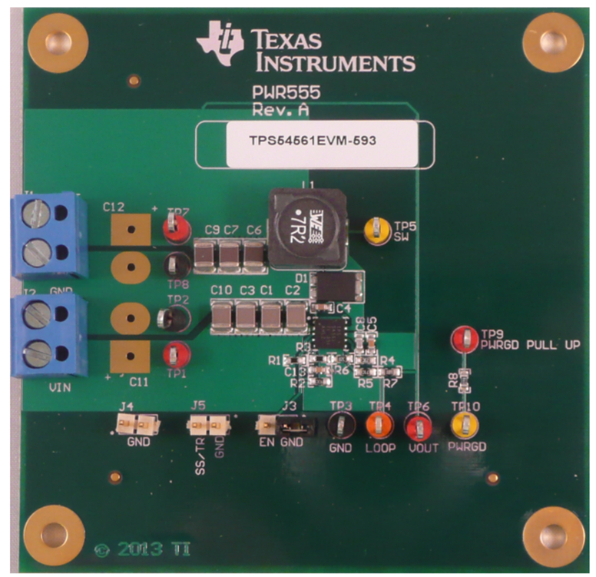
Figure 72: TPS54561EVM-593 Power Supply from TI

Software Design

The main software design of the project involves many different components working in tandem. By dividing the components into manageable sections, the project software was realized along with the necessary framework required for intercomponent cooperation. The following sections outline the flow and steps required to achieve a working software design for the project.

Software Design Overview

Deciding the necessary software aspects was a daunting task concerning the project. It mainly entails having to decide multiple matters within certain constraints ranging from hardware to economics and safety. When concerning the development of the software, the team approach required maximizing hardware usage to achieve maximum efficiency while providing a robust software platform. Essentially, multiple software modules were developed to obtain the necessary functionality for each specific portion of the project. The following is a representation of the components necessary to achieve a working prototype derived from the software flow diagram.

Software Flow

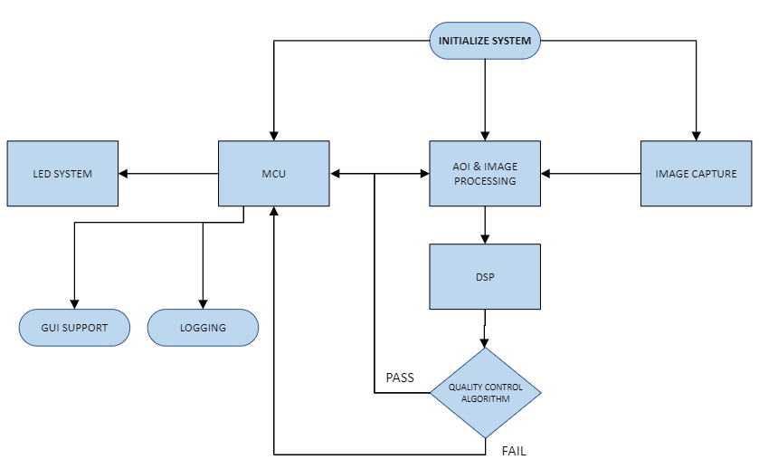

Figure 73: Software Block Diagram

Software Design Components

By breaking down each component, the project software could be subdivided into manageable applications and services that lead to the overall goal while maintaining manageability. These development modules could then be programmed in parallel while providing an independent environment for unit testing. With every decision made in the design, the main purpose was to achieve a viable working prototype that delivered on the project requirements.

Virtual Machine Tool

While researching, the use of virtual machines developed into a practical method to begin development. With a dedicated virtual machine, each module could be virtualized in order to begin building the necessary libraries and functions for interaction between different modules of the software design diagram. The need for the virtual environment became evident due to parts acquisition and funding constraints. It also allowed for creating two independent systems that could interface with each other over a virtual ethernet interface. The independent virtual systems mimic the eventual physical hardware that the developed software will be deployed to in the project. When software is ready for testing, it will also provide an isolated environment to perform unit testing during the final stages of development. Using such a design tool will help minimize refactoring during deployment to the hardware and software systems in the project.

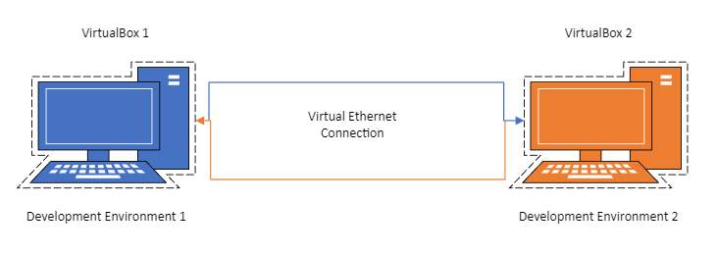

Figure 74: Virtual Development Environment

Integrated Development Environment (IDE)

Due to economic constraints, the development of the project was always to use tools to mitigate the cost as much as possible. Many different integrated development environments (IDE) exist that can make development less complicated and time consuming for the project. Fortunately, an IDE exists that has proven to be very versatile with no associated costs for setup.

Visual Studio Code was developed by Microsoft as a source-code editor for all major OS platforms. In seven years, it has become the most popular development environment due to its many plug-ins and supported languages. The fact that is supports many languages will provide excellent flexibility during project creation.

For this project, it will serve as the main development environment along with a few plug-ins for other features. Visual Studio Code will be installed on each development environment so that all application code will run natively when testing. With each virtual machine supporting independent integrated development environments, it will help in maintaining separate code bases to work from which will lead to better manageability. Maintaining a good sense of organization will encourage good coding habits since the code base could become confusing when modules are segmented to provide a loosely coupled system. What is meant by loosely coupled system is a system with modules that have some dependency between other modules but not dependent enough to cause major system errors due to functional changes in that module. The setup should also help to resolve most code incompatibilities before deployment to hardware, as well.

Version Control

The final element in the software design components is the use of version control software. With version control software, the developer of the project can keep a record of all changes and modifications without the need for backups. The possibility of losing data due to local storage is an unnecessary risk when developing such a project. With online version control tools, the setup of the system and added functionality is worth the additional time. In this project, it also means no added expenditures due to the use of the tool.

GitHub will serve as the repository for all code from each integrated development environment. With remote cloud storage provided through GitHub, the team will be able to pull the code base and collaborate on the necessary features to build the project system. Each team member will be granted access to the GitHub source code. When initial development begins, the remote master will serve as the origin for the project. Any pull from the remote master will be automatically branched to avoid unnecessary errors. Before any branch is merged to the remote master, it must be verified by the software team member. Upon inspection and testing, the team member will merge the branch with the master and inform the team of the updated code base.

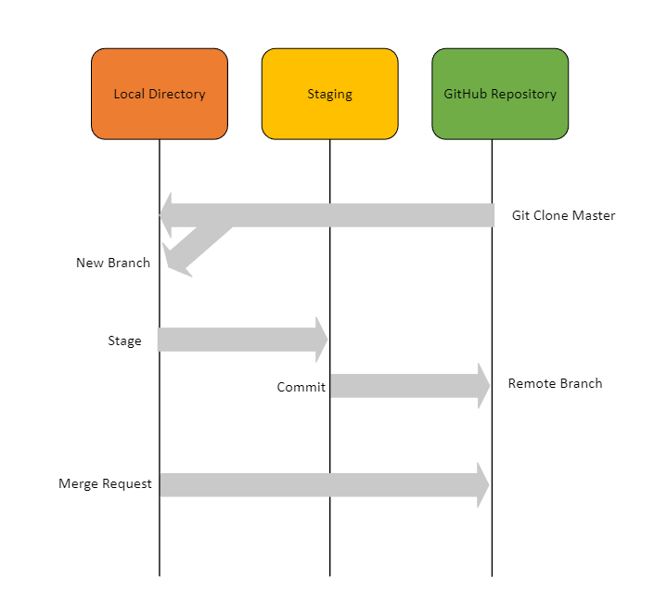

Figure 75: GitHub Flow Diagram

Image Acquisition Software

The software used for image capturing is developed by THORLABS to assist in camera configuration. It will allow the project to retrieve images continuously while the production line is in service. ThorCam utilizes a graphical interface to provide the necessary settings for the hardware device. In addition, an API is provided to developers seeking to program more functionally into the device. In this sense, the project may take advantage of the API to retrieve the necessary images depending on its ability to interface with the hardware discussed in the project. Overall, this segment should act as a straightforward plug-in for the project design. In the event of software issues, programming with the use of the API could add a delay to the project. The group will manage accordingly since this component is vital to the overall completion of the project.

Image Processing Software Overview

After image acquisition, the next necessary step is to prepare the image data for the algorithm. In the next two sections, the project will take advantage of image processing to adjust and fine-tune the data. The process is important to achieving a low error rate with the algorithm employed for classification. The cleaning of the data is always a good idea when dealing with machine learning algorithms.

Image Processing with MATLAB

During the initial research of software components, MATLAB was chosen to assist in processing the images that the project would utilize for classification. Upon further progress, the economic constraint associated with MATLAB became a barrier. Even though MATLAB requires a small contribution to the budget, in the end, the price for well-developed tools was worth the expense. In this case, the answer was resolved by the time constraint. The path forward to completion would be best served by the investment in MATLAB. With that justification, any extra time could be applied to benefit other aspects of the project in relation to development.

MATLAB will provide the toolset to work with the acquired images from the previous step. The software researched for the project draws from MATLAB to process the images received from the NIR camera. The first task involves pre-processing the imported images. During pre-processing, the image is converted to grayscale while also applying a contrast filter to expose the physical structures used in identification and classification. Additionally, pre-processing will allow us to further refine the image to perform the next procedure of segmentation.

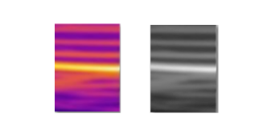

Figure 76: Pre-processing Example Image
With segmentation, the vital structures are further defined by applying an automatic thresholding process. The process serves as another step to hone the image to assist during binarization. During segmentation, the image is divided into regions to make for easy identification of specific shapes, textures or colors in a picture. To accomplish segmentation, the image is masked to produce regions of interest versus spaces that will be disregarded. MATLAB can produce an intensity graph that can help to isolate areas of interest. After defining the area, the image can then be segmented to depict the necessary outlines.

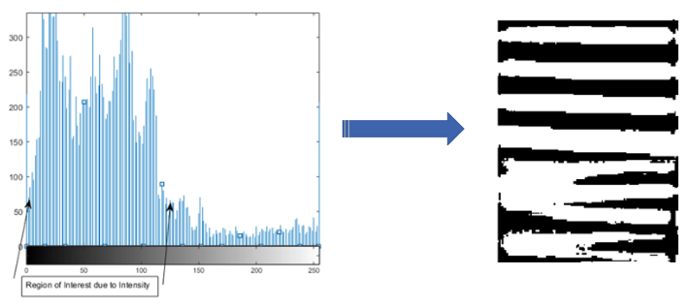

Figure 77: Intensity histogram of Example Image

Before the image can be classified by the final step, some post-processing will be used to remove noise that can hinder the general procedure. Using a smoothing method, the impact of noise will be reduced in each image. The impact of noise is reduced by apply a filter that calculates specific values per specific area of the image. The filter will then perform a sliding window augmentation on the image according to the values calculated in that specific area of the image. Overall, the image is now prepared and ready for the final processes of classification.

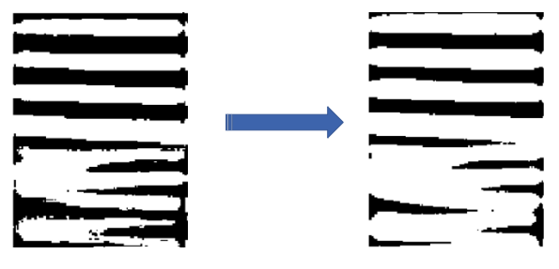

Figure 78: Noise Reduction Example

Quality Control Algorithm

Once the image has been processed by MATLAB, the classification of the resulting images can begin to be provided to the quality control algorithm. In this section, the analysis of the algorithm will be discussed as it works in the system. For classification of the images, Python is utilized due to its well-developed library of machine learning algorithms. The following diagram represents a general overview of the algorithm once trained and ready for deployment into the project.

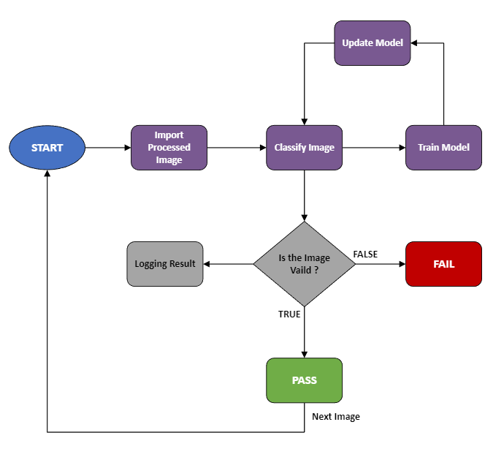

Figure 79: Quality Control Algorithm Flow Diagram

The machine learning model must first be trained on a proper dataset that is representative of acceptable and rejected images. The provided image dataset will consist of labeled data to train the model in a supervised manner. A balanced dataset is necessary during training otherwise the model will have a tendency to overfit which produces bias results. During training, the Decision Tree algorithm will utilize an impurity measure to define the tree structure. The mathematical model associated with the Decision Tree algorithm is shown below which can compute impurity using the other setting of entropy.

$$H_{i}= - \sum_{k=1}^{n}{p_{i,k}} \log_{2} \left(p_{i,k}\right) , p_{i,k}≠0$$

Decision Trees tend to overfit the data so regularization is required to optimize the model. Depending on the hyperparameters utilizes, regularization will be performed according to the best results obtained during the testing phase. Essentially, regularization will help to produce an efficient machine learning classifier for deployment. An artificial neural network was initially considered but the need for a larger dataset was not conducive to the progress of the overall software design. With that idea, a Decision Tree algorithm was implemented to handle the image dataset due to speed, efficiency and not requiring a larger dataset for training. The following diagram represents the training cycle that will help to develop the Decision Tree model algorithm.

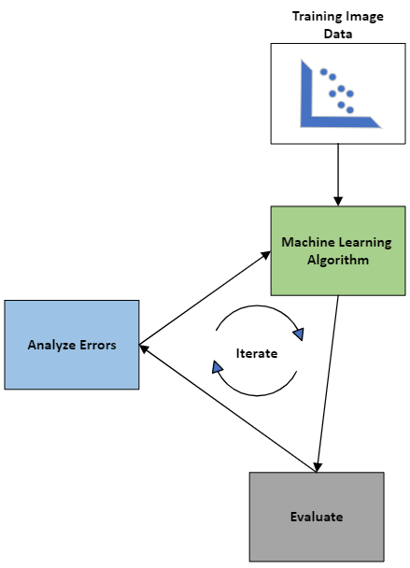

Figure 80: Machine Learning Algorithm Training Cycle

Once training of the model is complete, the team can continue to refine the model by manipulating features that can assist the model in predicting a passing image versus a failing image. Also, the machine learning algorithm can be deployed in the system so it can also serve to train more iterations of image data while in service. Additionally, extra training will help to minimize the error rate in the overall Decision Tree algorithm model.

Support Software

In this section, the support software that will assist in logging data and displaying it on a graphic user interface will be discussed. These components will provide added functionally separate from the main operation of the project. This added benefit will demonstrate the purpose of adding user interaction to the role of a working project. In turn, the following sections will discuss the necessity for utilizing support software to enhance functions beyond the main objectives. The sample use case demonstrates a simple example of interaction with the system.

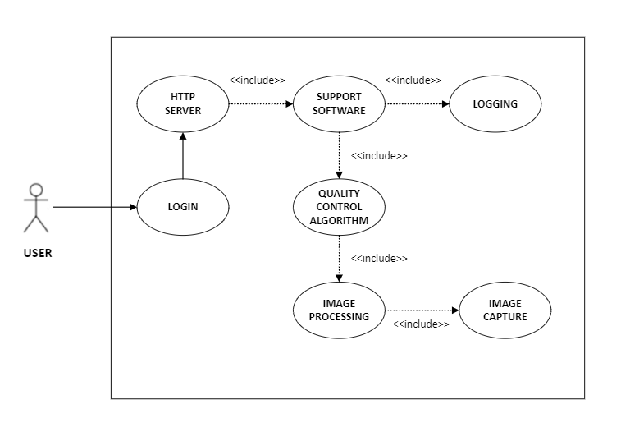

Figure 81: Use Case for Support Software

Logging

The benefit of implementing a logging service is to store historical data and to assist in troubleshooting real-time manufacturing issues that can arise during production. It also has the added bonus of providing data that can be analyzed for patterns which could provide an indirect method of observing manufacturing issues. The main purpose for the data logger is essentially to monitor and record environmental parameter related to the production line. The software service involved will maintain a count of changing variables through a secondary microcontroller unit.

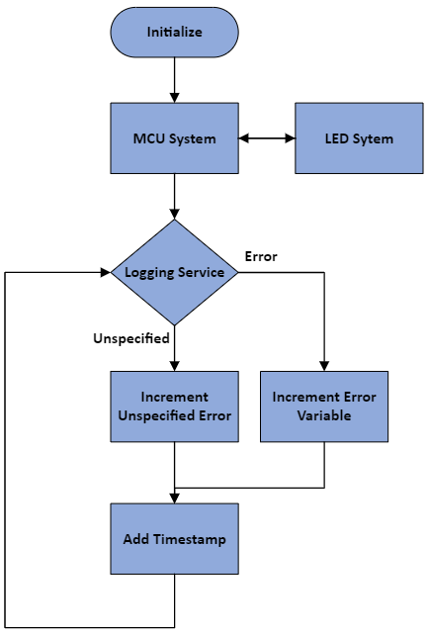

Figure 82: Logging flow diagram

During service, it will count major and minor mistakes while also monitoring the status of the primary microcontroller unit. In addition, a time of date stamp will be appended to each log entry. Logging will be the primary method of retrieving the overall status of the primary system. The logging service will continually monitor certain variables in the LED support system and increment the appropriate values. This will allow a user to observe changes in real-time via the GUI setup. Whether for troubleshooting the manufacturing line or system, the addition of a logging system benefits the over productivity of the system to all users.

Another support feature implemented was to monitor the status of power to the primary microcontroller unit. In the event of a power fault to the primary microcontroller unit, special fuses were added to detect for an issue. The fuses support software logging in the case of an interruption in power. With this upgrade, the fuses will provide a simple report to the log in case of failure. This notice will also be integrated into the GUI and LED support system to maintain inter-device cooperation.

Graphic User Interface (GUI)

A graphic user interface will be used to access certain characteristics of the project when in service and for monitoring purposes. The GUI will serve to visualize count data associated with the manufacturing line. It will also display normal operational data related to the project status during service. The interface will be access through an ethernet port via a HTTP server. A browser will access the HTTP server through an IP address for direct monitoring. Once logged into the server, the browser will display on-screen data related to current working conditions. The information will be retrieved through polling the on-board MCU variables associated with system operation. The webpage will automatically update in real-time to maintain recent information. The following represents a flow chart of the software polling required for the system to function.

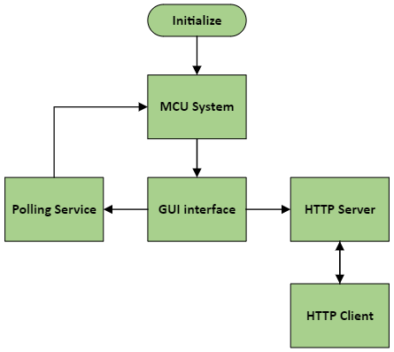

Figure 83: GUI Interface flowchart

LED Support Software

The final support application will service the physical LED system. The LED system will provide a physical visual status during system operation. Upon system initialization and readiness, the green status LED will remain illuminated. The green LED provides a general overview of system status and condition indicating system fully operational. A yellow LED will serve to indicate an error that is not classified as detrimental to service but an issue maybe developing. It is a warning to possible future failure but without causing system stoppage. It will act as an early warning system using a simple function. The red LED will indicate system error due to malfunction. During red LED activation, the system will need to be diagnosed in order to clear the error. Upon resolution, the green LED will illuminate to indicate service nominal and operational. The following diagram shows the LED system flowchart.

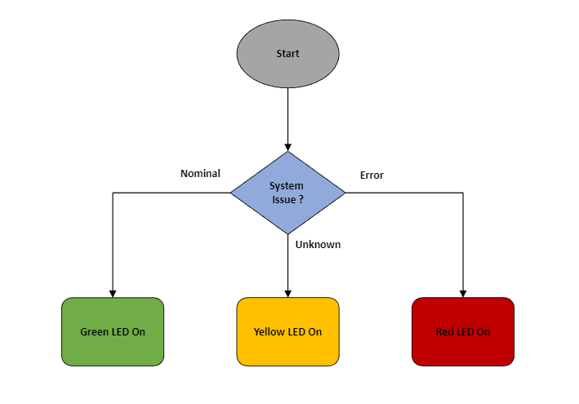

Figure 84: LED System Support

In the LED support software, a service will poll the MCU for active conditionals that will be monitored during operation. The conditionals will change accordingly and cause a corresponding LED to illuminate. The deciding conditions for each LED will be discussed further during the software testing phase. Software development for the LED support system utilizes rudimentary conditions that illuminates one LED depending on the conditions detected by the system.

Table 18: LED Identifiers Table

LED Status | Cause | Logging | Resolution
Green | System Nominal, no issues detected, no unusual reading from system | None | Working as designed
Yellow | Possible issue detected but not fatal, minor reading errors, unusual readings detected from system, unidentified errors | Yes | Reset system, check alignment, verify connectivity between modules
Red | Error in system, power failure, no reading detected, sensor issue, camera issue, software failure | Yes | Verify power, check operation of modules, reinitialize system

Software Design Summary

After developing and applying the software, the project will have the functionally to coordinate the necessary modules during service. Each module will perform a function independent of another module. The loosely coupled modules allow for easier code upkeep and debugging without dealing with overly dependent software modules. Ultimately, the software will be modifiable and reusable which are quality attributes necessary for a reliable and stable system.

AOI

This section will go over the design choices, the component choice decisions, and the over optical properties of the AOI system.

AOI View
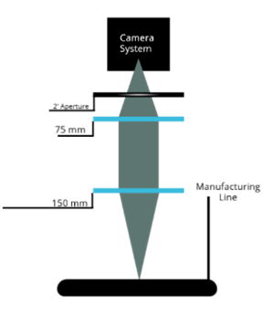

Figure 85: AOI Overview Diagram

AOI Component Choices

The AOI optical telescope system is more refined for deciding what to buy. The lens system for this portion of the project is not only more complex with more lenses, but they also much be capable of transmitting the wavelength of light emitted from the heated copper through the system. We have decided to buy a system worth of NBK-7 Uncoated lenses.

Shape of Lens | Plano-Convex
Substrate | NBK-7 Uncoated
Wavelength Range | 350 nm – 2000 nm
Lens Diameter | 1”

The reason for this is two-fold. One, because the wavelength of acceptance includes the visible light spectrum, we will be able to use these lenses to do visual alignments and imaging to get the baseline of our system started. Trying to tune the system directly in the IR range seemed to be too great of a challenge, so being able focus our camera system in the visual range is of great benefit. As well, a simple IR filter on the front end of the optic will prevent any visible light from passing through once it is time for IR imaging to begin. Though in theory, there should be no reason to need an IR filter with a proper camera sensor, it is an extra failsafe in case troublesome images occur. Demo procedures have shown that a 1000 mm front end plano-convex optic with a 125 mm eyepiece produced an image to the viewer, through their eyes, of a 1600 µm x 1600 µm object space. This was satisfying news seeing as the original design wanted a plano-concave mirror in order to magnify the initial image, and it showed that we were more than on the right path.

Sensor/Camera selection has been incredibly difficult to procure. A stand-in, Thorlabs microscopy camera was chosen as a baseline in order for the electrical team to continue with their work with building the PCB and power system. The microscopy camera, the CS135MUN, is a 1.3 MP camera with a USB 3.0 power output. It does not have the sensor capable of imaging in the IR range that we expect.

It is mission critical to find a proper sensor. The issue is the difficulty in finding a naked sensor to install or an affordable camera that has the capabilities that we need. Assistance in the two-week period between SD1 and SD2 is already planned to fast track a solution. Therefore, the OSE student has decided that additional support will be given to the electrical team to make up for the time lost.

As of Senior Design 2, it was decided that finding a thermal imaging system that would be capable of maintaining both a high enough resolution with an appropriate frame rate would not be possible within budget constraints. Therefore, we had to move on from the IR component of the project, and work in visible light. This led to choosing the Arducam HQ IR-CUT Camera 12.3MP 1/2.3-In IMX477 w/ 6mm CS Lens for Jetson Nano. This camera, at the cost and compatibility with our Jetson Nano, was a solid choice for our change in design scope. The 6mm lens system that comes with the unit can be pulled out of the camera system in such a way to create magnification across the sensor. This means the resulting image is a quarter inch section of the fabric. For the purposes of our project, working in visible light, this produced acceptable results.

The lenses that were used in this portion of the project were a 150mm and 75 mm lens. With an infinitely collimated front-end optic, the 75 mm lens was able to be placed anywhere directly behind the lead optic, with the Arducam placed roughly 75 mm behind the second optic. A 2 inch aperture was placed in front of the 6mm lens kit in order to prevent ambient light from flooding the sensor. The simplicity of this design bodes well for the future development of this project. We are confident that this systems image quality will be improved exponentially in the future with future budgetary and hardware support.

Table 19: Final Component Table for AOI System
Component | Description
150 mm Lens | Plano-Convex Focusing Lens (NBK-7)
75 mm Lens | Plano-Convex Lens (NBK-7)
Aperture | 2 inch Aperture
Arducam | 12.3 MP Senor with 6mm CCTV lens

Laser Counter

The following section shows the design, and comparison section for the Laser Counter that will be used for counting analysis.

Laser Counter Design and Cross Section

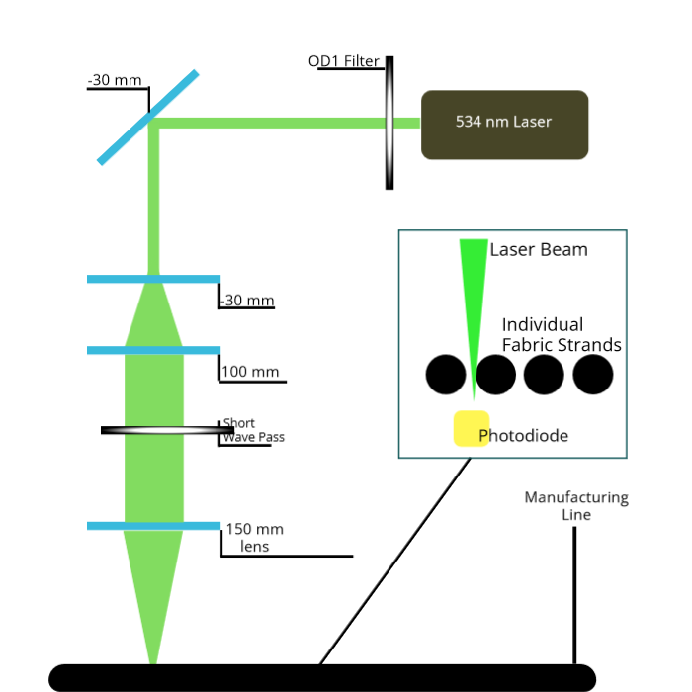

Figure 86: Laser Counter

Component Selection

Lenses
In regard to the Laser Counter, the necessary lenses are heavily influenced by the optical design of the system. (Show laser system?) As we can see from the design below, the two elements are used for a simple beam expander, with a focusing lens being the front-end optic. The magnification coefficient, and the physical parameters of the system are the real deciding factors. Mimicking the final demo for OSE SD1, a 30 mm lens coupled with a 100 mm lens would be used for the beam expander. A 150 mm lens would then be used to focus the light. The specific models of these lenses are rather easy to come by and be matched to spec from the demo.

Shape of Lens | Plano-Convex and Plano-Concave
Substrate | NBK-7
Wavelength Range | 350 nm – 700 nm
Lens Diameter | 1”

The lens diameter for Laser Counter optical system is bigger than what we need. However, finding smaller lenses is difficult, and price reflection is not worth the smaller size. As well, the larger diameter does not impede the dimension specifications.

Laser Comparison

Developments have occurred that have led us to believe that a HeNe laser may not have the required optical power for meaningful readings to be read by our photodiode. The manufacturing team has lent our team a small, semiconductor laser that runs off two double A batteries for preliminary testing purposes. This laser is a 533 nm laser, with a power output greater than 50 milliwatts. Direct measurement of the beams power is not able to be done at this time, for all photosensors in our possession become over saturated with non-attenuated setups.

Table 20:Comparison of HeNe Laser and Semiconductor Laser
Laser Type | HeNe | Semiconductor
Wavelength | 632.8 nm | 533 nm
Power Output | 1.5 ~ 2.5 mW | 50mW +
Power Source | 100 – 240 VAC power supply | Two Double A Batteries
Beam Diameter | ~0.9 mm | ~ 1 mm
Beam Divergence | 1.3 mRad | Unknown

The capabilities of this semiconductor laser, relative to the price, maintenance and the power output it can provide, there is a strong chance that this will become our final laser to use. The reason we decided to use a HeNe laser in the first place was because of the cost-effective nature that it provided with the abundance of units that could be borrowed for the project. However, the scope and the demand of this project has now made us reconsider, but the core design still has not changed. Even the electrical support can be supplemented and change slightly to provide this system with constant power. This paper, however, will continue to reference the HeNe laser since a majority of our work was made with the unit in mind.

As of Senior Design 2, the core fundamentals of this project did not change too drastically. Two core issues did arise that needed to be addressed. Reflecting the light off of the fabric itself was not feasible due to time and resources and created a more complex mechanical system than was capable of being produced. The team decided that the best course of action would be creating a beam block system for the laser. A photodiode would be placed just behind the loose ends of the thermos chromatic wires. As each thread passed in front of the photodiode, the photodiode would register the voltage difference as a count just as stated before.

Our current semiconductor laser also had too much dispersion when in contact with a surface. An OD1 filter and a short-wave pass filter was implemented to reduce the power on the surface of the fabric and the photodiode.

Table 21: Final Component Table for Laser Counter System
Component | Description
-30 mm Lens | Plano-Concave Lens (NBK-7)
100 mm Lens | Plano-Convex Lens (NBK-7)
Short Wave Pass Filter | 50% Wave pass Filter at ~530 nm
150 mm Lens | Plano-Convex Focusing Lens (NBK-7)
Mirror | 1 inch Reflective Mirror for Beam Guide
OD1 Filter | Optical Density Filter

Laser Goggles

Since we are now deciding to possibly pivot to a green high-powered laser, the use of laser goggles is now in serious consideration. This laser is considered a class 3-B laser, because it has a power output greater than 5 milliwatts but less than 499-milliwatts. Though we could not check the exact power output, we know it is less than the 499-milliwatt benchmark since an attenuated photosensor could register a 50 milliwatt reading. The dangers that a Class 3-B laser pose are severe. Retinal damage can occur within 320 feet of direct eye contact, while a focused beam can cause skin irritation, skin damage, and burn threats. We plan on buying two pairs of LS16 laser safety goggles from Edmund Optics once laboratory testing with provided goggles has been completed. Further safety protocols will be discussed in the Standards section of this paper.

Spot Size and Depth of Focus

Preliminary development of the laser counting QC system shows that it is necessary for the spot size of the beam to be around 50 microns. Taking a cross section of the wire that is being analyzed shows that its diameter is 100 microns. The average spacing between each wire is around 60 to 80 microns depending on the design that the manufacturing team uses. By having a such a small spot size, the light from the laser should never skip. (EXPAND)

Creating such a small spot size for the laser can be achieved with multiple optical properties. A Galilean Beam expander that was mentioned previously can help increase the natural size of the beam emitted from our laser. Assuming that a one-millimeter beam is emitted, we can use the magnification calculation to determine the expansion of the beam. For example, a lens with a 30-millimeter focal length with a collimating lens of 100 millimeters would lead to a beam expansion of 3.3x. With a beam diameter that is now roughly 3 millimeters, a focusing lens can now be used to focus the light to its ideal size.

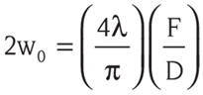

Using the calculation above shows the relationship between the focal length of the focusing lens, the wavelength, and the diameter of the incoming beam. If we are to use the HeNe laser profile, with a 3x magnifying beam expander as mentioned before, then a focusing lens of 150 millimeters would suffice. This correlates well into our system since we are planning for the front optic of the system to sit at a height of around 6 inches from the line. The actual beam waist with a 150 mm lens would roughly be around 40 microns, which is even better than what was expected. This means there’s more tolerance to any unforeseen error that can occur during setup, which is very much possible due to the level of precision we are attempting to achieve.

Another critical aspect that needs to be recognized is the depth of focus for the beam in question, and the Rayleigh length. These two concepts are similar, in fact the depth of focus is simply the Rayleigh length times two. It’s either side of the laser spot where the beam shrinks to √2 times its size, and then grows √2 times its size. The importance of solving for this value is to know the general tolerance that fabric has when it moves along the beam axis. A depth of focus that is too short will mean that a natural flex in the fabric while it rolls across the line may cause the beam spot to become so large that it covers multiple wires, which would make the laser irrelevant.

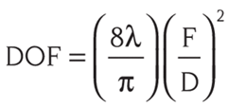

As we can see in equation above, the depth of focus equation follows the relationship of the beam waist calculation that was previously mentioned. The idea is that all parameters are shared across the two equations to have a true understanding of how the beam responds when focused. If we use the previous parameters for diameter and focal length, we will get a depth of focus of around 4 millimeters. That means there is 2 millimeters of tolerance in the positive and negative direction of the laser axis. The beam expansion at a factor of √2 its size, that means our 40-micron beam waist then becomes around 56 microns instead. We are hoping that with a stable design of the manufacturing line, that a ±2-millimeter tolerance is reasonable and is the maximum change that will be seen on that specific portion of the line where the counter is placed.

It is to be noted that during the optical demo, if it would be possible to not require a beam expander, and to only have one single element lens. We do not believe reducing the optical elements of the system would be conducive to a successful project. The issue arises due to the relationship between the focal length of the final lens, and beam diameter. It is possible to have a single lens placed in front of the laser in order to focus the beam down to our 50-micron target. In order to achieve this threshold, though, we would need a lens with a focal length around 60 millimeters. This equates to a distance that is about 2.3 inches above the manufacturing line. There would be no way to stay within height specifications while maintaining a proper beam.

Rayleigh Criterion

The Rayleigh Criterion, or Rayleigh Resolution, named for John William Strut, the 3rd Baron Rayleigh, is a criterion of resolution. When two points of light in object spaced are imaged through a lens, the Rayleigh Criterion determines the diffraction limited resolution that an optical system can provide. The core elements to the equation are as follows:

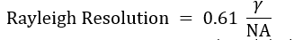

As seen above equation, the resolution is dependent on the wavelength and the numerical aperture of the optical system. Numerical aperture is a dimensionless figure. It is the index of refraction of the medium light travels through multiplied by half of the maximum angle, in radians, that light can enter through a lens objective. The resulting number that the equation solves for is the minimum radial distance between two objects in order for the images to resolve. However, this project is not focusing on point sources of light, but even so, the equation still holds merit. With improper resolution, the resulting photos will not be useable for machine learning or operator analysis. The thermal patterns that are being analyzed will look relatively undefined, with lack of defined edges and incomparable patterns against benchmark photos will result. Therefore, it is important to develop a system with enough quality in order to get a target Rayleigh resolution. We will want to be able to resolve, at minimum, an object space around 800µm x 800µm. We believe this will be an acceptable range to produce quality images. However, we do hope to achieve better resolutions.

Project Prototyping & Testing

On-Board Power Supply Testing

The power supply is a crucial component of the entire design not only to provide power to other component parts but also to ensure the efficiency and the performance of the entire system. For that, it is imperative that individual component testing needs to be done before we set the completed design. The testing is not limited only to the power supply but also to all components of the system as it must be done.

Unfortunately, an individual on-board AC-DC power supply cannot be done because of the components’ delay. Once we receive all our parts we can proceed to that testing. Despite the absence the materials, the power supply testing can be described as follows. In our project, we aim to have a minimum output voltage of 12V DC from this AC-DC power supply to energize the system. As it is going, we are not bound to that voltage because there are other components that require different voltages to be on. Therefore, in this case, we still can use the DC-DC power supply to bring energy to our system by using the Triple DC channel Power Supply just to have the 12V power that we are looking for. The following figure shows such testing.

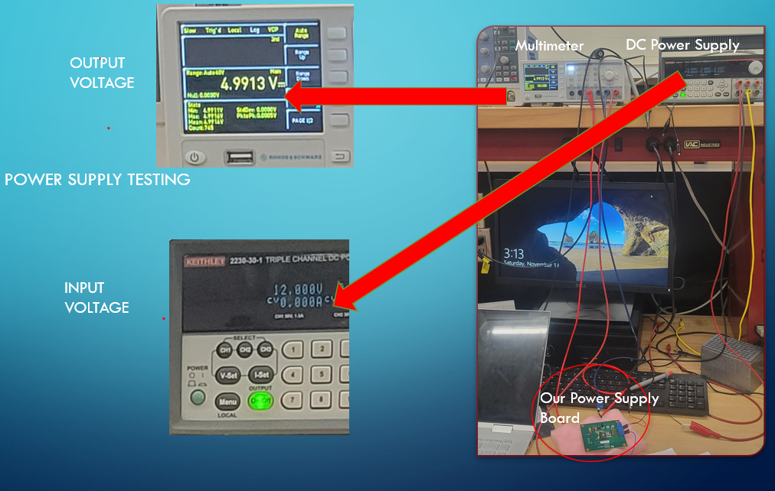

Figure 87: On-Board Power Supply PCB Testing

Hardware Prototype Construction

Breadboard testing became quite delayed due to the selection and acquisition of many vital components. Specifically, the high cost of the NVIDIA Jetson Nano Development Kit has us waiting for the project sponsors to approve and purchase for us. The Raspberry Pi Pico had scarce availability and arrived a few days before submission of this report. Thankfully, the A4988 Stepper Motor Driver Carrier came in well in advance, and I already had possession of a NEMA 17 Stepper Motor to pair with it. With the only components on hand being the Raspberry Pi Pico, A4988 Stepper Motor Driver, NEMA 17 Stepper Motor, and various common electrical components, we implemented the LED system and motor for the Auto-Focusing Software on a breadboard pictured below. However, given the only recent arrival of the secondary MCU the Pi Pico, the adequate time need to familiarize ourselves with the Raspberry Pi Pico’s programing did not exist. Therefore, at this time, our breadboard testing has been limited to simple assembly of the components but testing of the various PWM signals for the LEDs and the UART communication protocol to drive the stepper motor are unable to happen at this time. This will be our second priority after submission of this report, with the first priority being the acquisition of the other required components.

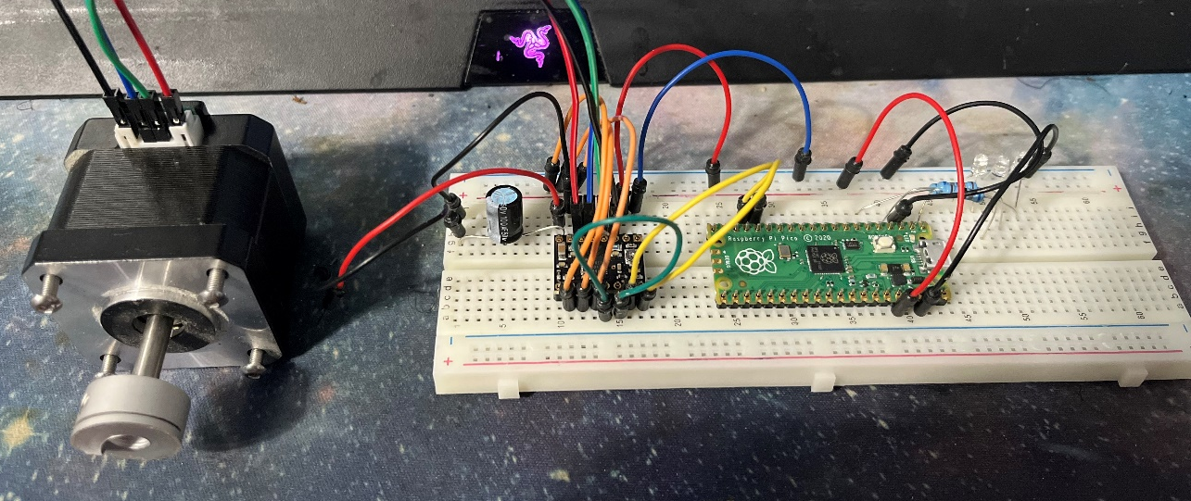

Figure 88: Breadboard Testing Draft Assembly

Software Testing Overview

With the development of all necessary modules complete, the system will now be combined virtually before deployment into the physical system. Using virtual machines, the modules will be used to perform unit testing amongst other components to determine interoperability between each element. The virtual setup will allow debugging to expose any inter-module communication issues that were not discovered until testing. In addition to debugging, virtual software testing will assist in developing a more robust system between loosely coupled components.

Simulated Software Testing

With the usage of virtual machines, the software can be tested and debugged with minimum use of hardware. By researching and implementing the use of virtual machines earlier, the project can proceed forward with testing at this stage of the project to resolve application errors. During simulated testing, we can observe inter-process communication between modules. In the event of an error, debugging each virtual machine will not interfere with any other virtual setup.

The camera will not be mounted to the virtual machine during the simulated test so data will be provided manually to the image processing microcontroller unit. Initially, each data image will not be modified to establish a base running session. The base run will demonstrate the most common scenario while detecting any faults. Upon establishing the base run and correcting any faults, the system will begin to run with failing images to demonstrate false conditions are working properly. If faults are detected, they will be corrected before continuing with testing the virtual system. Once all bugs from both tests are resolved, the virtual system will start testing a mixture of passing and failing data. The system should remain stable if all main bugs were resolved properly. Since the project will be working at a rapid pace when fully functional, a speedier version of alternating data will be used to test at capacity in the virtual environment. After the basic testing is completed, edge cases will be implemented to test the adaptability of the software system. By adding random data and changing speed, most cases should be resolved of bugs.

During image testing, the other aspects of the support systems will be tested. These other tests will require analyzing the log data after each simulated test to determine the accuracy of the system in counting and recording. The graphical user interface should display the appropriate results when log into the HTTP server from a browser. The bugs associated with these support systems will be corrected before deployment into the physical software test.

Physical Software Testing

In the next section, the initial bugs found during simulated testing have been cleared and now the software is ready for a physical implementation test. Before the full setup is completely installed, each component will undergo a hardware unit test with its particular software module mounted. The purpose of this test is to identify any individual incompatibilities before continuing with combining each component to the full system. With each integration test checked and passed, the full system can be assembled and tested for service.

Before the system is set into motion, each physical device will be checked for availability and service. A system check service will be initialized during startup to verify each component is operational. This will occur as part of startup and feed into the LED system to signal any errors during power up. This test will be a preliminary check to confirm system component in ready mode before moving on into service mode. After this first stage, the fully connected system can proceed to the testing phase.

The fully connected system will begin by testing the common use case of passing images. From previous testing, most aspects of the project should work properly. In any event, prior testing should have cleared most bugs and only hardware-software related bugs should be present, if any. Afterward, failing images will be used to prove the opposite conditions of the fully assembled running system. Any flaws will be rectified during this test before continuing to the alternating images test. Once the alternating images test is working properly, the system will test using randomness while increase the speed of the production line. During testing, inspection of support modules will help to verify the log and graphical user interface are functioning properly. The testing will conclude with looking into edge cases that might have been observed during analysis. A long-term burn-in period will be used to further demonstrate the stability of the system in service. Afterward, most of the system will be fully functional and ready for real service in the production line. The methods described above are not exhaustive and additional system issues could be encountered during demonstration time. The testing of the system will mitigate most issue but the group understands that a thorough test is not practical in the allotted time for the project. It will be expressed that the time constraint was a major obstacle during the whole process but managing through is an essential learning experience.

Control System PCB Testing and Implementation

As previously mentioned, upon receiving revision 1 of the control system PCB, it was apparent that the eFuses could not be implemented by hand with the tools available to us. So, we had to remove it from the overall schematic. Given that we also wanted to implement power for the fabric, a new revision of the board was made based off Control System Schematic V4. With the Control System PCB V2 in hand, we went straight away to attaching its components and testing. Before attaching components, all the traces were testing for continuity to ensure that they worked. With all traces confirmed, using the reflow stations in the Senior Design 2 lab I set the heat plate to 50°C and the hot air gun to 400°C. This configuration worked perfectly, and all components flowed properly.

Upon testing the now assembled PCB, we noticed some issues. The RX pad of the Pico which is vital to the UART communication with the Jetson Nano was being grounded. We tried a few work arounds such as bypassing the pad with wires connected to another UART pad, but that did not work as the whole trace was grounded out. We suspect that some solder flowed underneath the Pico during assembly and is bridging the RX pad to the 5V GND pad next to it. As we were unable to remove the Pico to fix or confirm this, a new identical board was made. This new board passed all the same testing, this time with no pads being unintentionally grounded. With this issue addressed we moved on to other issues.

When testing the photodiode results coming into our ADC on the Pico, we noticed the large inaccuracy previously mentioned with the voltage reference point. The value being read jumped between 0V and 0.3V consistently and this is understood to be from the ripples of the internal power supply of the Pico. So, by removing resistor R7 from the Pico board we isolated the voltage reference point of the ADC and used 3.3V through a voltage divider from our own 5V power supply. This worked better as the ripples now occurred between 0.1V and 0.3V. This however is still too much oscillation, and can be remedied in a future revision of the board by implementing a simple linear regulator in place of the voltage divider.

The stepper motor driver board, while implemented on the board is ultimately going unused. This was originally purposed for an auto-focusing system, but that system was later dropped from our goals. Then, due to some issues with our sponsor being unable to supply us with access to their manufacturing line and subsequently moving fabric, we sought to repurpose the stepper motor to simulate moving fabric. As we attempted to do this however, we hit an unforeseen issue. The stepper motor libraries used take too much computational power to run consistently and began to induce lag in our UART readings on the Pico. Originally, these motor libraries would have been used at the beginning of our code to focus our optics, then would have gone unused. However, by using them during the entirety of our code, our Pico could not keep up and began to read results from the Jetson in its buffer. This caused several readings to go unread or double read with other readings. Practically, this caused a whole one-minute delay in response from the Jetson reporting a failure, to the Pico illuminating the red LED. As this was unacceptable and an unforeseen constraint of the Pico, the stepper motor was cut.

Finally, regarding the new potentiometer and 2 pins for powering the fabric. We mistakenly added this feature after designing and setting the parameters of our power supplies. This resulted in the fabric drawing too much current and causing our over current protections to trip. This led to the feature being unutilized until a stronger power supply can be sourced.

The Schottky Diode that was implemented to protect from back feeding power was tested as a success. This test was done by plugging in USB power to the Pico and monitoring the voltage at the 5V terminal block to see if any power back fed. Which it did not and allowed for us to safely have the PCB powered via our power supply and connect to the USB port at the same time.

Connectivity to the Jetson Nano was made via a 5-pin jumper on the right side of the Control System PCB. This included UART_TX, UART_RX, 5V_GND, +5V, and +5V. The UART communication and common grounding worked perfectly as intended. However, powering the Jetson via the 2 +5V pins and GND proved to be an issue. This issue was routed in the lab power supplies on hand only allowed up to 1.5A of current to be used when the Jetson could pull up to 5A. This caused the lab power supply to trip whenever we attempted to power the Jetson. Due to some issues in sourcing our own power supplies, this feature was never able to be utilized. The Jetson was therefore powered via a dedicated micro-USB port connected to an outlet.

Finally, with the UART communication confirmed, the LEDs where tested and configured to respond to this communication. As intended, whenever a “Pass” was sent to the Pico the green LED illuminated and whenever a “Fall” was sent the red LED illuminated.

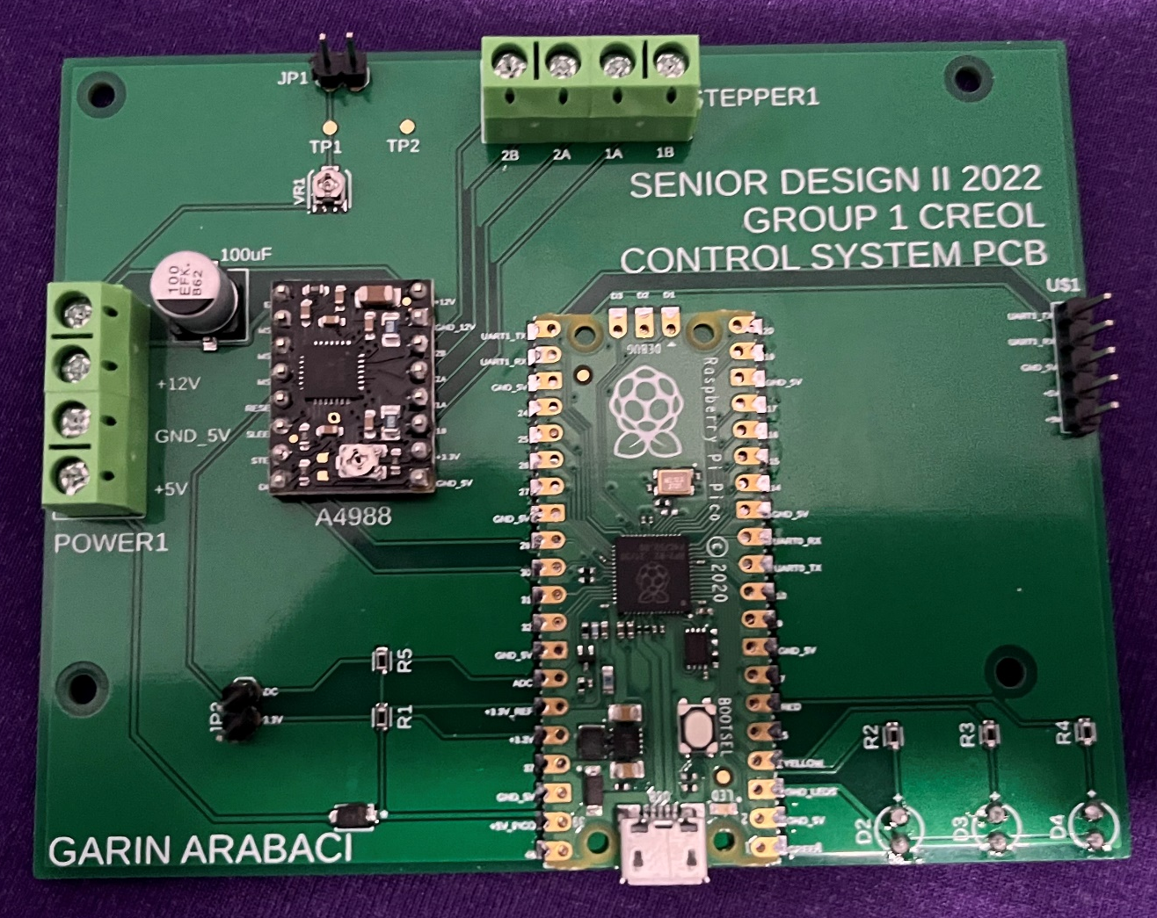
Figure 89: Control System PCB V2 Final Assembly

Conclusion

Initially, when the group was formed and accepted the proposal, it was the beginning of the arduous task of senior design. Each member was ready to contribute and prove their learned knowledge could be used to demonstrate the ability to design a working project as a team. The project would require different facets of engineering in order to yield a design prototype.

As we proceeded through the process, the group discovered that many engineering challenges would need to be solved to realize the design. After the initial meetings, the objectives and requirement specifications were decided upon in the project. The group then decided on the appropriate members to handle the necessary modules. In a final regard, the team would provide support to other group members to accomplish the final design document.

With the guidance provided, each member sourced the information to design the prototype for a working Infrared Automated Optical Inspector (IAOI). One key issue with the project was that most of the group was unfamiliar with the complexity of designing an automated optical inspection machine. Even with this deficiency, the team was dedicated to producing the associated design elements for the project.

A general examination of automated optical inspection machines helped to bring members up to speed on what was to be achieved. The main purpose of such a machine is to inspect and verify optical components. They use illumination, a specialized camera and processing software to ensure the quality of optical products. These mechanisms align well with the project design except the group will utilize the IAOI to quality control manufactured fabric on a production line. The difference between the group design project is significant due to the inspection of fabric over optical materials. Essentially, this was the first major obstacle associated with the project design. The realized solution involved the use of the physical attributes of the manufactured material, a laser and a specialized camera. This one solution was only the beginning of many more to come from the project design. Afterward, other engineering trials challenged each member in their respective design modules, but cooperation help to work pass those issues.

The difficulties encountered were an enlightening experience which brought about a shift in knowledge and application. The task to create such an apparatus required many different attributes both known and unknown to the group. Between finding parts and determining the best applications to develop were moments of many successes that drove the team to the objective.

With the current times, the group encountered many issues acquiring parts for the project. Many lead times for components came with long wait times beyond project completion. This forced the group to adapt to the everchanging situation that is 2022. In addition, the microcontroller units needed were in short supply and came with an exorbitant cost which really caused issues in the budget. With cost overruns, some sacrifices were made so that the project would not suffer from lack of hardware during the testing phase. These are the more difficult decisions related to the economics and time constraints associated with the project design. Overall, the team adjusted to compensate for each part issue while in the shadow of a pandemic.

On the software side, the team had to deal with developing the system to provide service to the project apparatus. Many ideas arose but many also didn’t fit the requirements for the project design. Software design was hindered by hardware which, in turn, was caused by the current times. To adjust, the team utilized virtual machines to get the development off the ground and moving. The procedure saves time but also exposed the team to possible incompatibilities between a virtual environment and actual hardware. The risk was worth the expense in time just to have development proceed with configuration of the environments and version control. It also adds time to the testing phase where the machine learning algorithm will undergo training and optimization. We predict some issues to evolve from this portion but the additional time gained will help to offset the loss. All decision related to the software development phase were made to the best knowledge in helping achieve the project design goal.

In conclusion, after many setbacks and obstacles, the group was able to produce the design document necessary to build the hardware prototype. Through the struggle and stress, each member succeeded in pulling together practical solutions from ideas on theory. Overall, it seems like just the beginning of another phase that will be just as challenging as the first phase. We hope to participate and come out on the other side with an improved appreciation in our respective engineering disciplines.

Administration Content

Budget
Our Budget will be funded through the Chromorphus Research Team with a maximum of $2500 and the potential for more if it is determined to be vital to the project's success. A majority of the cost in this project will go towards the Optical Sensors themselves and to a lesser extent the power supply to run it. As a cost-saving measure, we can make the enclosure for all this into a 3D print with a metal brace.

Budget Estimations

Table 21:Electronics and Power Budget Estimations
Item | Cost Estimate
Custom Power Supply | $300
Custom PCB | $150
Custom Enclosure (3D print) | $20
Microcontroller | $80
MISC/Unforeseen | $150
Total | $700

Optics

Table 19:Optics Budget Estimation
HeNe Laser | $592 (Can be borrowed for Demos)
NIR or IR camera | $1800
Lenses | $280
Total (Borrowed) | $1700
Total | $2892

Table 20:Optics Budget Actual

Semiconductor Laser | $0 (Borrowed)
Arducam | $120
Lenses | $280
Total | $400

Milestones
Table 21: Senior Design I Milestones
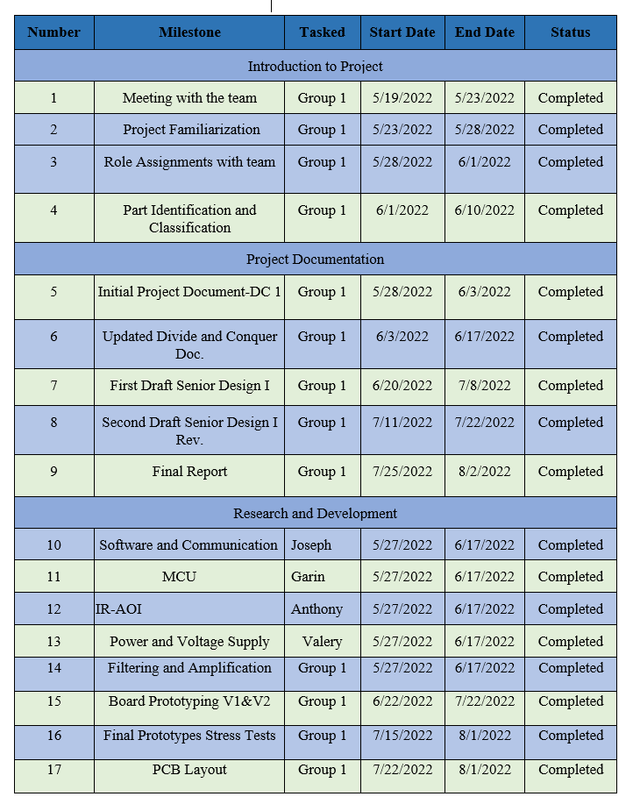

Table 22: Senior Design II Milestones
Number | Milestone | Tasked | Start Date | End Date | Status
1 | Working PCB V1 Stress Test | Group 1 CREOL | 8/26/2022 | 10/13/2022 | Completed
2 | Final PCB Stress Test | Group 1 CREOL | 10/14/2022 | 10/31/2022 | Completed
3 | MTC IR-AOI | Group 1 CREOL | 10/14/2022 | 10/31/2022 | Completed
4 | Conference Paper | Group 1 CREOL | 11/1/2022 | 11/11/2022 | Completed
5 | Design Demonstration | Group 1 CREOL | 11/14/2022 | 11/30/2022 | Completed

The “Milestones” of our project are divided in two-part tables “table 5 Senior Design I Milestones” and “table 6 Senior Design II Milestones.” Each table was defined by the workload, tasks assigned to the team, dates of accomplishment, and their status. The workload of each milestone will be divided by group member. Each member will be assigned a limited period of time to execute their assigned milestone. The status of each milestone will depend on its completion in relation to its time constraints. “Infrared Automated Optical Inspection,” is proving to be very challenging due to the constraints the team is facing. However, we are making a great effort to combat these challenges within the time and schedule that we have to make our project successful.
Table 5 Senior Design I Milestones is divided into three sections where each section is a step of progress for the project. The Introduction to Project includes all the meetings with the team to know our project’s scope, identify parts, and set assignment roles with the team group. The Project Documentation is all the turning papers for the group and their period to be completed. Finally, the Research and Development include all the workload to make the project successful with the time constraints.
Table 6 Senior Design II Milestones is showing the future work and assignments that include the conference paper, the final paper, and the final demonstration of our project. Since we don’t have specific dates yet; they are remaining dates pending until we have dates available to us. Our workload will stand accordingly with the future schedule that will be applied to the Senior Design II activities.
In general, the milestones are our guidelines on how we will be working as a team, the work division is set, and we will be making progress to complete all the tasks.

Instruction Manual

General overview and startup of jetson

The following picture shows the location of the onboard SD card that contains the operating system and data for the jetson nano to run properly. A back up of the file has been created to guard against possible data loss. The backup is dated 11/12/2022 and stored on external site along with a duplicate SD card.
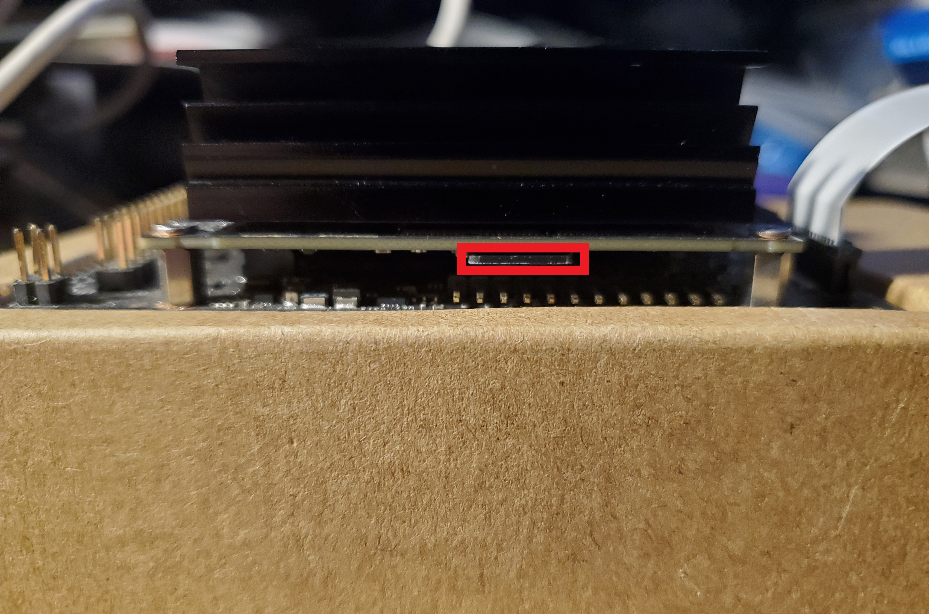
Figure 90:View of SD card

A green LED will illuminate on the jetson when it is powered on. Currently, power is delivered using a MicroUSB cable connect to a phone wall wart. It can also accept power through a 5v-2.5A DC barrel jack depending if jumper is inserted onto the board.
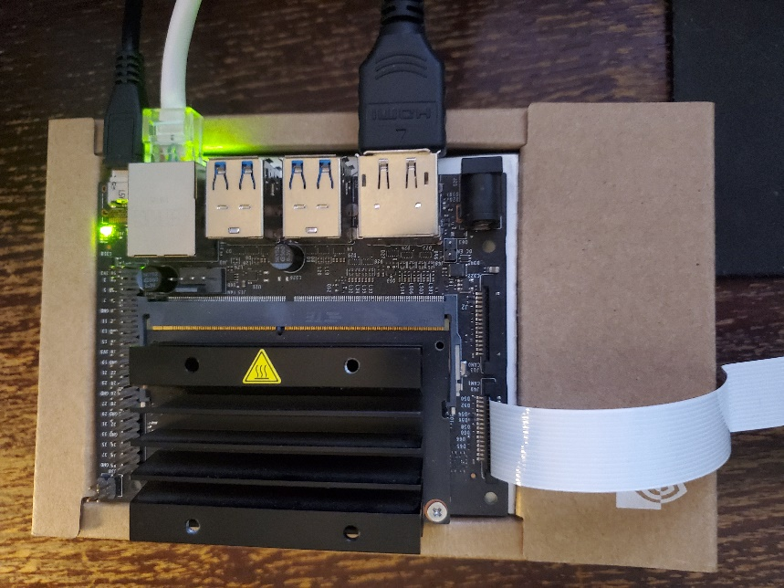
Figure 91:Overhead shot of jetson nano

The jetson nano powers on in less than 30 seconds to the Desktop screen below. It can take a little longer but it has consistently been quick to boot.
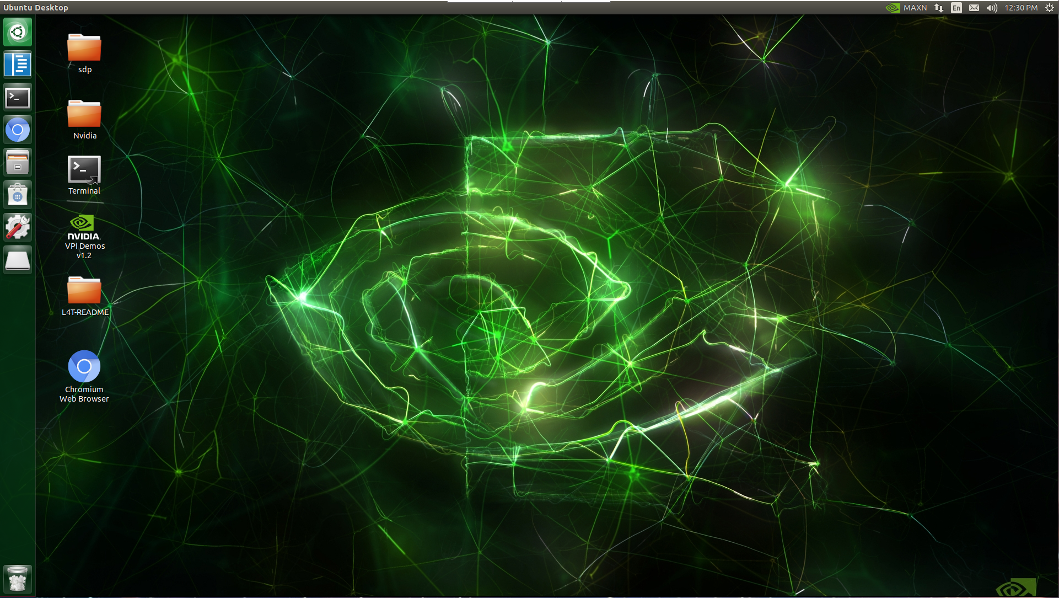
Figure 92:Jetson Nano Desktop Screen

The following icon allows the development environment Code-OSS (VS code) to start. It is used to alter and edit code for the SD project.

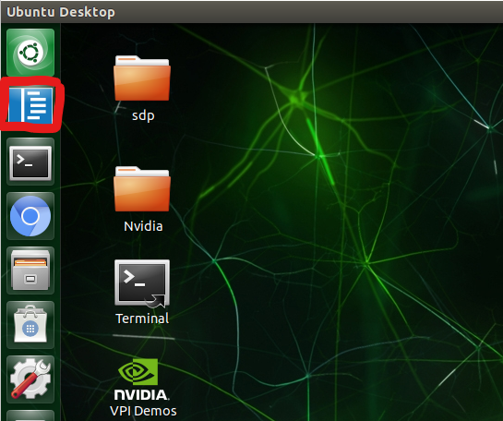
Figure 93: Code-OSS

The following shows Code-OSS running and displaying the cameraTest.py file.
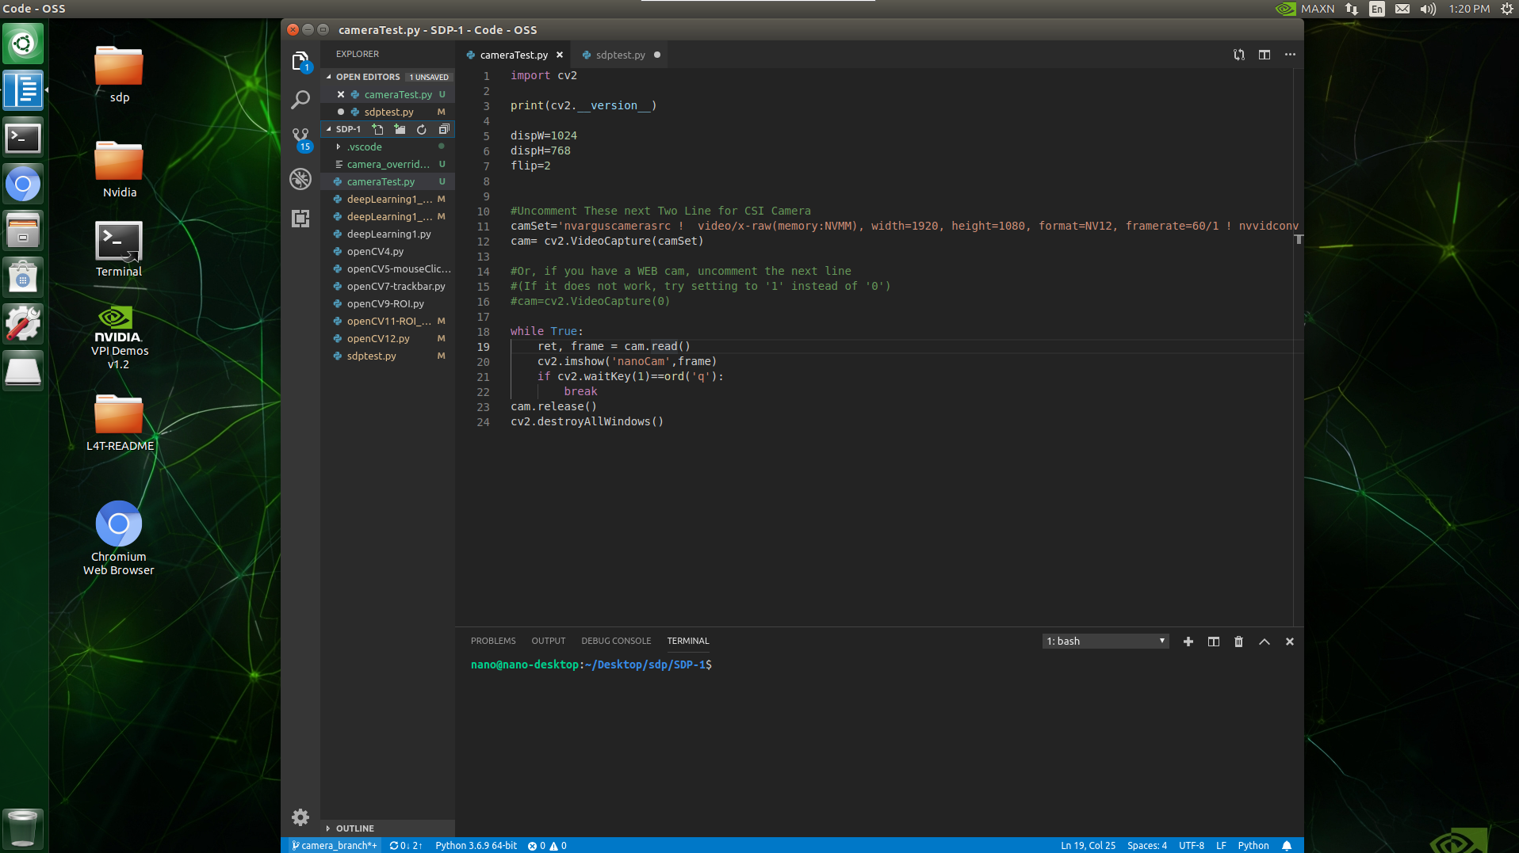
Figure 94:Code-OSS application
Right clicking in coding panel and selecting “Run Python File in Terminal” will start code execution. For this code, the camera will only display a live stream. To quit out of the running code, make sure to select the running live stream window and hit the ‘q’ key on the keyboard. This will stop execution of the program.

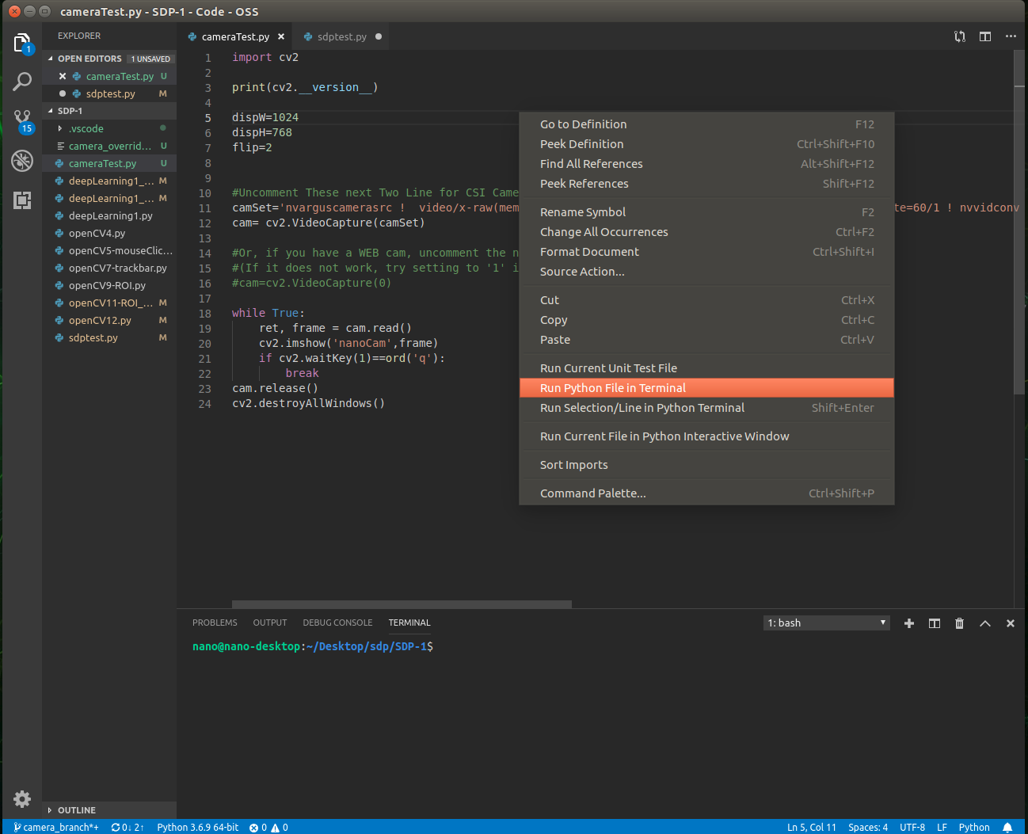
Figure 95:Running code in code-OSS

The following 2 file are the most important files on the jetson nano. For the sdptest.py, that is where we run the code to test the machine learning project. This will run the camera with the trained neural net.

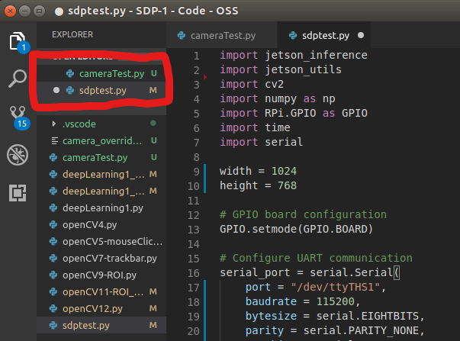
Figure 96: Two important files for testing project

Creating initial files for capturing and training

If starting a new training set, some initial files have to be created before capturing can commence. Using the File explorer, we will navigate to Downloads/jetson-inference and create a new folder. The folder will be name “myTrain” but can be whatever you choose. Open the “myTrain” folder and create a new text document named “labels.txt”. Open the “labels.txt” file and add the names for the classes that, you will train. They must be in alphabetical order. Once complete, save the file and continue to capturing images.
If a training set already exist with labels, just continue to capturing images.

Capturing Overview

In order to train a neural net, we have to first capture images for training. The following instructions will help in providing the directions necessary to perform this task.
First, we want to use the Files icon to open a file explorer in out Home directory. From there, we navigate to Downloads/jetson-inference/tools which will put us in the correct directory to access the camera-capture tool. Open a terminal in the current directory by right clicking in an empty area and select “Open in Terminal”.

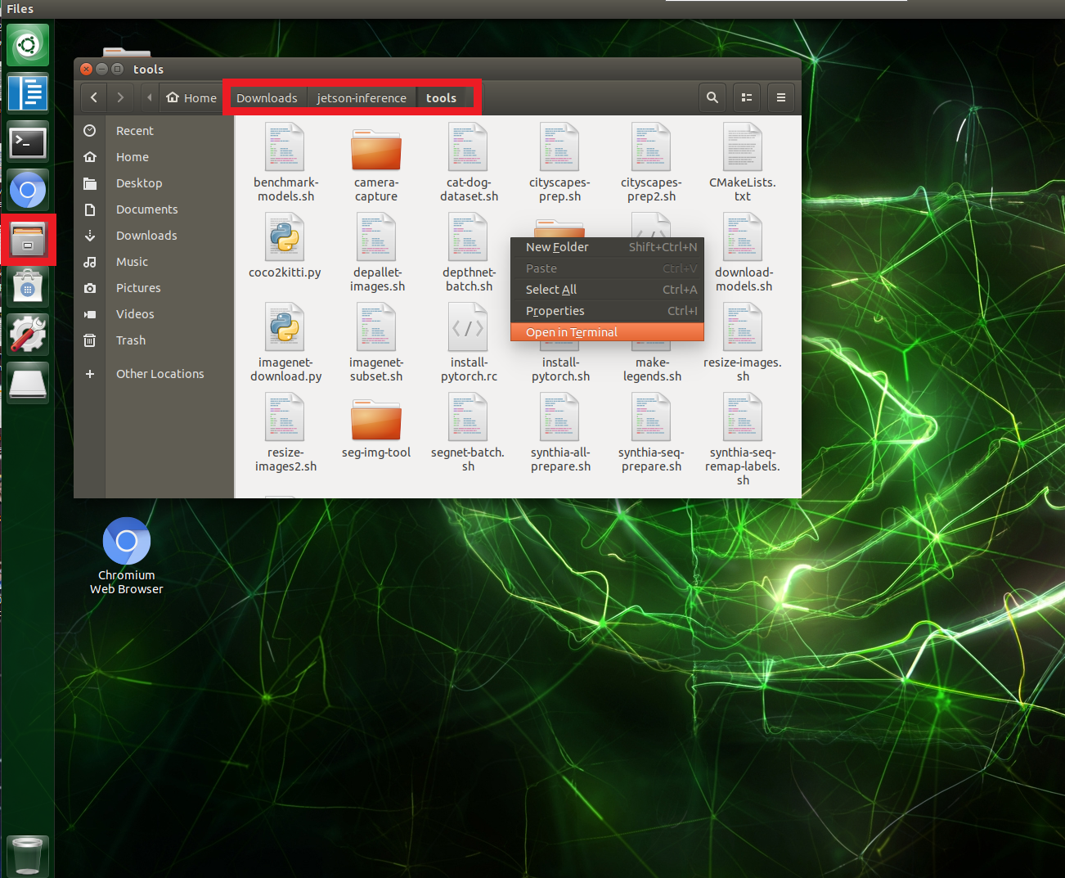
Figure 97: Opening terminal for camera-capture

Run the following command in the terminal to start capturing images. I utilize a smaller resolution to minimize size of images to capture.
$ camera-capture --input-width=800 --input-height=600

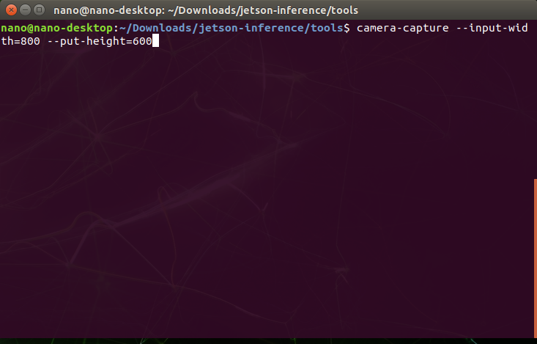
Figure 98: camera-capture starts using terminal

The following selection box will open for us to specify certain attributes. Our Dataset Type is Classification. The Dataset Path will be set to the folder where the labels.txt file is located. The Class Labels will be set to the labels.txt file. Once those attributes are set, we can begin to capture images for training. The Current Set refers to the training, test, or validation sets of the Current Class selected. In the image below, we can start by capturing the training set for the “fail” class. It is best to capture at least 50 images for beginning training followed by 20% for validation set. The test set is to manually test images once training is completed. It is not used in the training phase. Once capturing is complete, close the windows and move on to training. Try to maintain an even distribution of images across classes to avoid overfitting to one particular class.

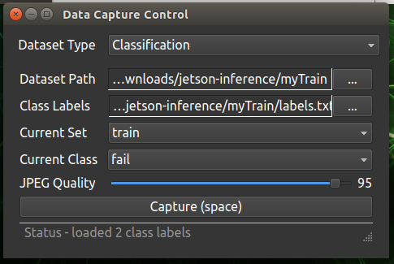
Figure 99: Data Capture Control window

Training Overview

With our images captured, we will begin training the neural net on those images. Using the file explorer, we will navigate to the following path on the jetson nano.

/Downloads/jetson-inference/python/training/classification/

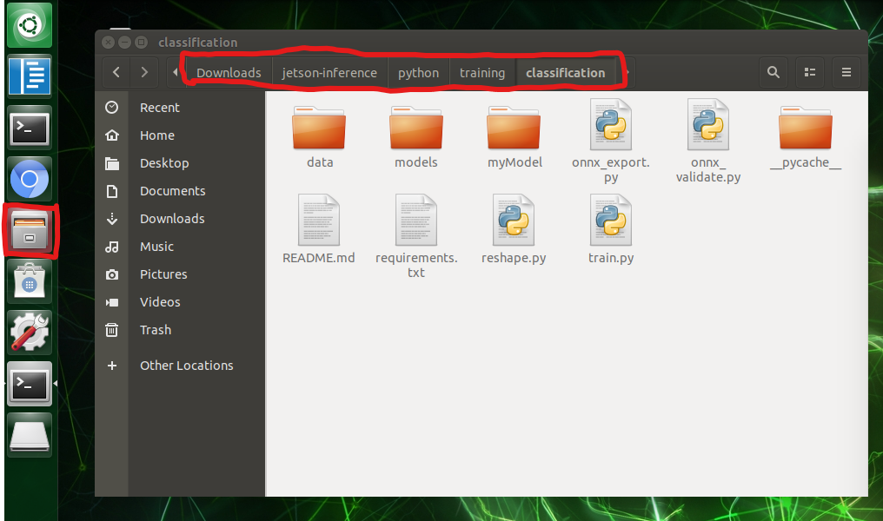
Figure 100: Path to train.py

Once there, open a terminal window to run the following command to start training.

For training a new data set with no prior training run the following:

$ python3 train.py -a resnet18 --model-dir=myModel ~/Downloads/jetson-inference/myTrain/

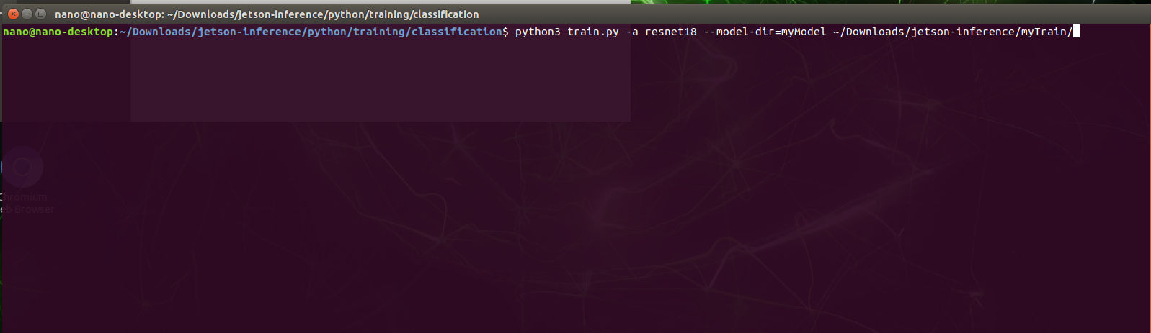
Figure 101: command to start training

When using this command, training will be performed using the resnet18 neural net with the model directory indicating where the trained algorithm will place its files. In this case, it will be the “myModel” directory. The final portion of the command indicates where the training data is located using the absolute path.

Once training starts, the terminal will begin to show the results of each epoch/iteration of training performed on the training set. Training on the images will be performed through 35 iterations.

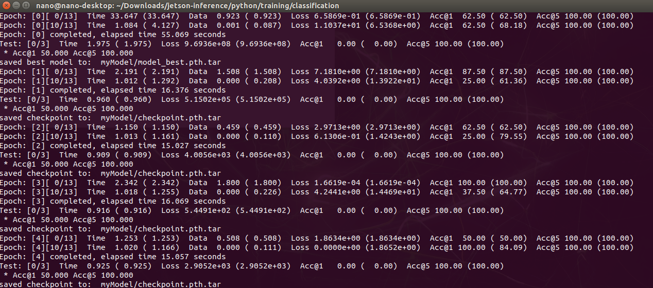
Figure 102: Training progress

For resuming training from a previously trained data set run the following:

$ python3 train.py -a resnet18 --model-dir=myModel ~/Downloads/jetson-inference/myTrain/ --resume myModel/checkpoint.pth.tar

Here we append the –resume along with the directory where the restore point is located. In this case, “myMode/checkpoint.pth.tar” is the file name of the save point. When resuming, the neural net will train for 5 more epochs using the data in the myTrain directory. This is best used to continue training when new data images are captured.

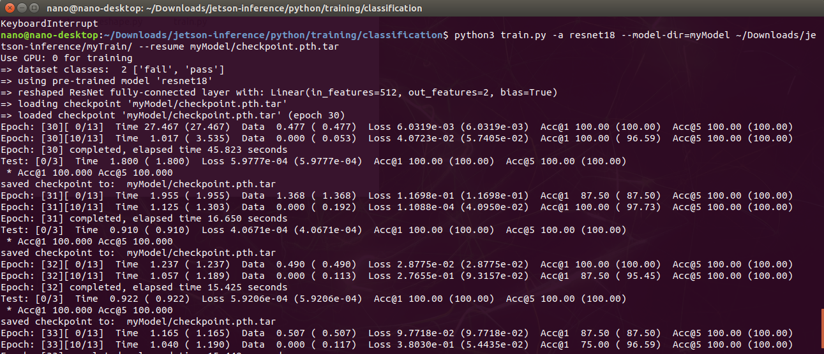
Figure 103: Resuming Training

Once training is complete, we need to export the trained neural net using the following command.

$ python3 onnx_export.py --model-dir=myModel

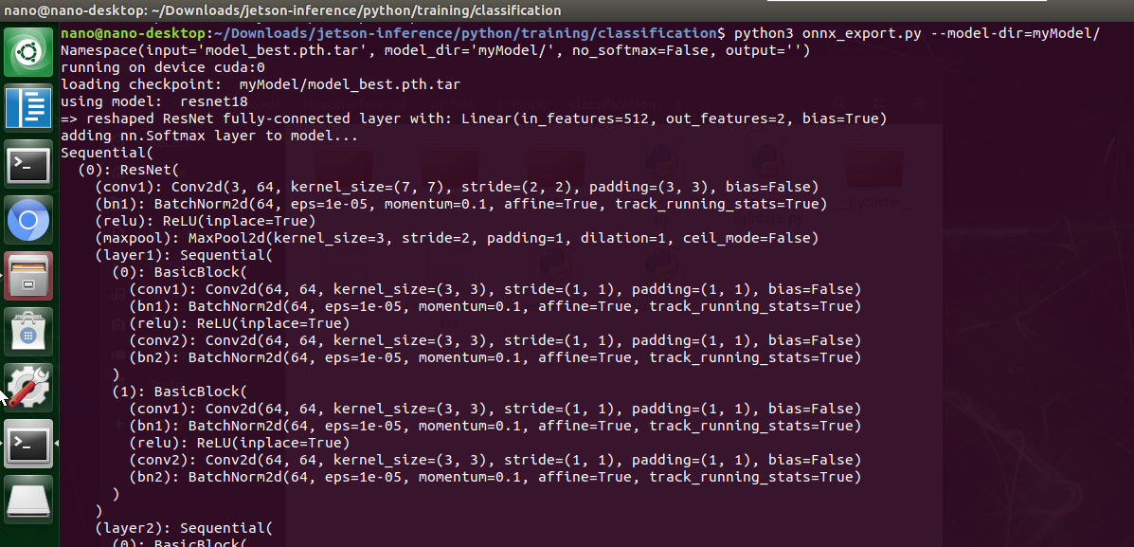
Figure 104: Exporting trained neural network
The model directory refers to the place where the neural net stored all files during training. In this case, the “myModel” directory. You will also be given the name of the neural net that was exported. The name will be added to our code-OSS sdptest.py file. In this example it is named “myModel/resnet18.onnx”.
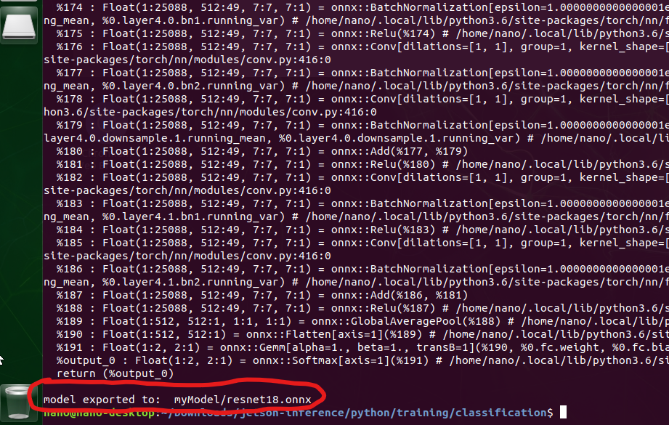

We can close on training windows and move on to testing the newly training neural net.

Testing trained neural network

When is come to testing the newly trained neural net, we just have to edit line 35 in the sdptest.py code. This line contains all the information necessary to test, currently. It does not need to be altered if the same data or a resumed model is name as before. It is only altered if a new model is being used. The following line will implement the trained neural net.

net = jetson_inference.imageNet('googlenet', ['--model=/home/nano/Downloads/jetson-inference/python/training/classification/myModel/resnet18.onnx', '--input_blob=input_0','--output_blob=output_0','--labels=/home/nano/Downloads/jetson-inference/myTrain/labels.txt'])

The initial portion of the code that encompass ‘googlenet’ does not perform any function when using a trained model. The code after designates the location of the exported model along with the location of the labels using the absolute path.
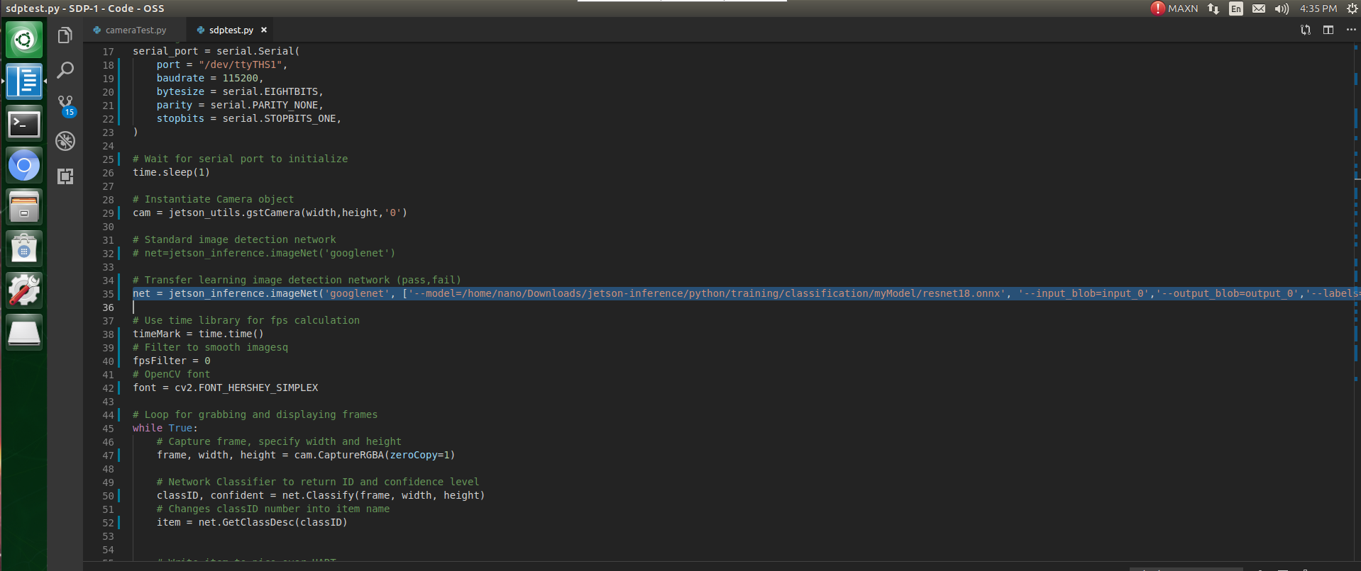
Figure 105: command to add to application

Run the code as before and test, accordingly.

Things to know

- The code is commented to make things clearer.
- The more images captured the longer the training will take.
- Resume training, to eliminate long training time.
- More training data will make neural more robust.
- Different neural networks can take more time due to added resources.
- The program can be run from the cmd prompt for better framerates.
- Capture using stable background and don’t add unnecessary data to images.

Source Code
Source code for each portion of the project. Each block is an object that can be double-clicked to access the source code for each portion of the project. The code is also on the following GitHub repository under camera_branch.

https://github.com/jdsauceda/SDP

Jetson Nano Code

Jetson Nano GUI code

Raspberry Pi Pico Code

Appendices

Appendix A – Datasheets

- Raspberry Pi Pico
  - https://datasheets.raspberrypi.com/pico/pico-datasheet.pdf
- RP2040 (Raspberry Pi Pico’s main IC)
  - https://datasheets.raspberrypi.com/rp2040/rp2040-datasheet.pdf
- NVIDIA Jetson Nano 2GB Developer Kit User Guide
  - https://developer.nvidia.com/embedded/learn/jetson-nano-2gb-devkit-user-guide#id-.JetsonNano2GBDeveloperKitUserGuidevbatuu_v1.0-40-PinHeader(J6)
- NVIDIA Jetson Nano System-on-Module (Maxwell GPU + ARM Cortex-A57 + 4GB LPDDR4 + 16GB eMMC)
  - https://developer.download.nvidia.com/assets/embedded/secure/jetson/Nano/docs/JetsonNano_DataSheet_DS09366001v1.1.pdf?zew_ljCKhBhwxhpAYcjfVQHqBlN0cr9xna7fcgxtHR7yceFefcoa9XfXD_QZS6NfYnvmUwZW71skSmMbULuuY0tJJvRzqNWm-8QgH_CMwjlTj-qhhrX629gd54Dldllkahe3PkbA58qUj--o_2-YyhLKKDQRNgPlihIIA94oeFcM3uE2uWw6-Yv3OavkcA&t=eyJscyI6ImdzZW8iLCJsc2QiOiJodHRwczpcL1wvd3d3Lmdvb2dsZS5jb21cLyJ9
- NVIDIA Jetson Nano Pin and Function Names Guide
  - https://developer.download.nvidia.com/assets/embedded/secure/jetson/Nano/docs/Jetson_Nano_Pin_and_Function_Names_Guide_AN_DA-10193-001_v1.0.pdf?xeEw59pkRTP1ffpHsYLkvy9qA1RIh5Z17IORmERLoykDBO9m4sEoITX-QvCz_ShyI-HV_IRDqjDkb95RlJVgLyH0rtAhf_rxNKAvt7lPa7oiIRJbo0pWER6PX3BO-Lls-QnD7S6cLALX_C7VU1X0GrpyWXFIKzIVc-Movy_QEddoW-UzXfU5r2wZ8Oshp5YyWQP1UgWlzXJgxIpyBQ8g0EKR8kOVMGsg&t=eyJscyI6ImdzZW8iLCJsc2QiOiJodHRwczpcL1wvd3d3Lmdvb2dsZS5jb21cLyJ9
- Mounted Si Photodiode SM05PD2B
  - https://www.thorlabs.com/drawings/87a40382405af81f-6DB39030-F0BF-028A-E530EEF749007E81/SM05PD2B-SpecSheet.pdf
- CS135MUN - Kiralux 1.3 MP NIR-Enhanced CMOS Camera, USB 3.0 Interface
  - https://www.thorlabs.com/drawings/87a40382405af81f-6DB39030-F0BF-028A-E530EEF749007E81/CS135MUN-Manual.pdf
- 1N5817-TP Schottky Diode for Pico
  - https://www.mccsemi.com/pdf/Products/1N5817-1N5819(DO-41).pdf
- eFuse TPS25200DRVT
  - https://www.ti.com/general/docs/suppproductinfo.tsp?distId=10&gotoUrl=https%3A%2F%2Fwww.ti.com%2Flit%2Fgpn%2Ftps25200

Appendix B - References
eTechnophiles. (2021). Raspberry Pi 4 GPIO Pinout, Specs, Schematic (Detailed board layout). Retrieved from eTechnophiles: https://www.etechnophiles.com/raspberry-pi-4-gpio-pinout-specifications-and-schematic/#raspberry-pi-4-gpio-pinout
NVIDIA Corporation. (2022). Jetson Nano 2GB Developer Kit User Guide. Retrieved from NVIDIA Developer: https://developer.nvidia.com/embedded/learn/jetson-nano-2gb-devkit-user-guide#id-.JetsonNano2GBDeveloperKitUserGuidevbatuu_v1.0-40-PinHeader(J6)
Pololu Corporation. (2001). A4988 Stepper Motor Driver Carrier, Black Edition. Retrieved from Pololu: https://www.pololu.com/product/2128/pictures
RandomNerdTutorials. (2022). Getting Started with the ESP32 Development Board. Retrieved from Random Nerd Tutorials: https://randomnerdtutorials.com/getting-started-with-esp32/
Raspberry Pi Ltd. (2012). Raspberry Pi Documentation. Retrieved from Raspberry Pi: https://www.raspberrypi.com/documentation/microcontrollers/raspberry-pi-pico.html
Texas Instruments Inc. (2019). 11 Ways to Protect Your Power Path. Retrieved from ti.com: https://www.ti.com/lit/eb/slyy168/slyy168.pdf?ts=1659069893169&ref_url=https%253A%252F%252Fwww.google.com%252F
Texas Intruments Inc. (2013). MSP-EXP430FR6989 Quick Start Guide. Retrieved from Texas Insturments: https://www.ti.com/lit/ug/slau626/slau626.pdf?ts=1658359924926&ref_url=https%253A%252F%252Fsoftware-dl.ti.com%252Fmsp430%252Fmsp430_public_sw%252Fmcu%252Fmsp430%252FMSP-EXP430FR6989%252Flatest%252Findex_FDS.html
Thorlabs, Inc. (2017, September 7). SM05PD2B - Mounted Silicon Photodiode, 200-1100 nm, Anode Grounded. Retrieved from THORLABS: https://www.thorlabs.com/thorproduct.cfm?partnumber=SM05PD2B
Unconventional2. (2014, October 21). English: Annotated and cropped version of Connector USB 3 IMGP6024 wp.jpg. Retrieved from Wikimedia Commons: https://commons.wikimedia.org/wiki/File:USB_3.0.png
Wheeler, R. (2007, January 10). English: Category 5e ethernet cable, showing the twisted pairs of copper wires. Retrieved from Wikimedia Commons: https://commons.wikimedia.org/wiki/File:CAT5e_Cable.jpg
He, Kaiming et al. “Deep Residual Learning for Image Recognition.” 2016 IEEE CONFERENCE ON COMPUTER VISION AND PATTERN RECOGNITION (CVPR). NEW YORK: IEEE, 2016. 770–778. Web

Rectifiers and Voltage regulators
https://www.elprocus.com/bridge-rectifier-circuit-theory-with-working-operation/
https://www.electronics-tutorials.ws/diode/diode_6.html
Introduction to Linear Voltage Regulators (digikey.com)
http://www.eetimes.com/document.asp?doc_id=1272466
https://www.ti.com/lit/an/snva558/snva558.pdf
https://www.quora.com/If-an-input-voltage-is-108-V-AC-what-will-be-the-output-DC-voltage-of-a-bridge-rectifier

https://www.ti.com/lit/ds/symlink/lm5023.pdf?ts=1657159198233&ref_url=https%253A%252F%252Fwww.ti.com%252Fdocument-viewer%252FLM5023%252Fdatasheet%252Fabstract

https://www.monolithicpower.com/en/voltage-regulator-types#:~:text=How%20Does%20a%20Voltage%20Regulator,with%20the%20other%20electrical%20components.

Filters
https://www.ti.com/lit/an/sloa049b/sloa049b.pdf (filters)
https://www.electrical4u.com/active-low-pass-filter/
https://www.electronics-tutorials.ws/filter/filter_2.html
Amplifier
https://www.britannica.com/technology/amplifier

Voltage Divider
https://learn.sparkfun.com/tutorials/voltage-dividers/all
transformer
https://powertemp.com/what-is-the-purpose-of-a-transformer/

Terminal Blocks
https://www.electricaltechnology.org/2020/04/types-wires-cables.html

Enclosure
https://www.dfliq.net/blog/understanding-nema-ratings-electrical-enclosures/
https://www.nemaenclosures.com/enclosure-ratings/nema-rated-enclosures.html
https://amprod.us/products/

Heat Sink
https://www.radianheatsinks.com/heatsink/
https://electronics.stackexchange.com/questions/255731/copper-or-aluminum-heatsink#:~:text=Thermal%20conductivity%20of%20copper%20is,heat%20than%20an%20aluminium%20one.

